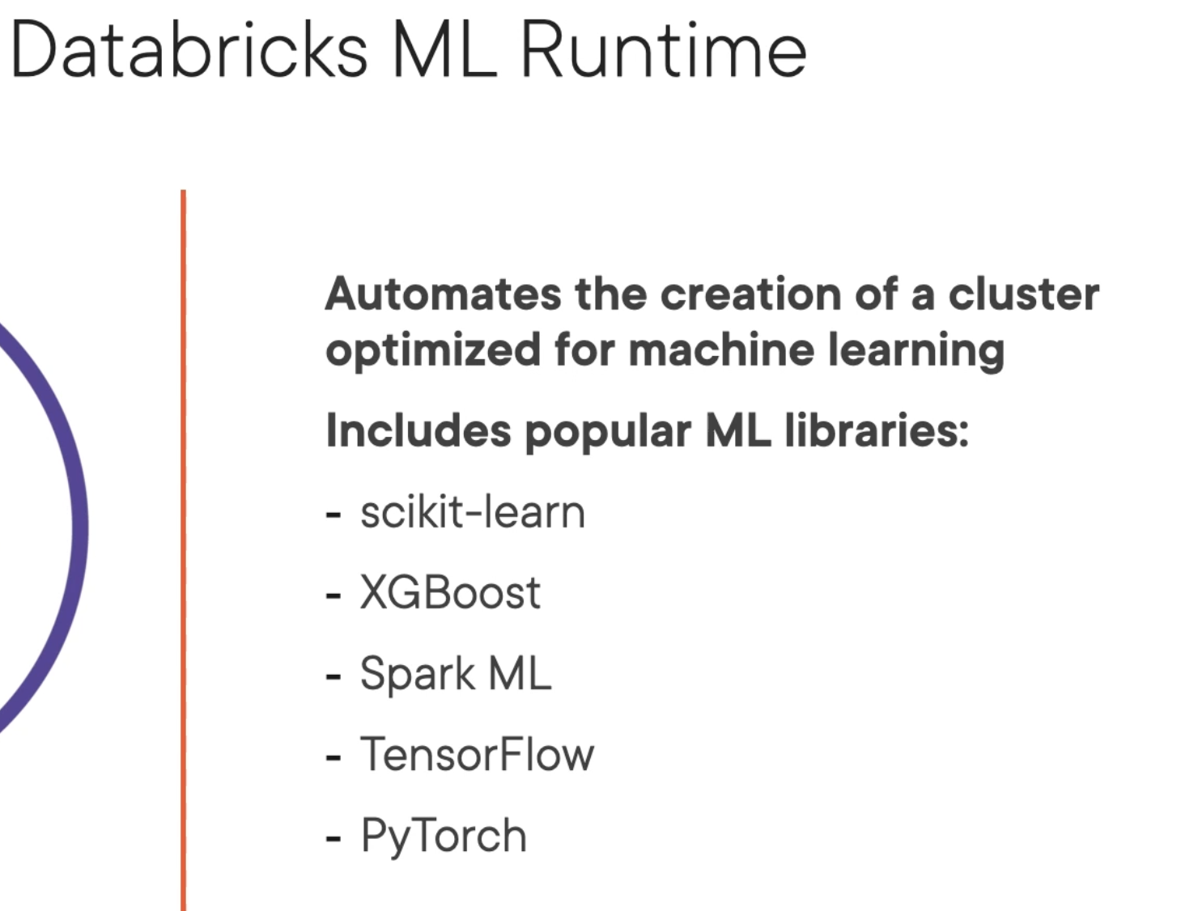

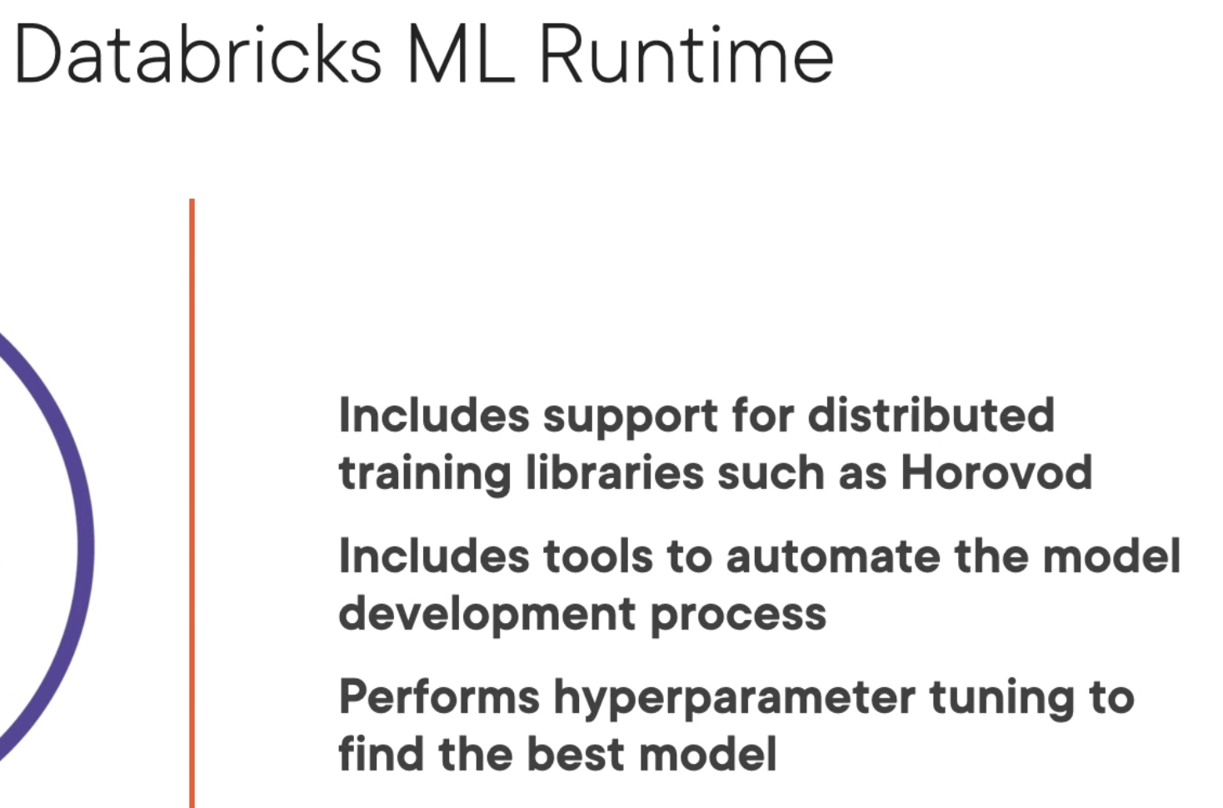

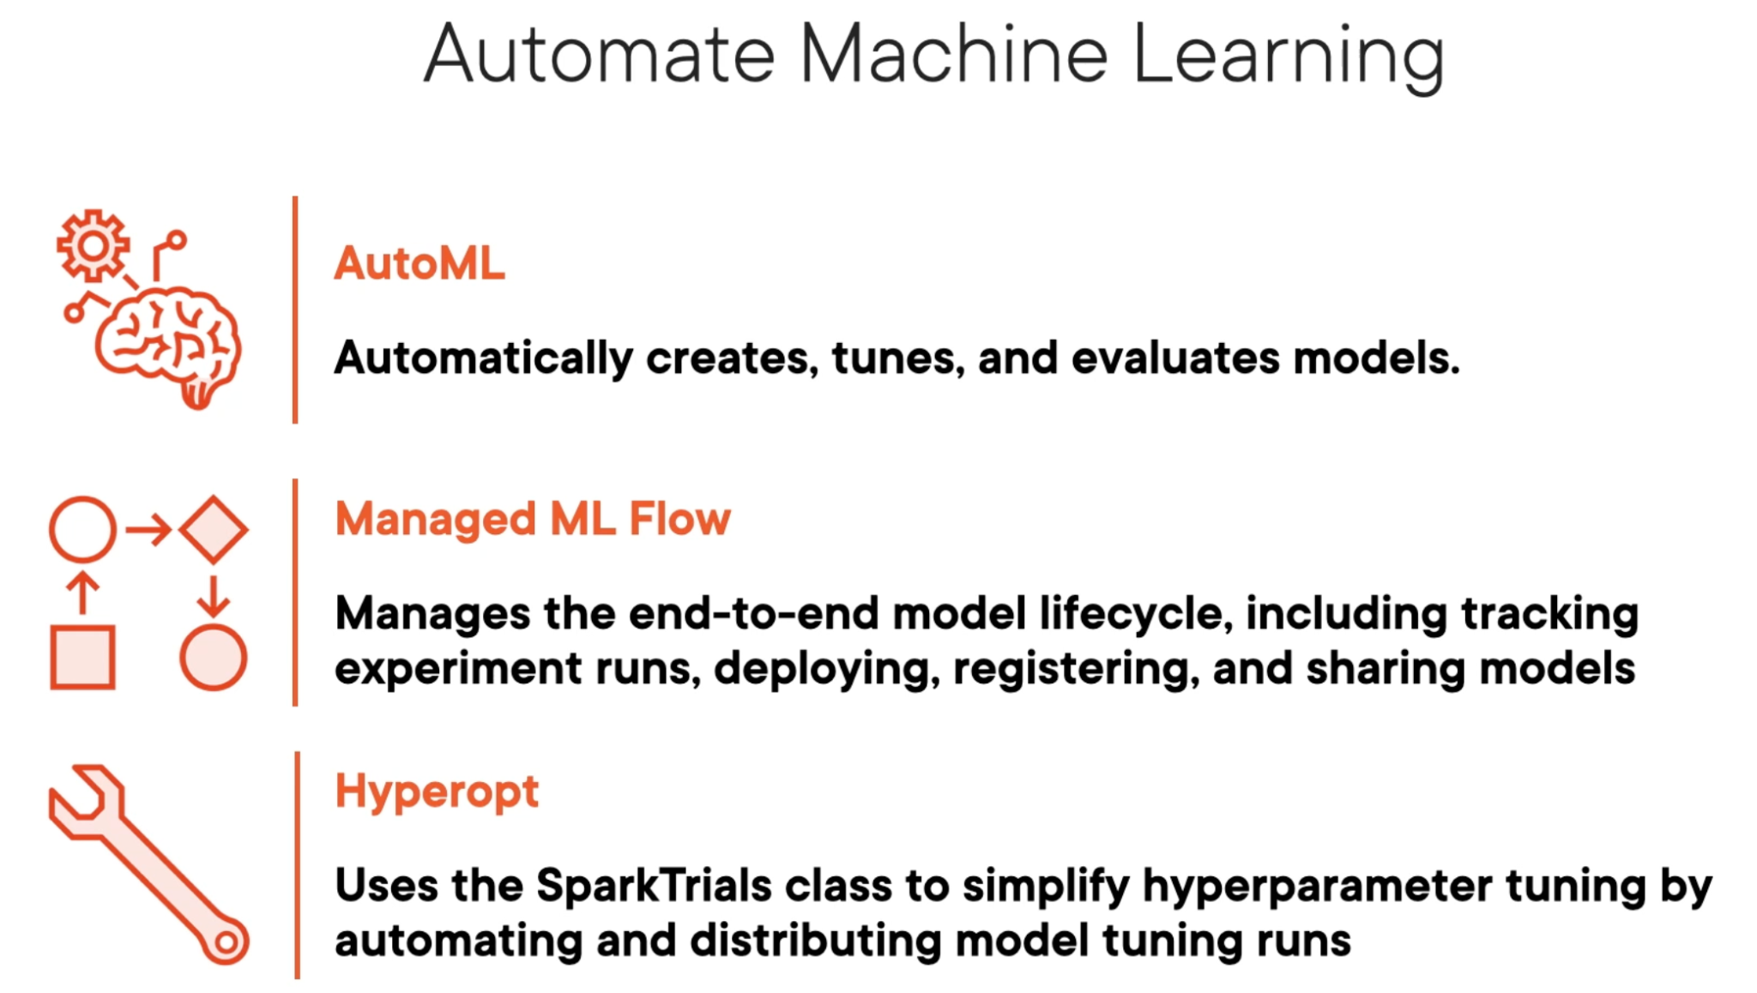

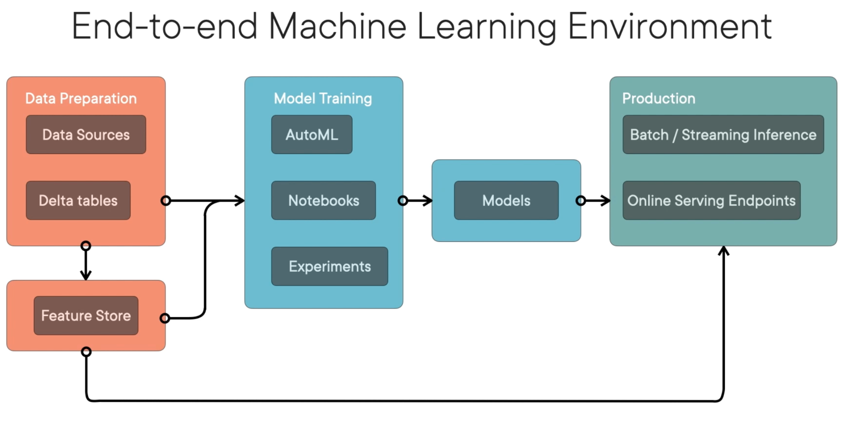

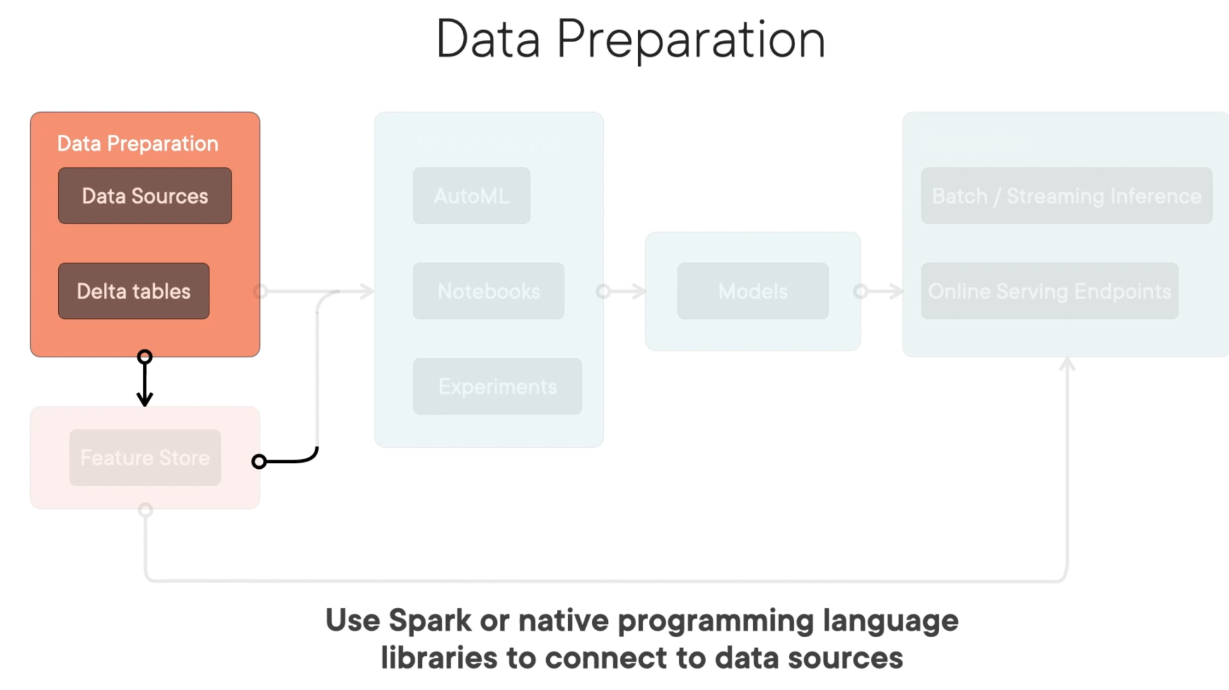

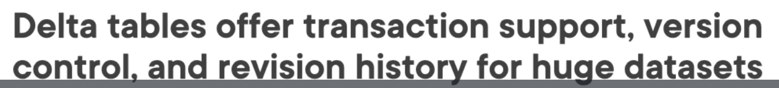

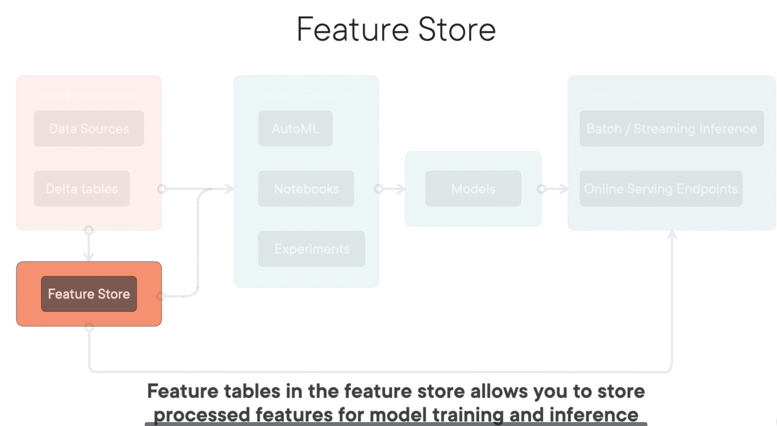

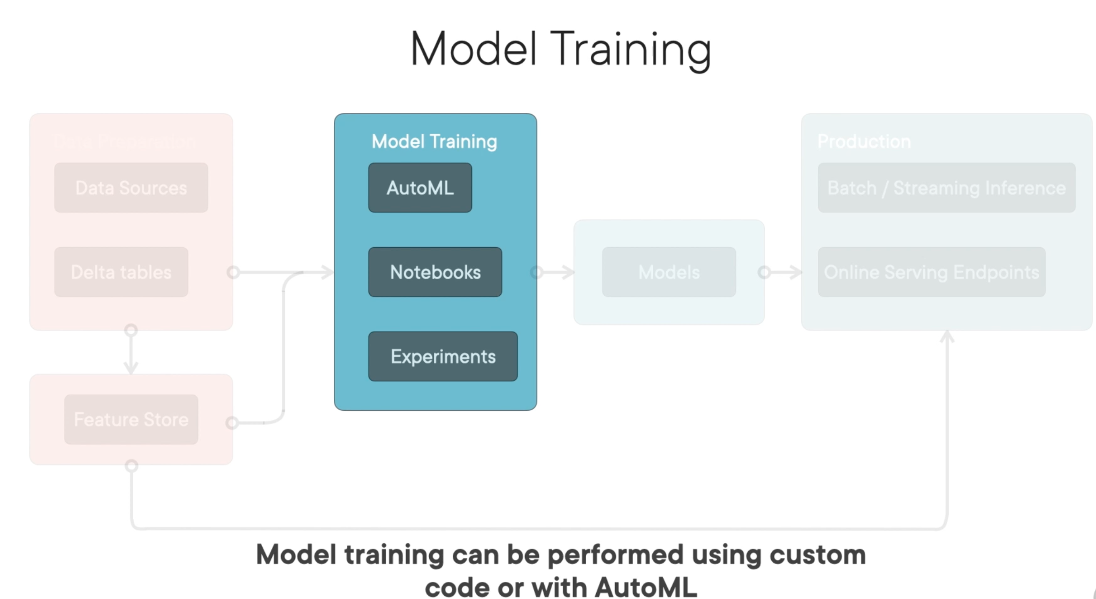

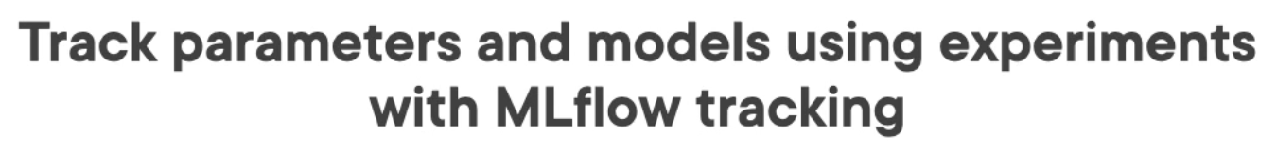

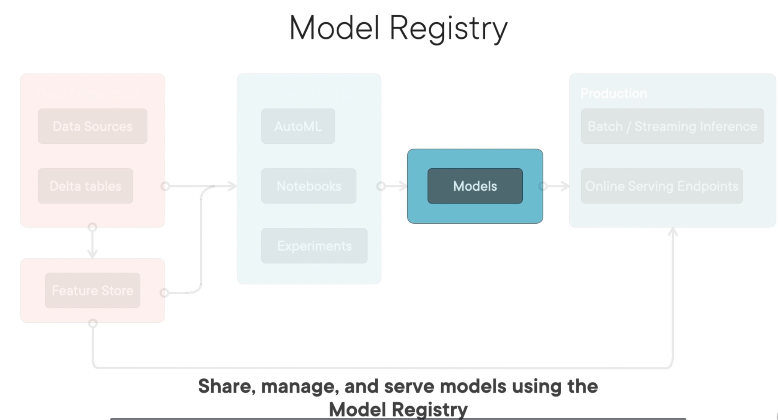

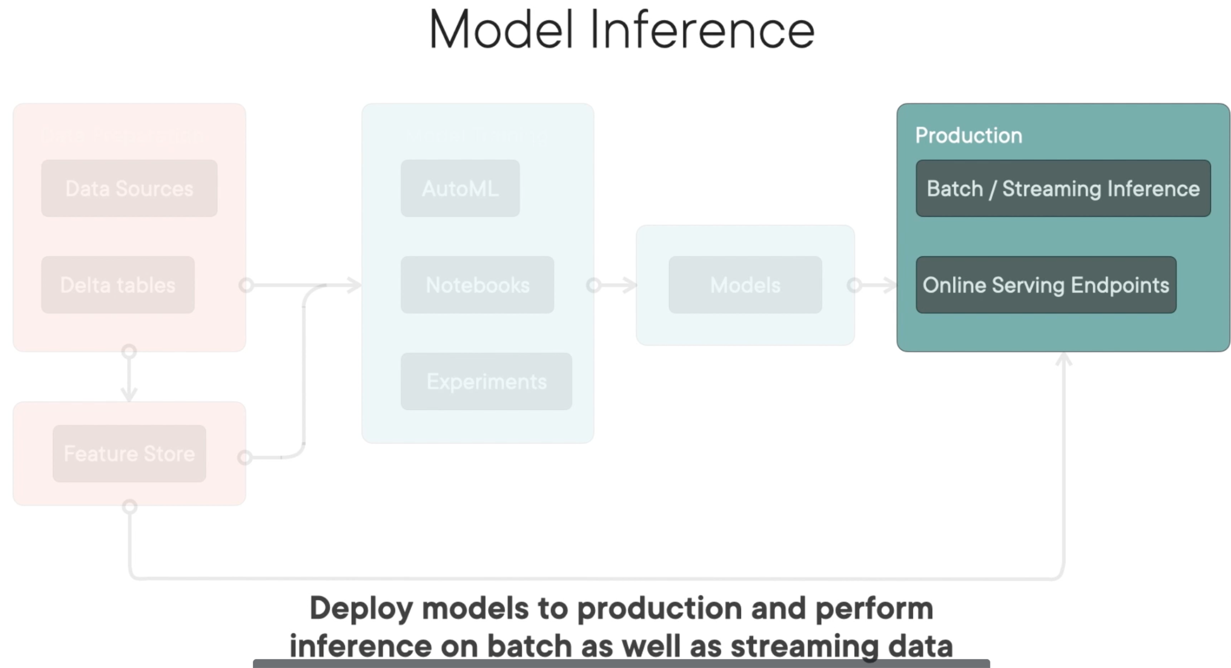

# Introducing MLflow

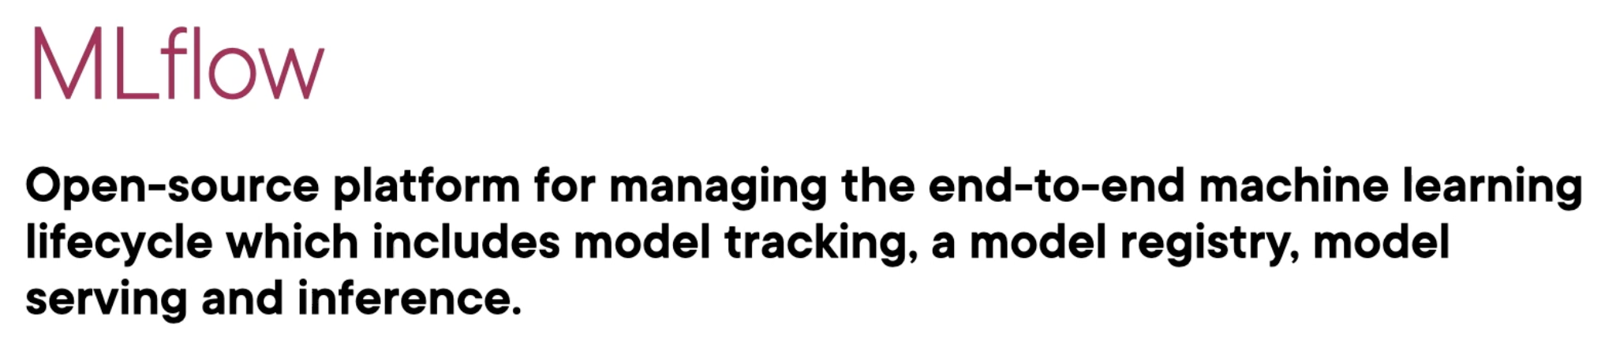

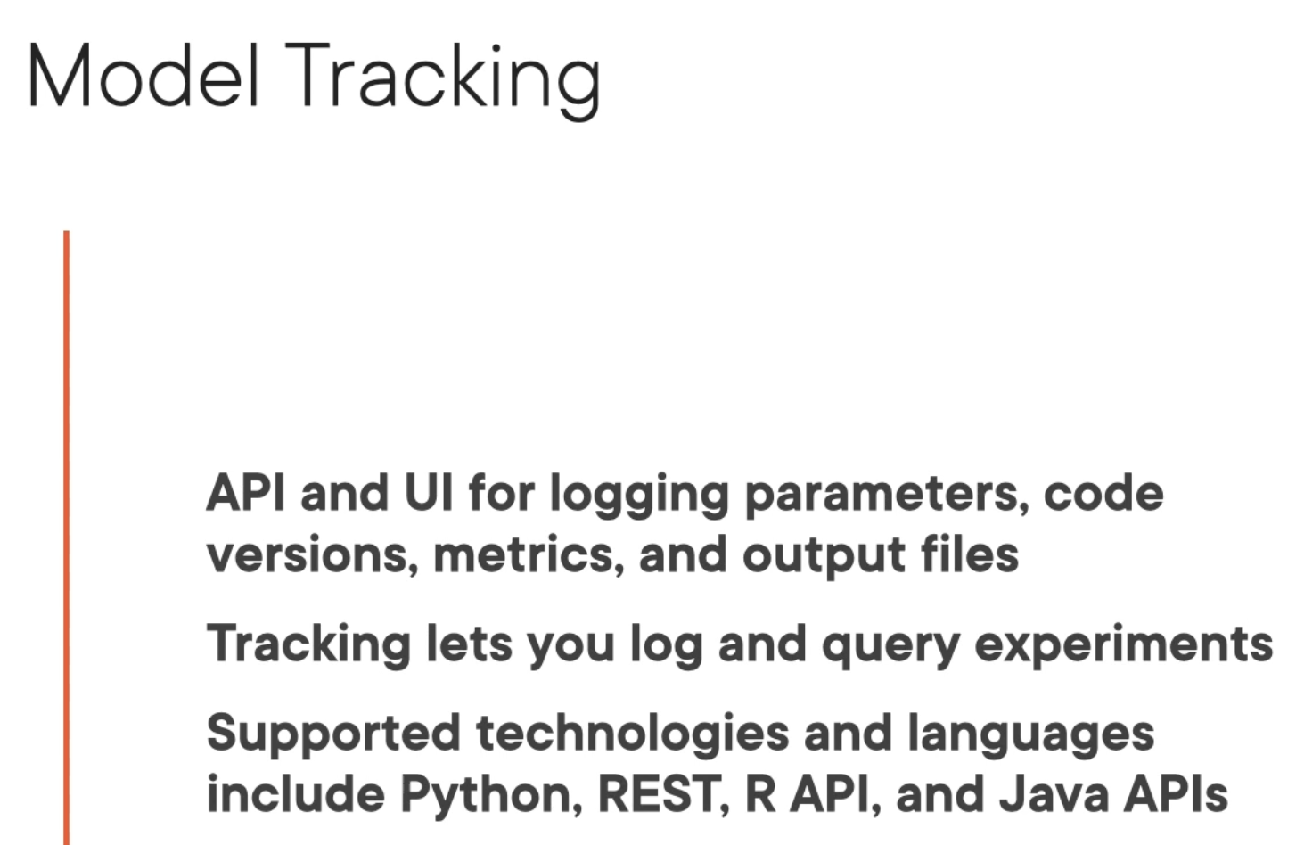

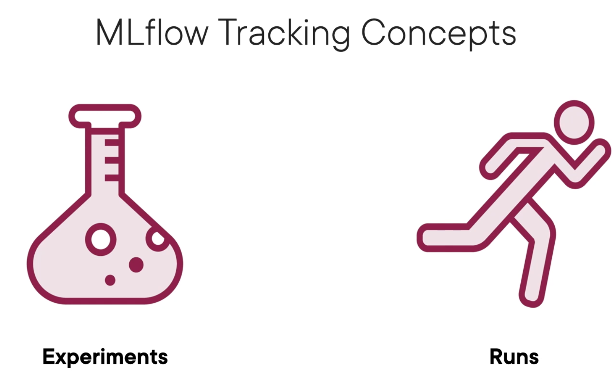

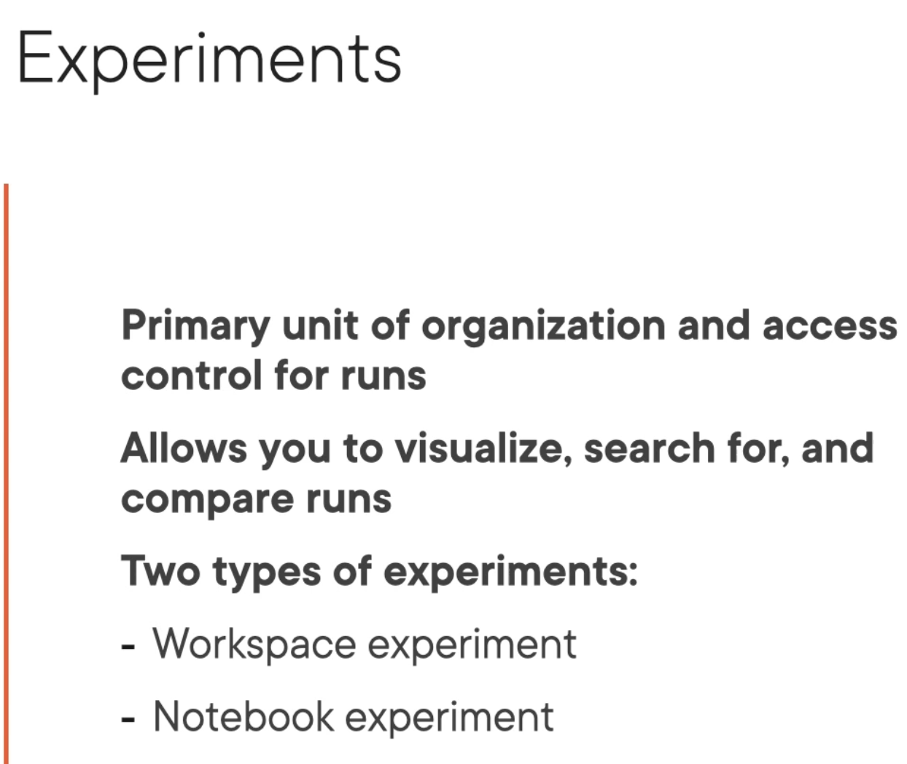

When you execute the model code within the run, but you haven’t created an experiment, MLflow will automatically create a notebook experiment for you. All of your model executions will then be logged to the experiment that is associated with your current notebook

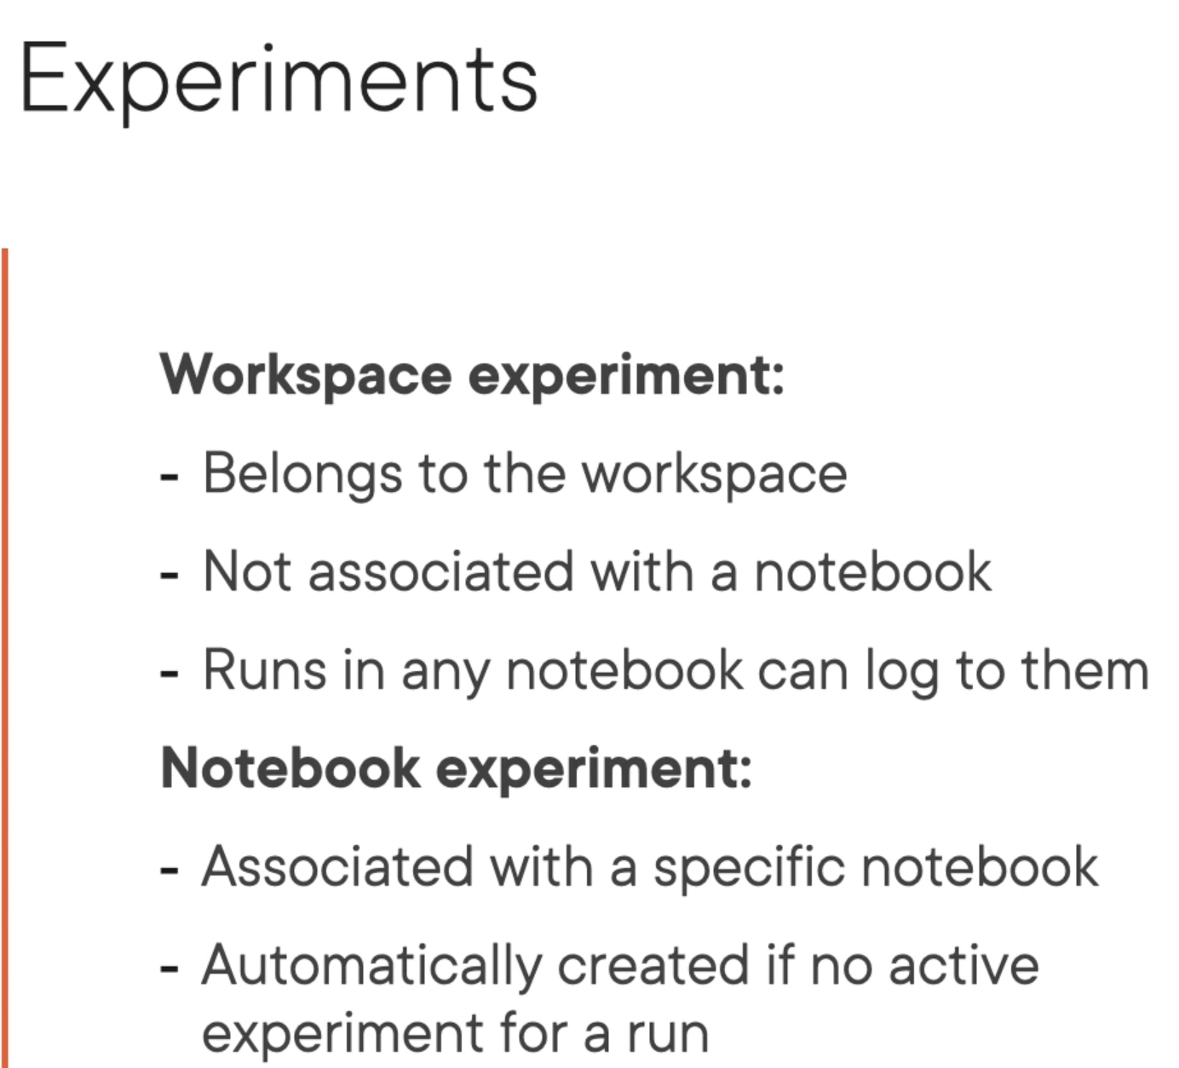

Model artifacts are files that associate with model execution, including the serialized model output with the trained model

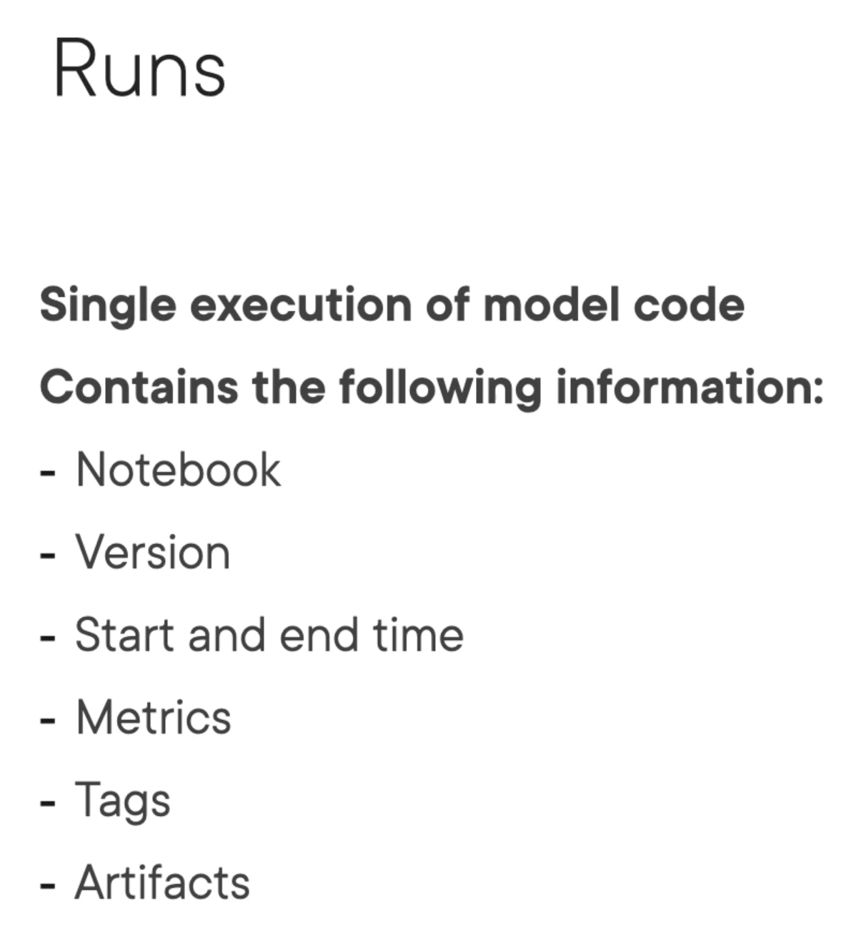

Real-time inference involves hosting your model behind a REST endpoint, which you can then invoke to make predictions

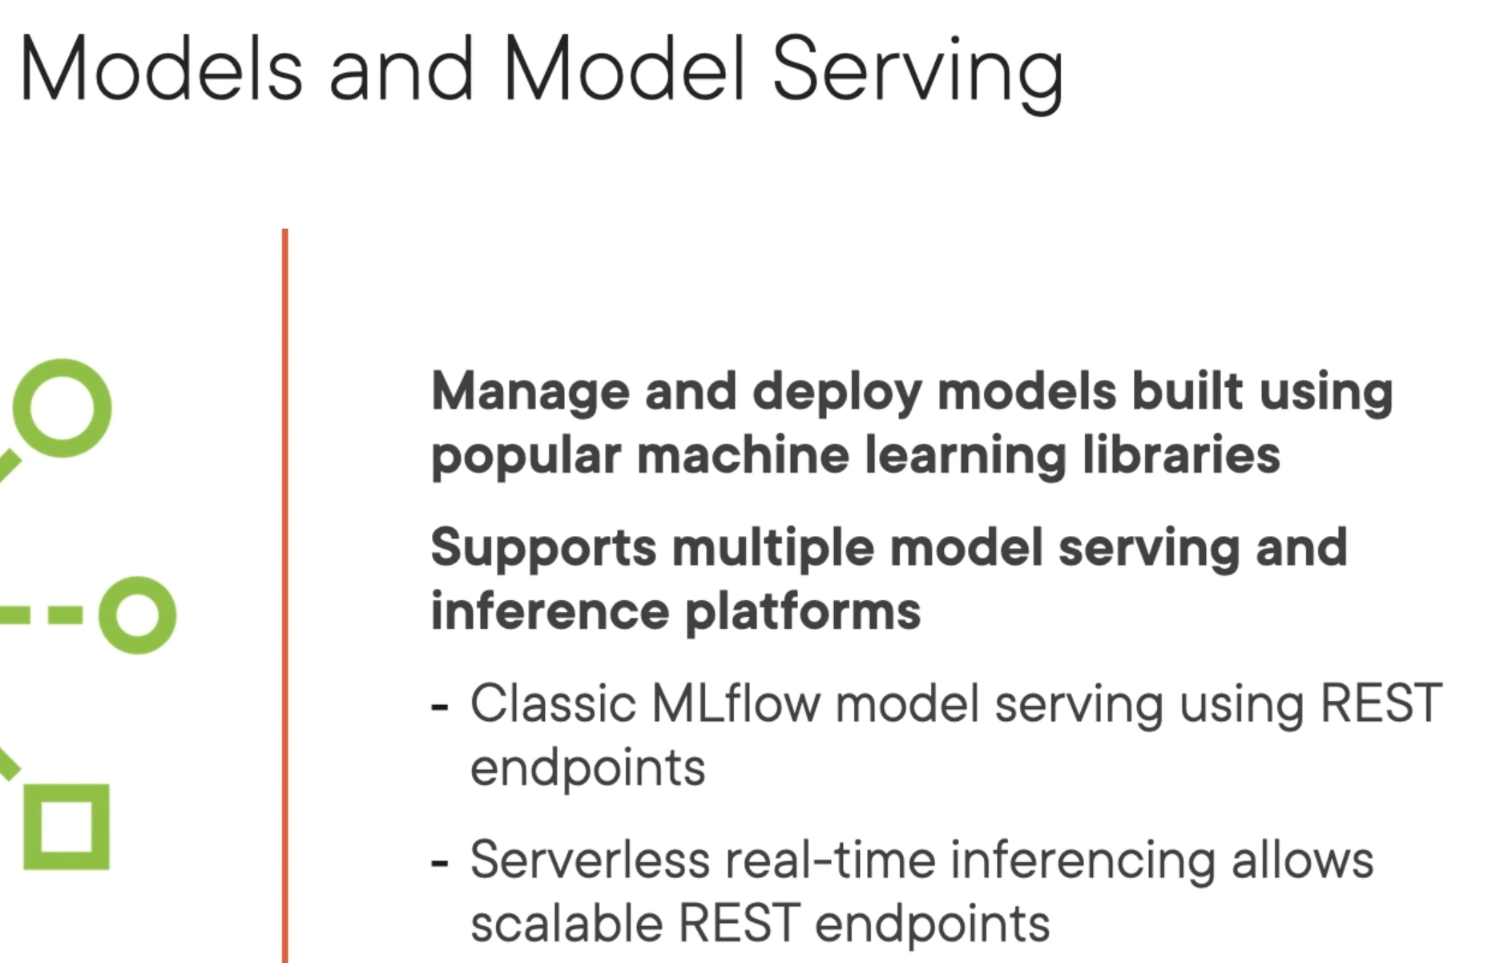

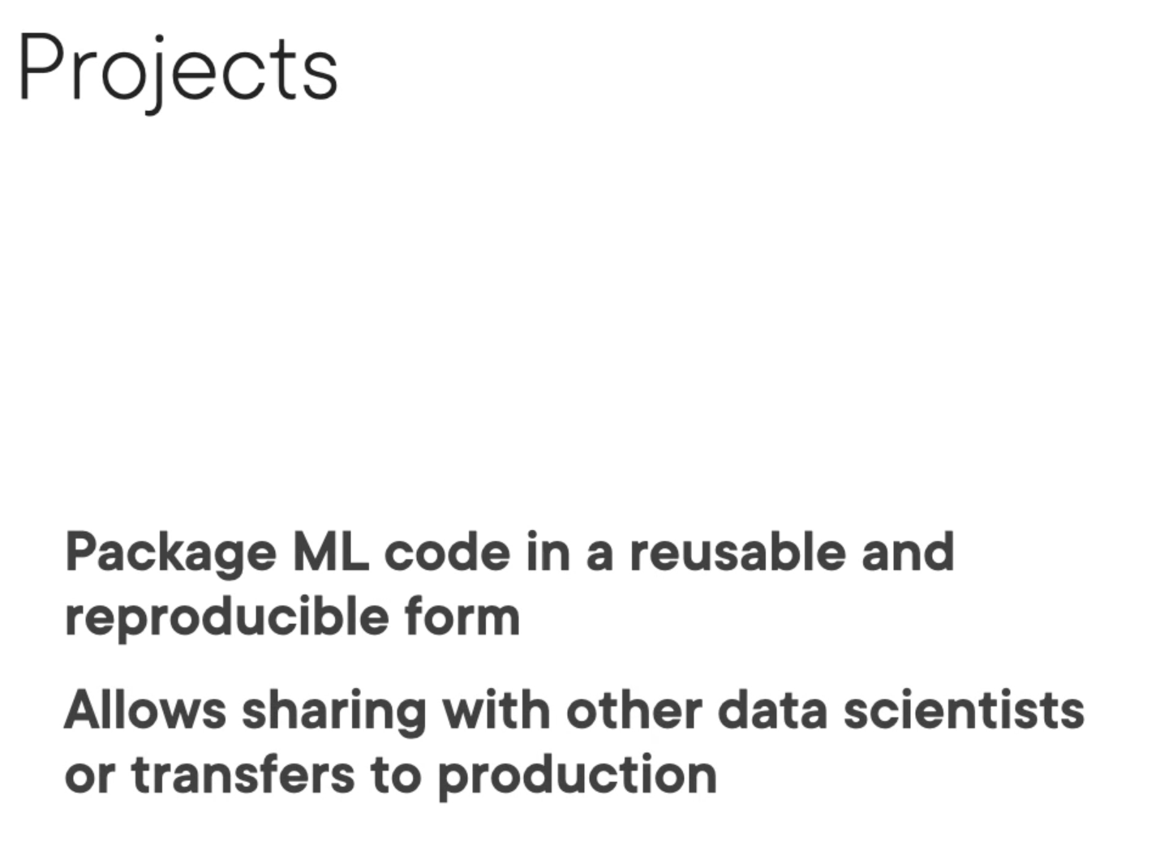

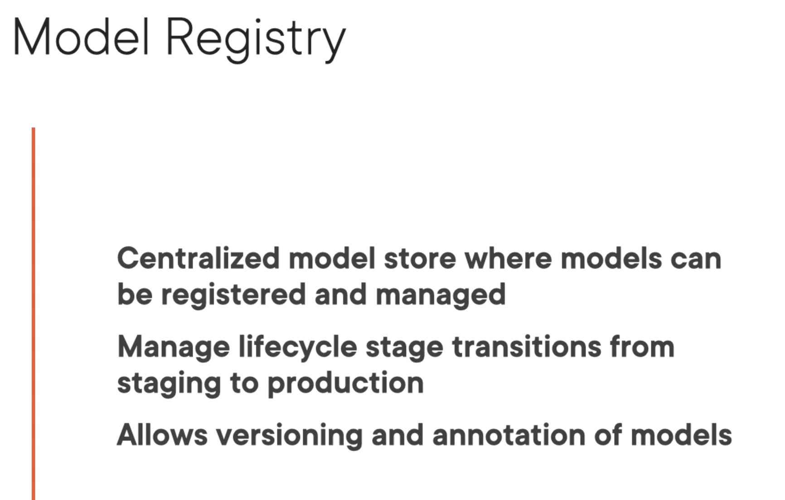

# Getting set up with the ML Environment on Databricks

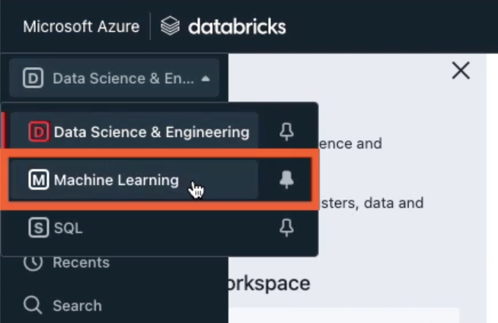

In order to be able to train our ML models, we need a cluster with the ML Runtime installed.

Head over to Compute, click on the “Create compute” option to set up a cluster.

I am going to set up a single node cluster, because that’s sufficient for the purpose of demo.

Under the “Databricks runtime version”, choose the ML runtime. Then, click “Create Cluster”

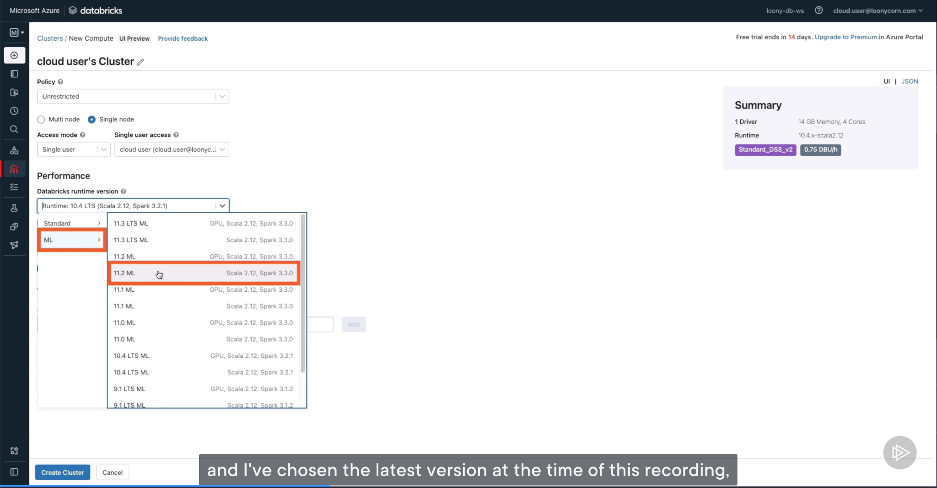

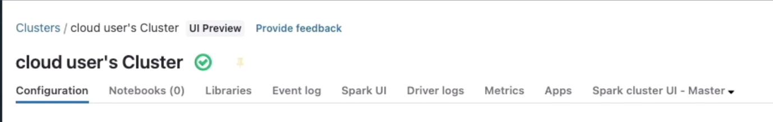

Once the cluster is running, we can move on to uploading the data that we use to DBFS

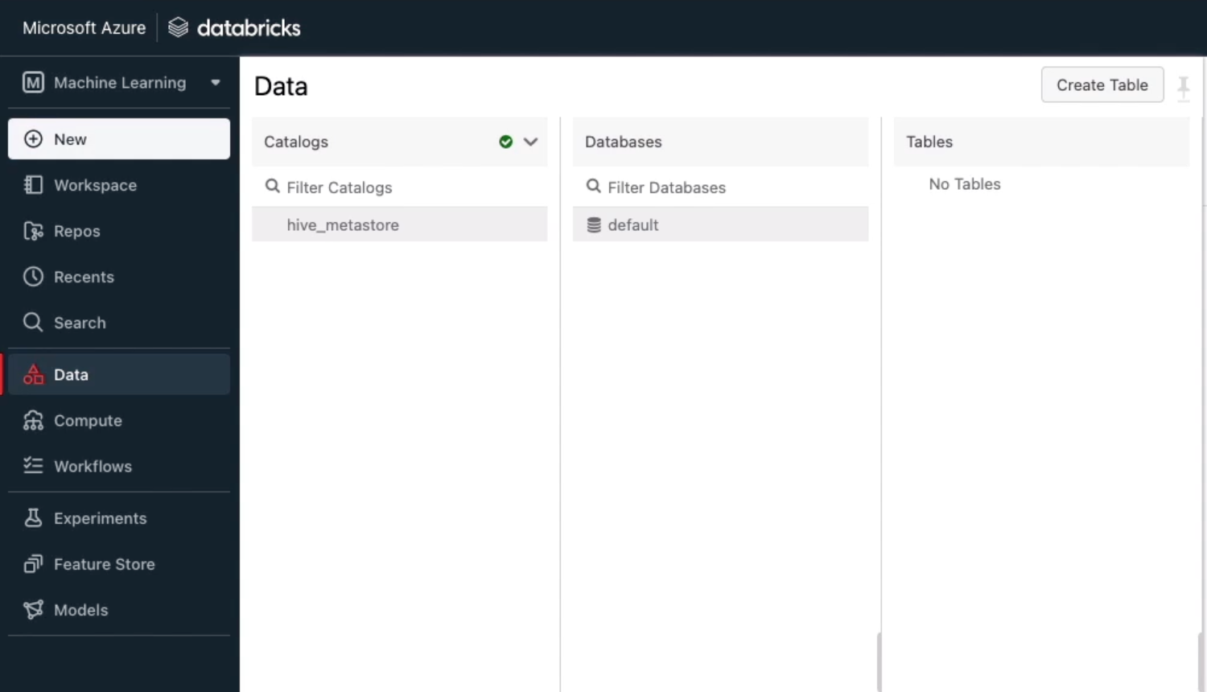

To see DBFS under Data, you need to head over to “Admin Console”

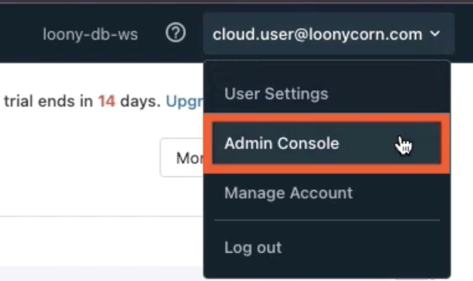

Go to “Workspace settings”

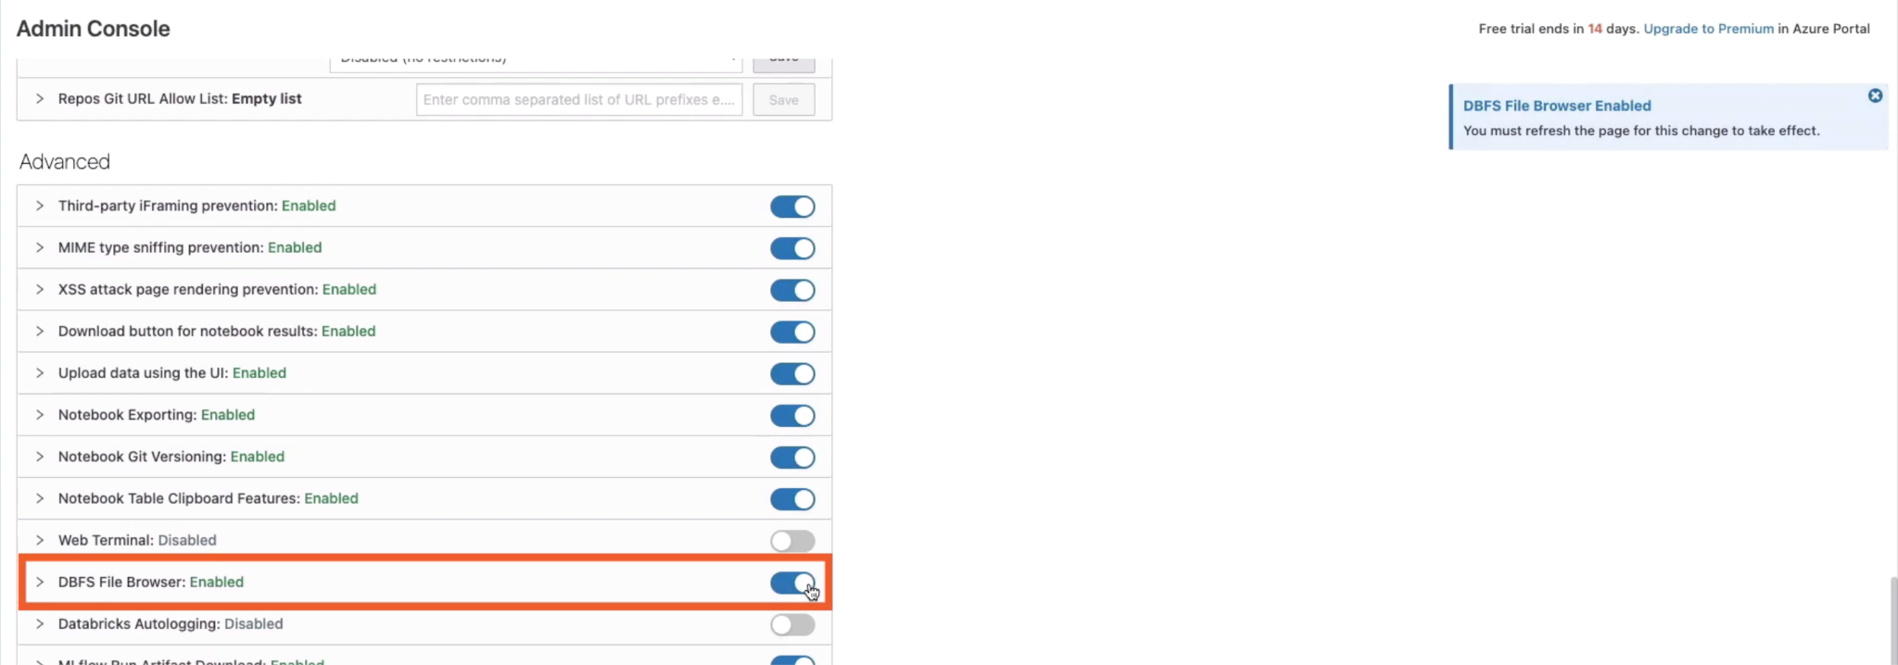

The Databricks File System browser gives us a file system to work with from our Databricks workspace

Now you will see DBFS under Data

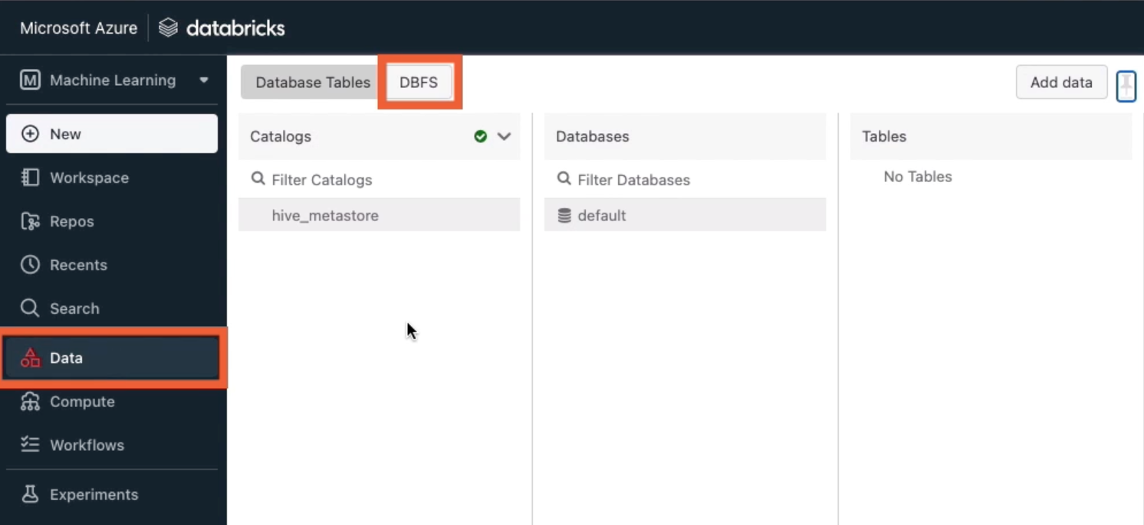

Go to DBFS->FileStore, right click FileStore, select Create folder “datasets”, this is where we’ll be storing all of the datasets that we use in the demos of this course.

Right click “datasets”, select “Upload here”,

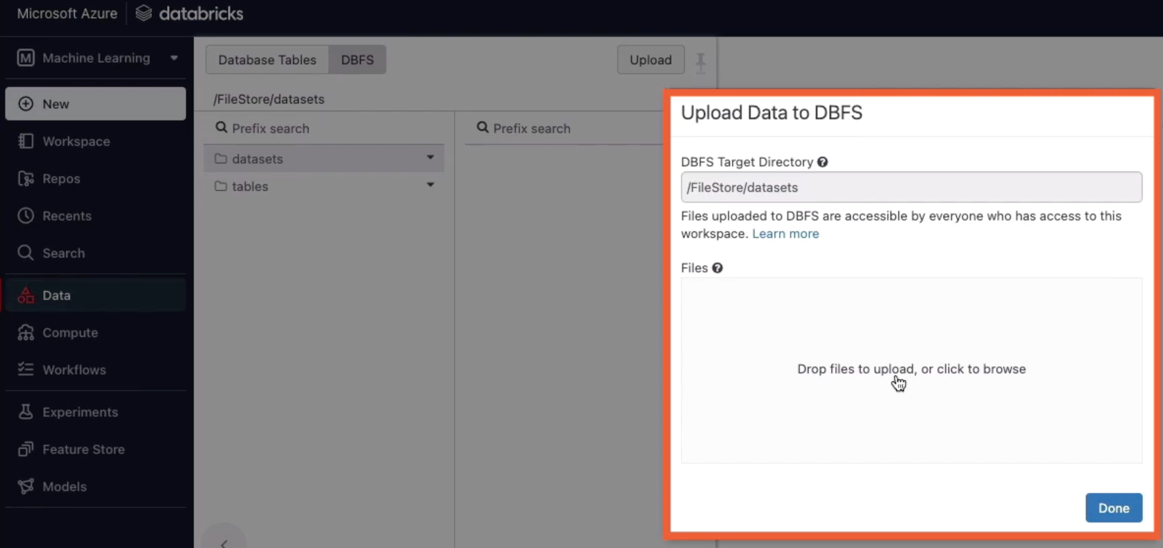

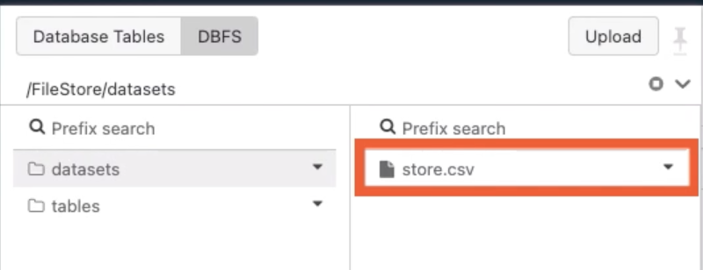

Head over to Workspace->Users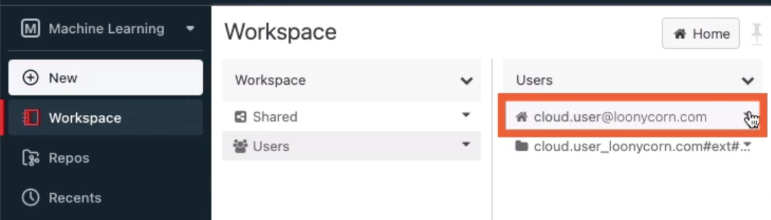

Import a notebook

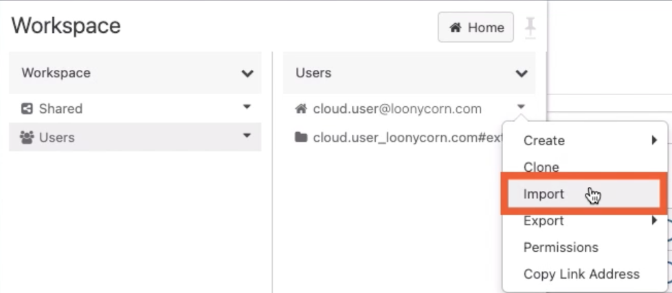

Make sure the notebook is connected to the cluster that we just set up

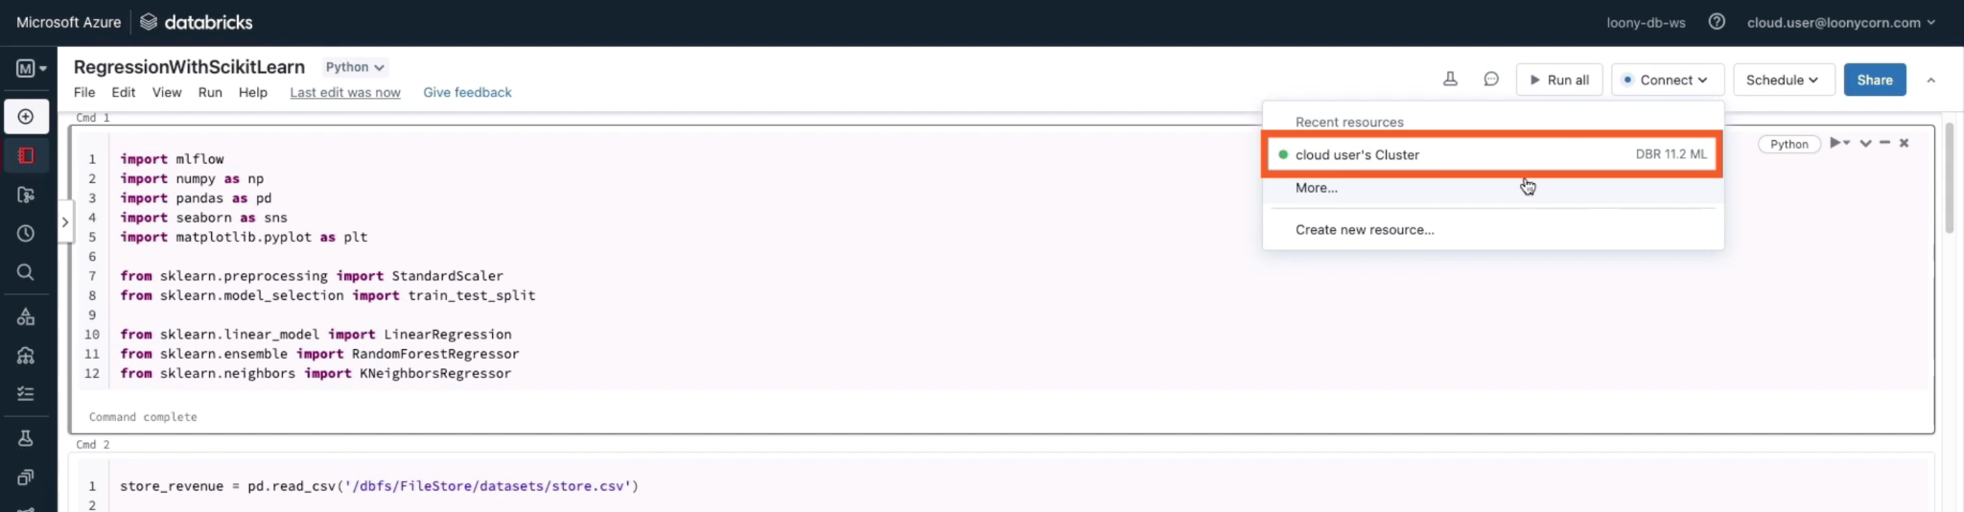

# Building and training a regression model in Databricks using scikit-learn and MLflow

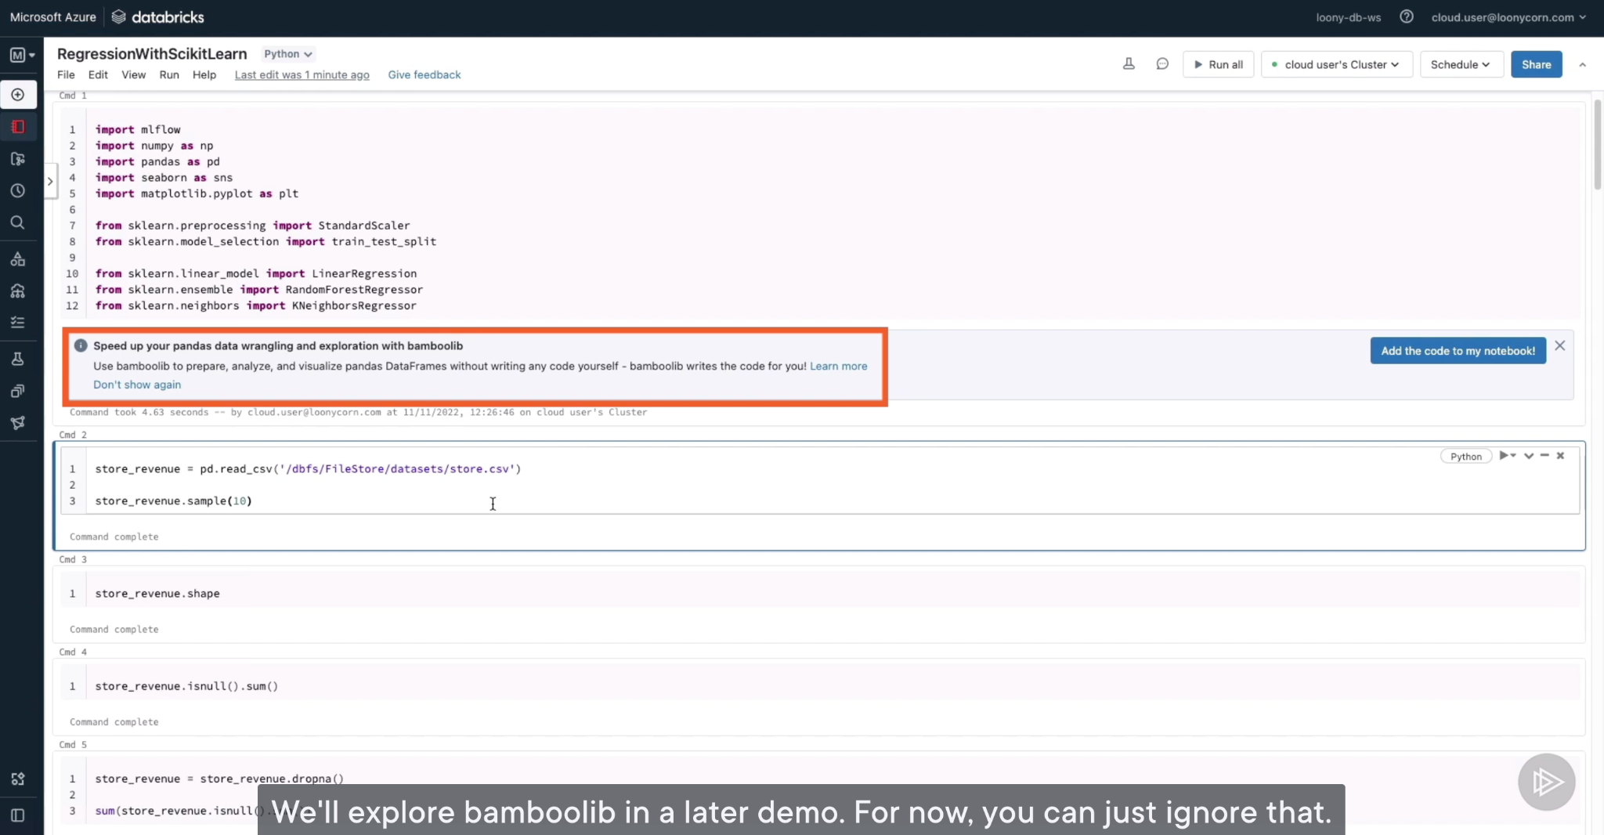

First, go to “Experiments”

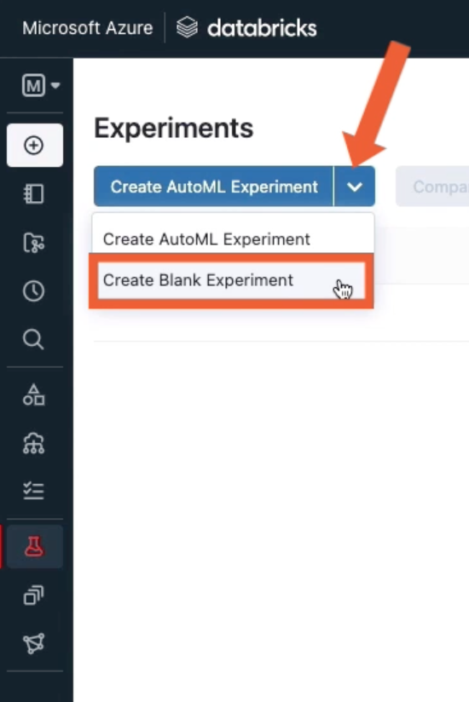

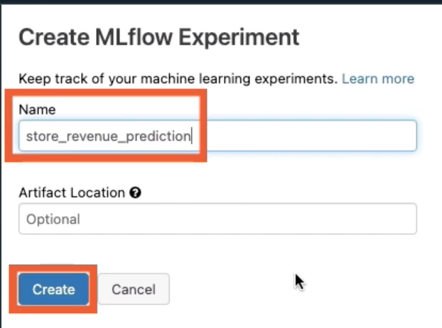

That’s where our experiment details will be logged

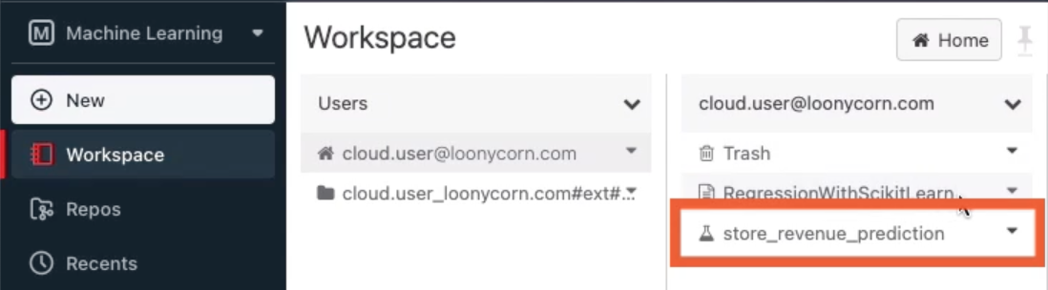

Go back to notebook, we need to add some codes:

I need to call mlflow.set_experiment if there is a particular experiment under which this run should be recorded.

If you don’t explicitly specify set_experiment, a new experiment for this notebook will automatically be created, and all runs within this notebook will be recorded under that notebook experiment.

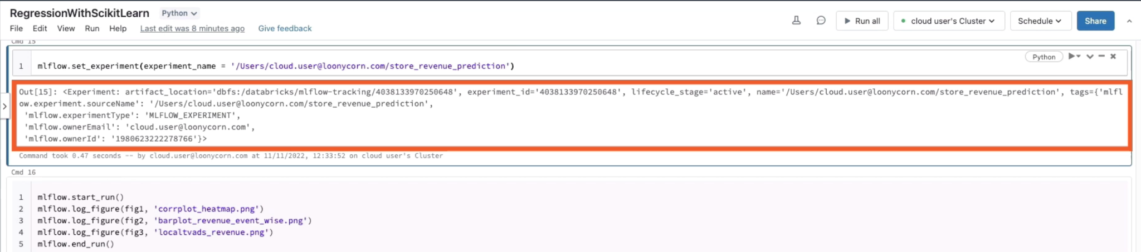

If you want to view all experiments that you have, you can view then right here within your notebook:

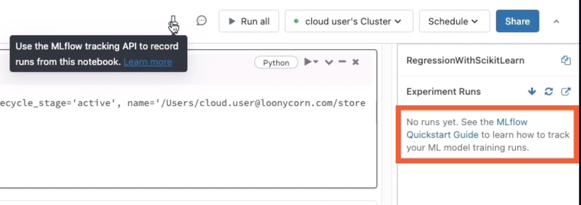

I will create first run to track some stuff. A run corresponds to a single execution of model code. In this first run, I will log 3 figures

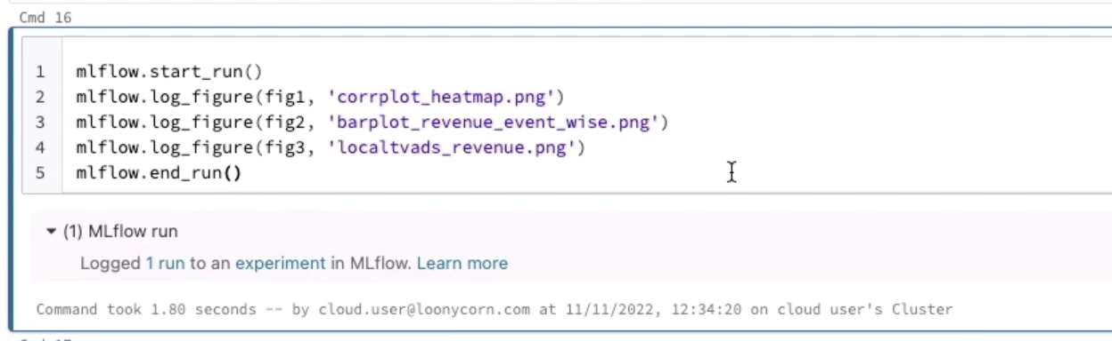

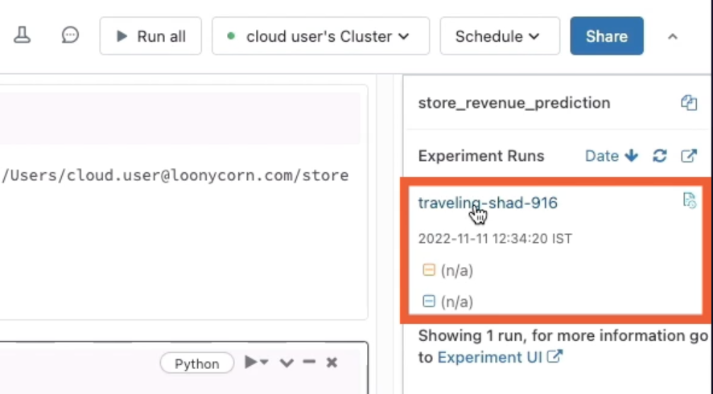

We have 3 artifacts/figures

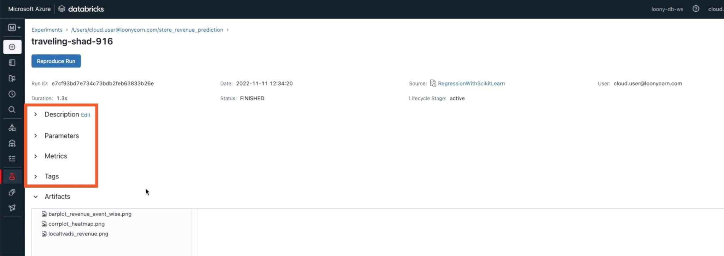

We use MLflow to track model metrics using automatic logging, which allows us to log metrics, parameters, and models without the need for explicit log statements

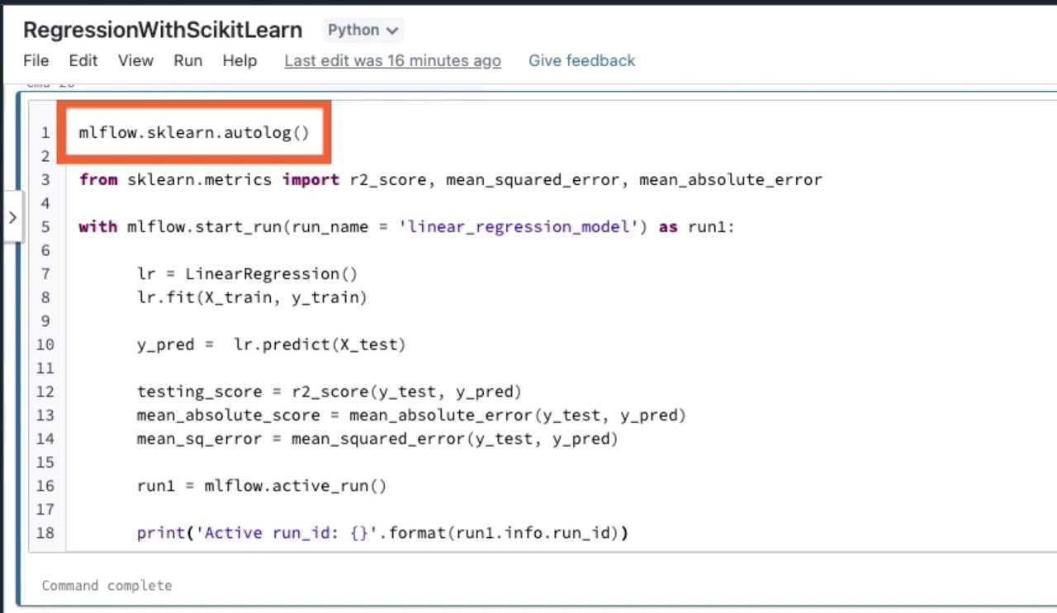

It’s a best practice to use the with block in order to start an MLflow run, because that run will automatically be ended once you executed your statements within your with block.

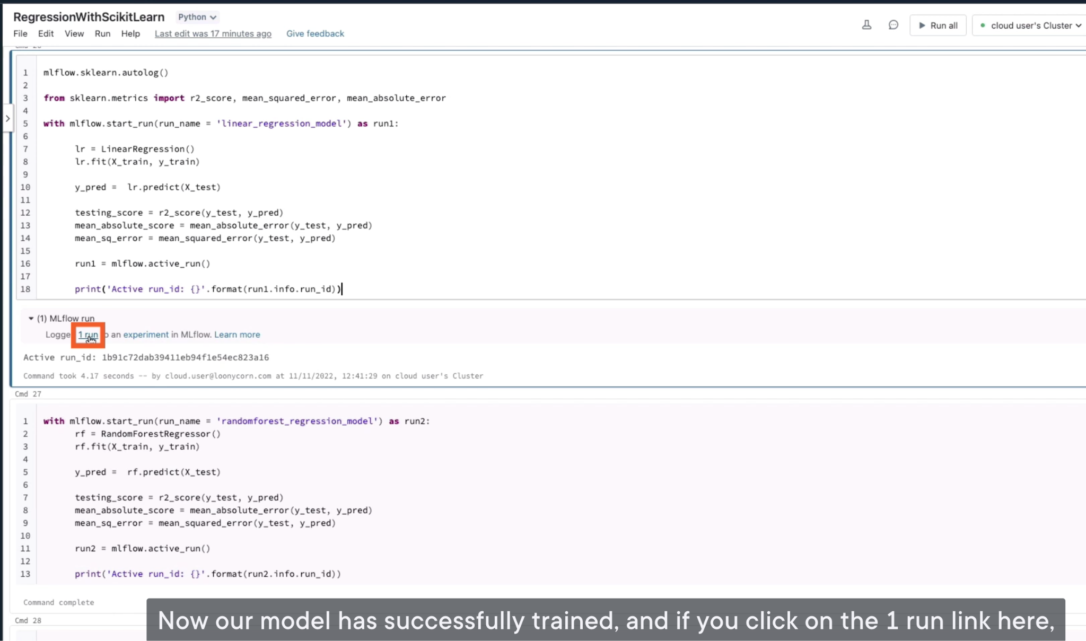

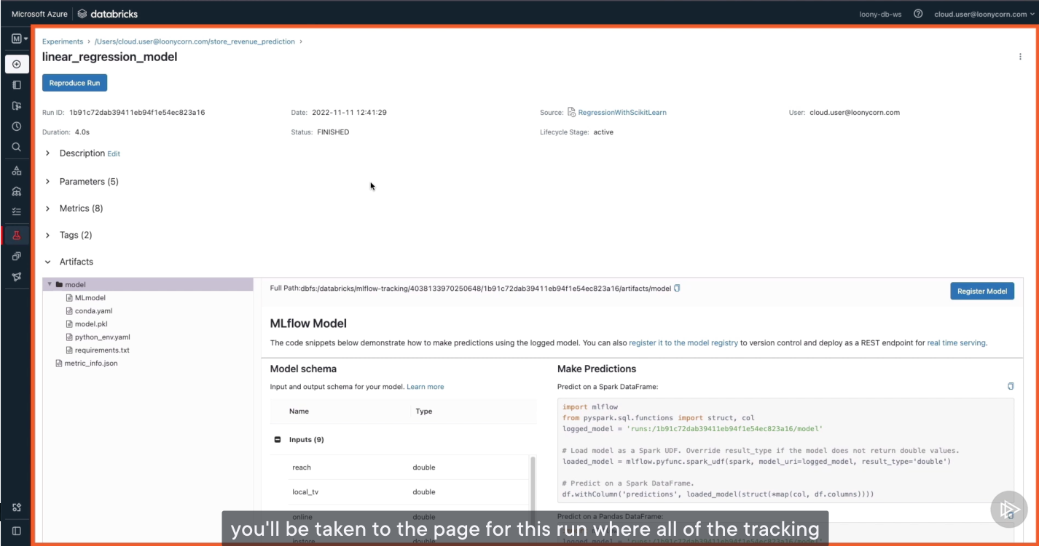

Autologging tracks a number of model parameters for the different ML models that you use by default

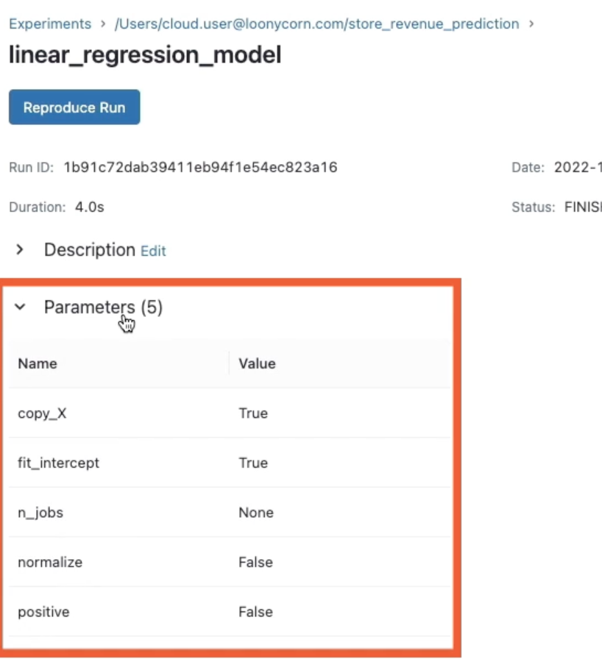

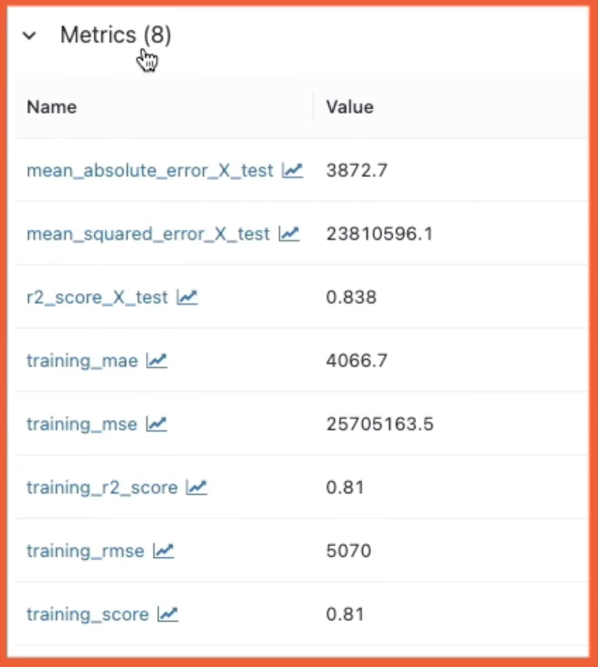

Tags are annotations that you can apply to your runs to track their attributes, or to identify your runs in some way. This help us identify which model was trained in this run.

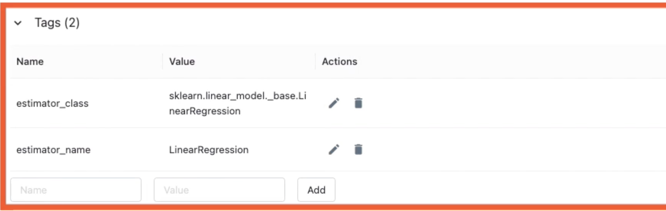

Artifacts are output files associated with the model that you’ve created, and these output files can be in any format.

Artifacts always contain a model directory, which contains arbitrary files under it, along with an MLmodel file at the root of that directory.

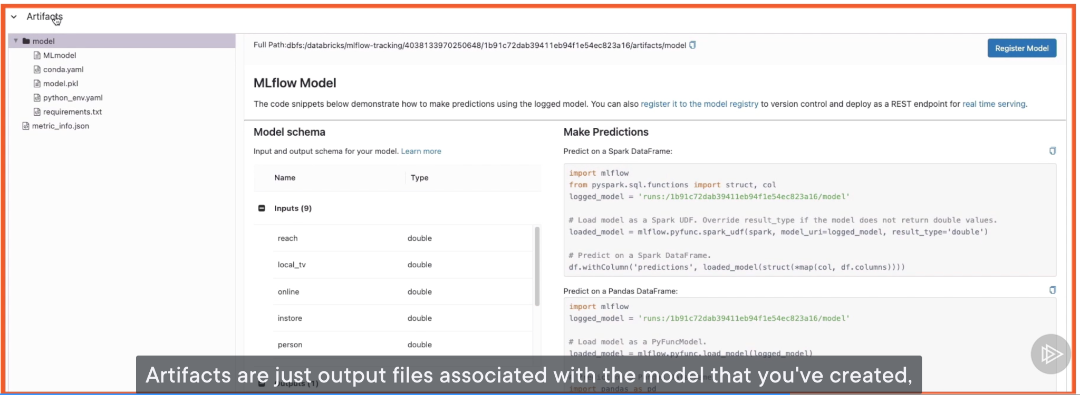

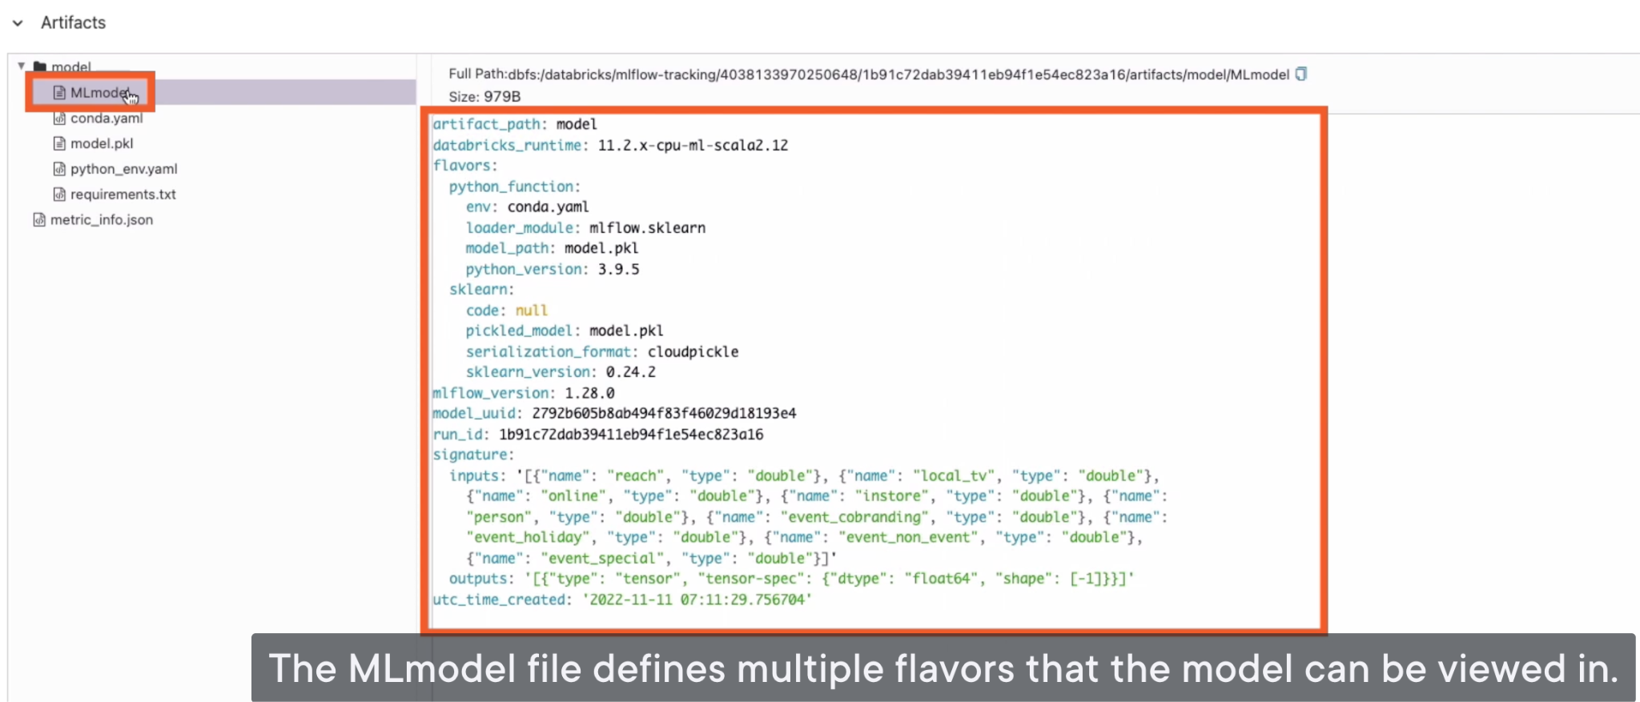

The model.pkl file is a serialized pickle file containing our model parameters. This was output by the scikit-learn library and is used for model predictions

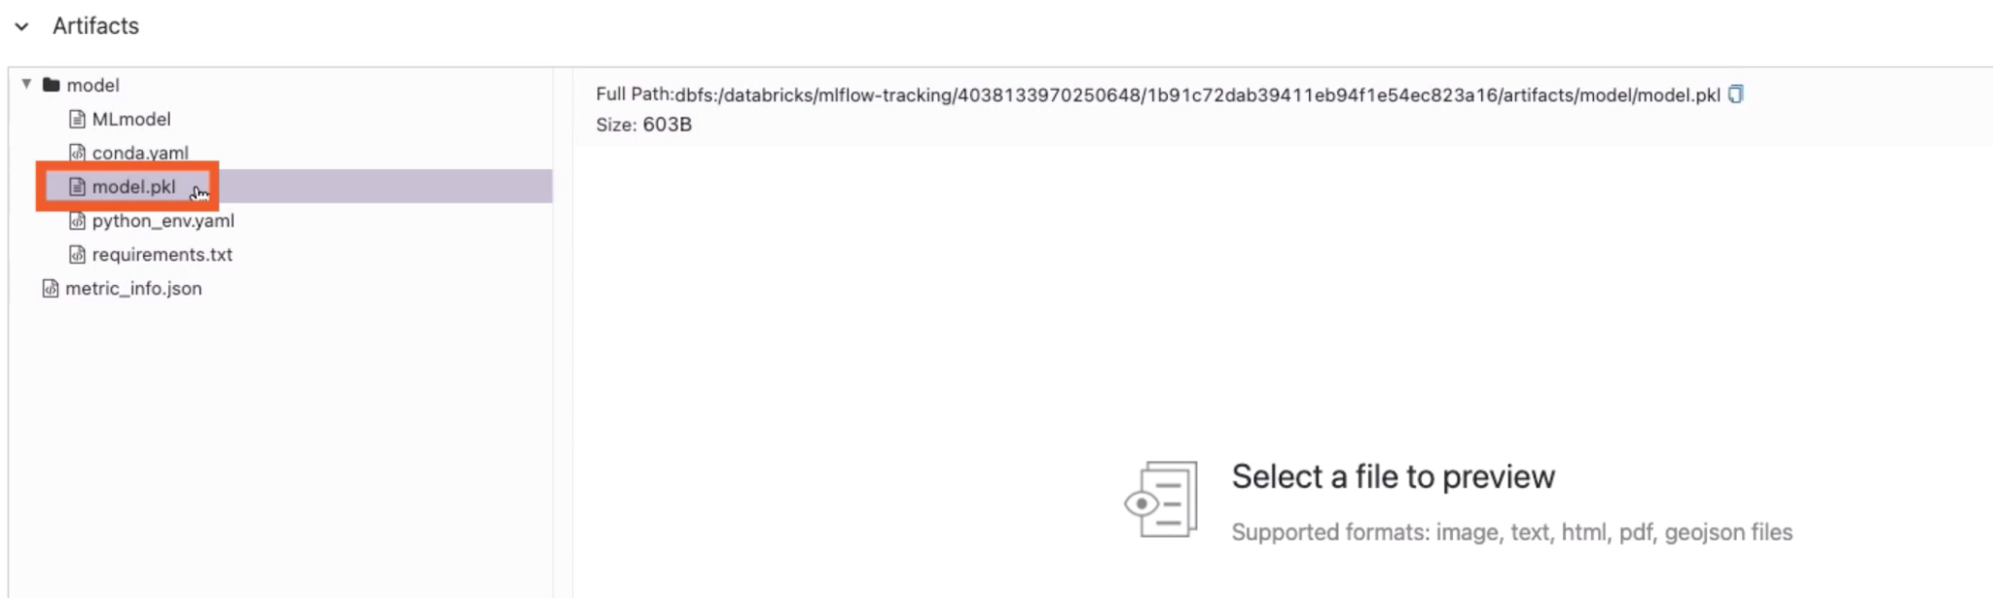

Let’s log another run to our notebook, and this time I want to train a regression model using a different algorithm.

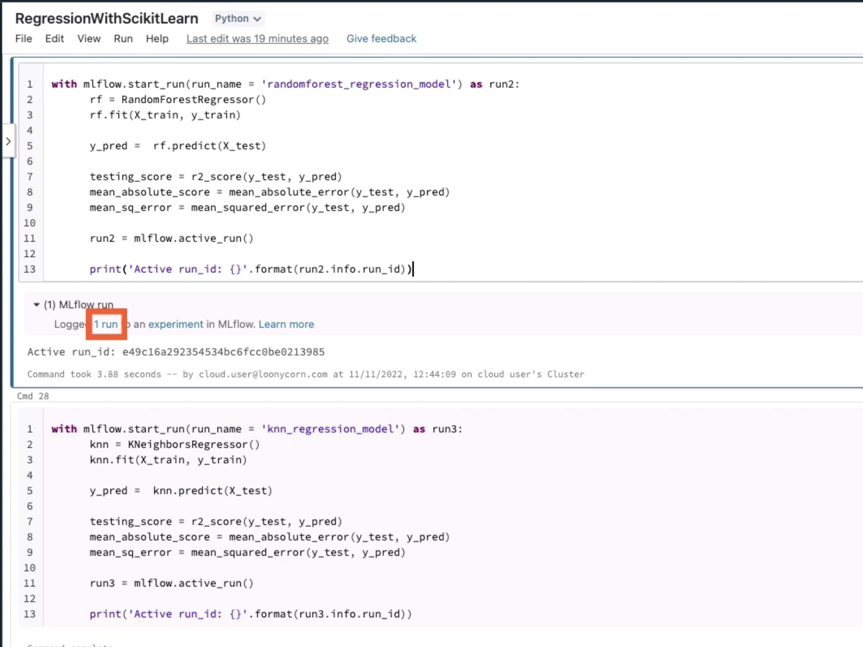

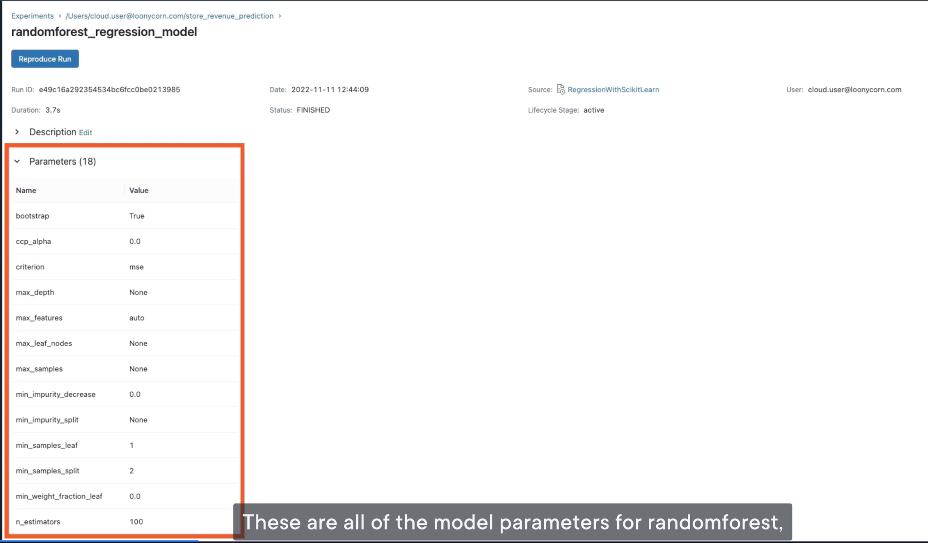

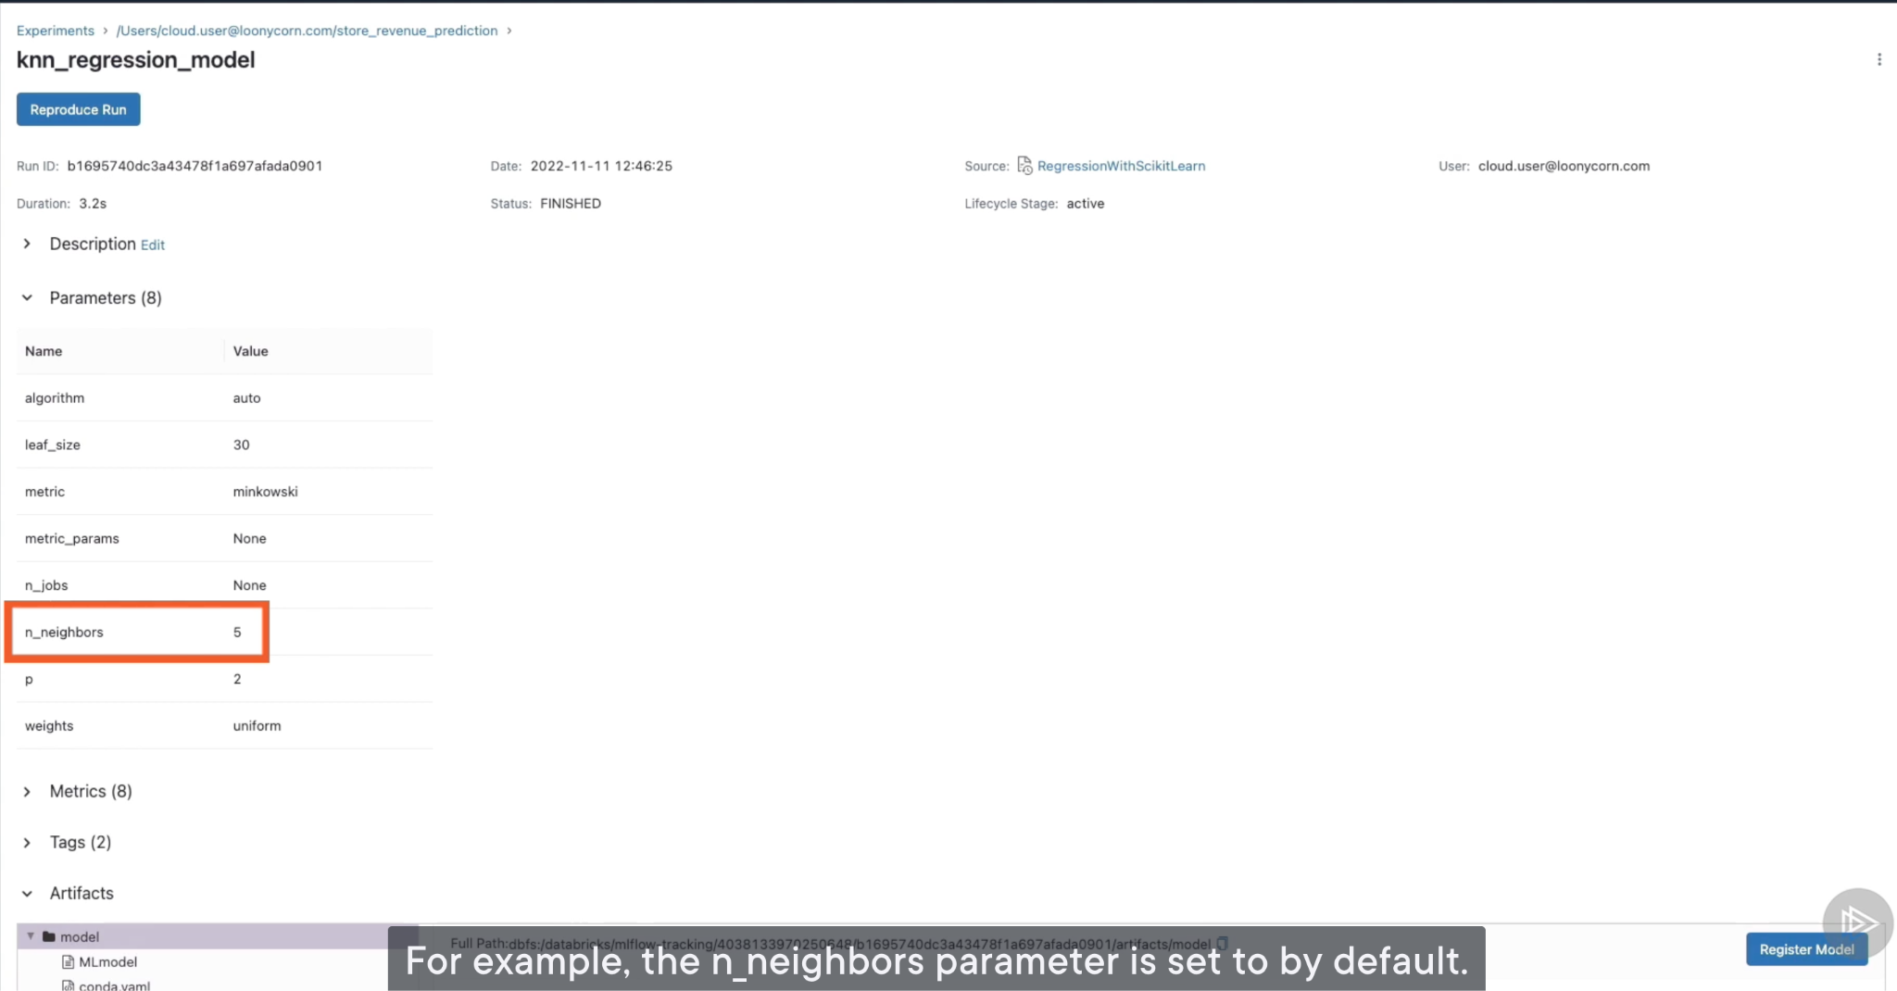

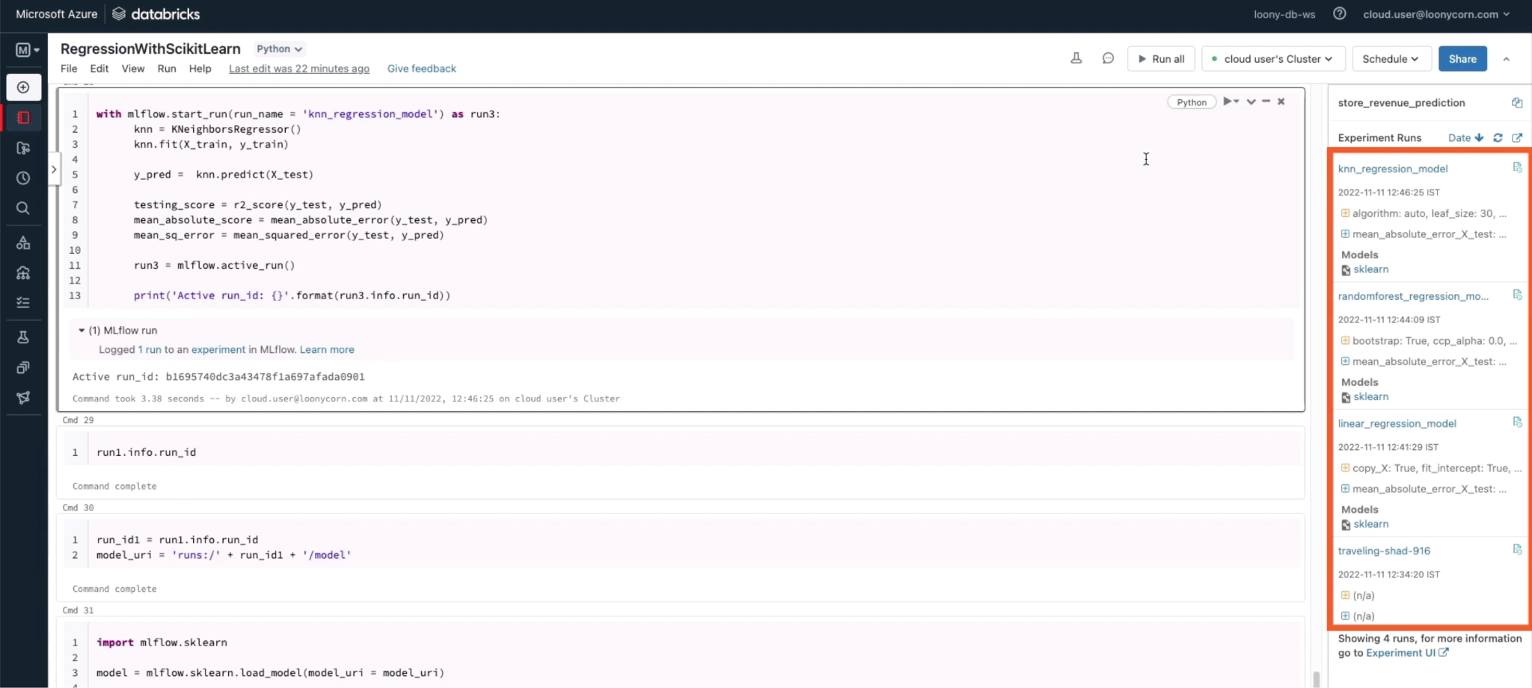

You can sort runs on metrics:

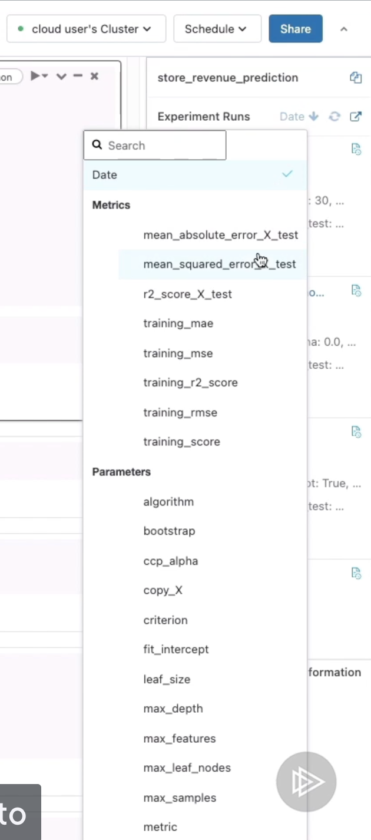

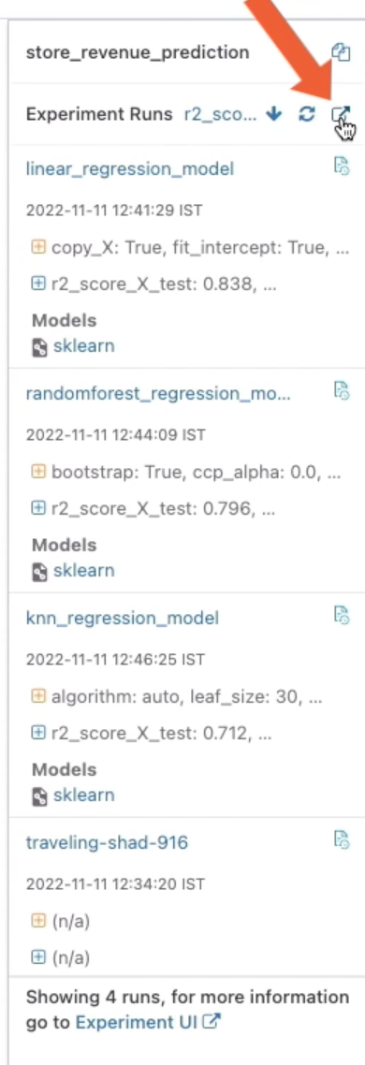

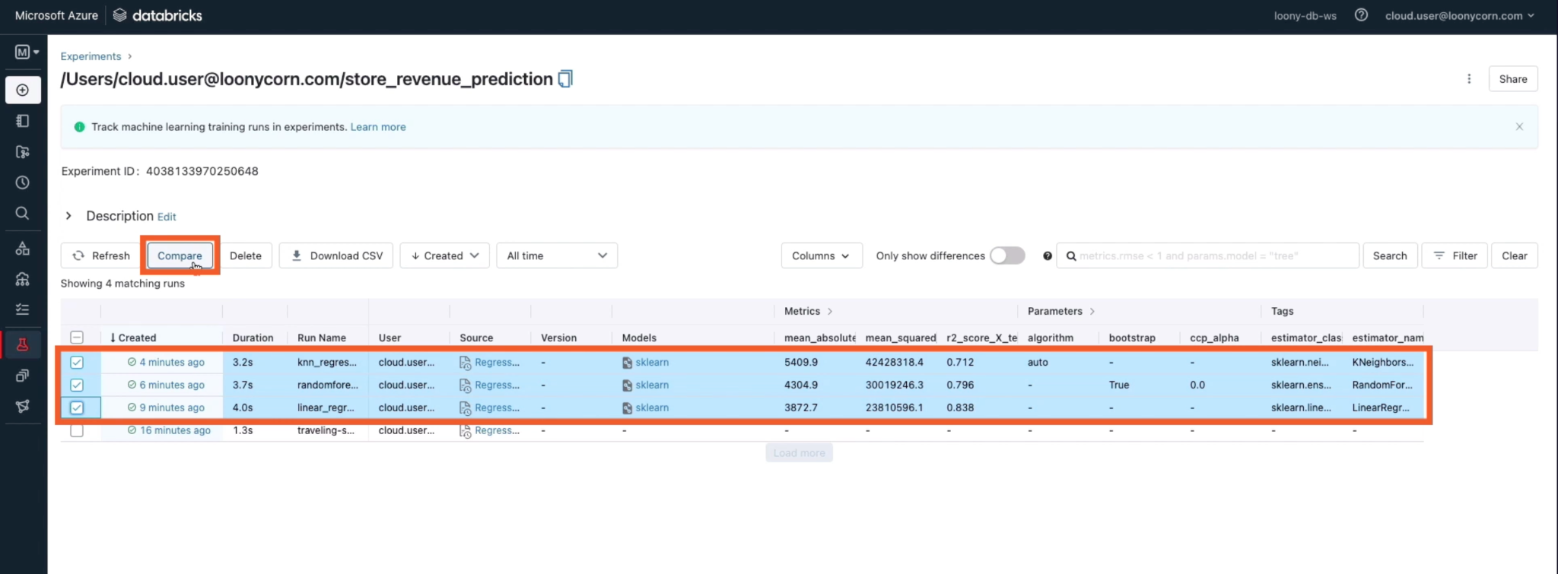

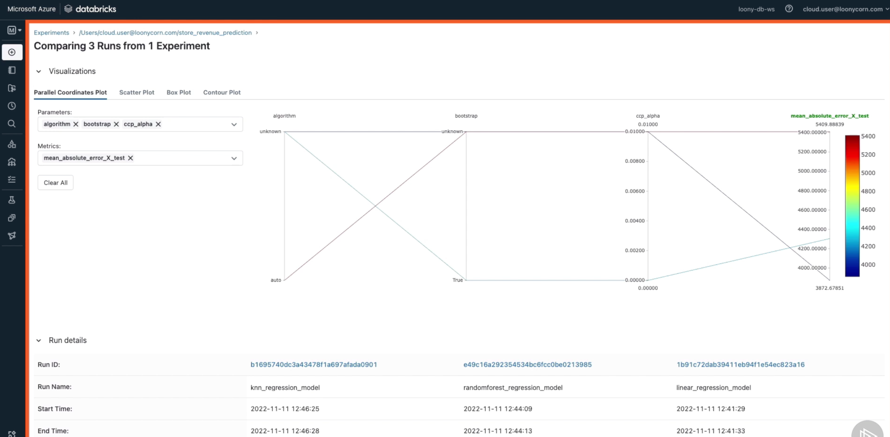

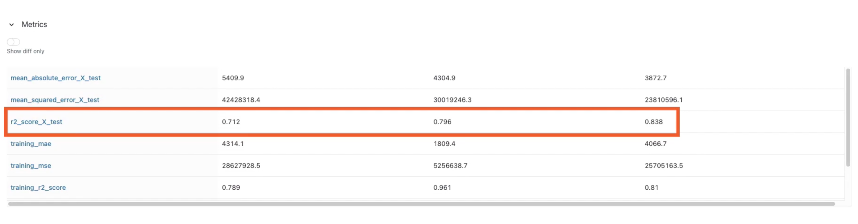

Let’s say how we can serve predictions from the model that we’ve chosen (linear regression model, run1)

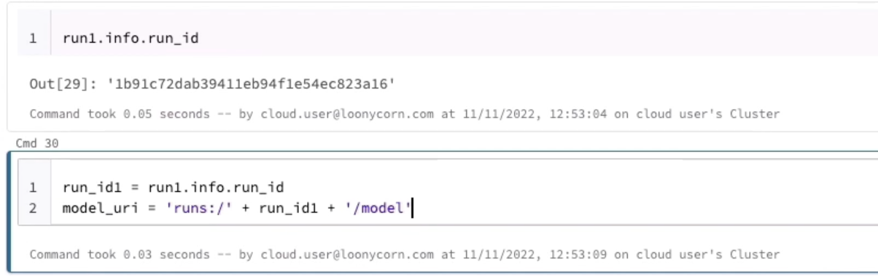

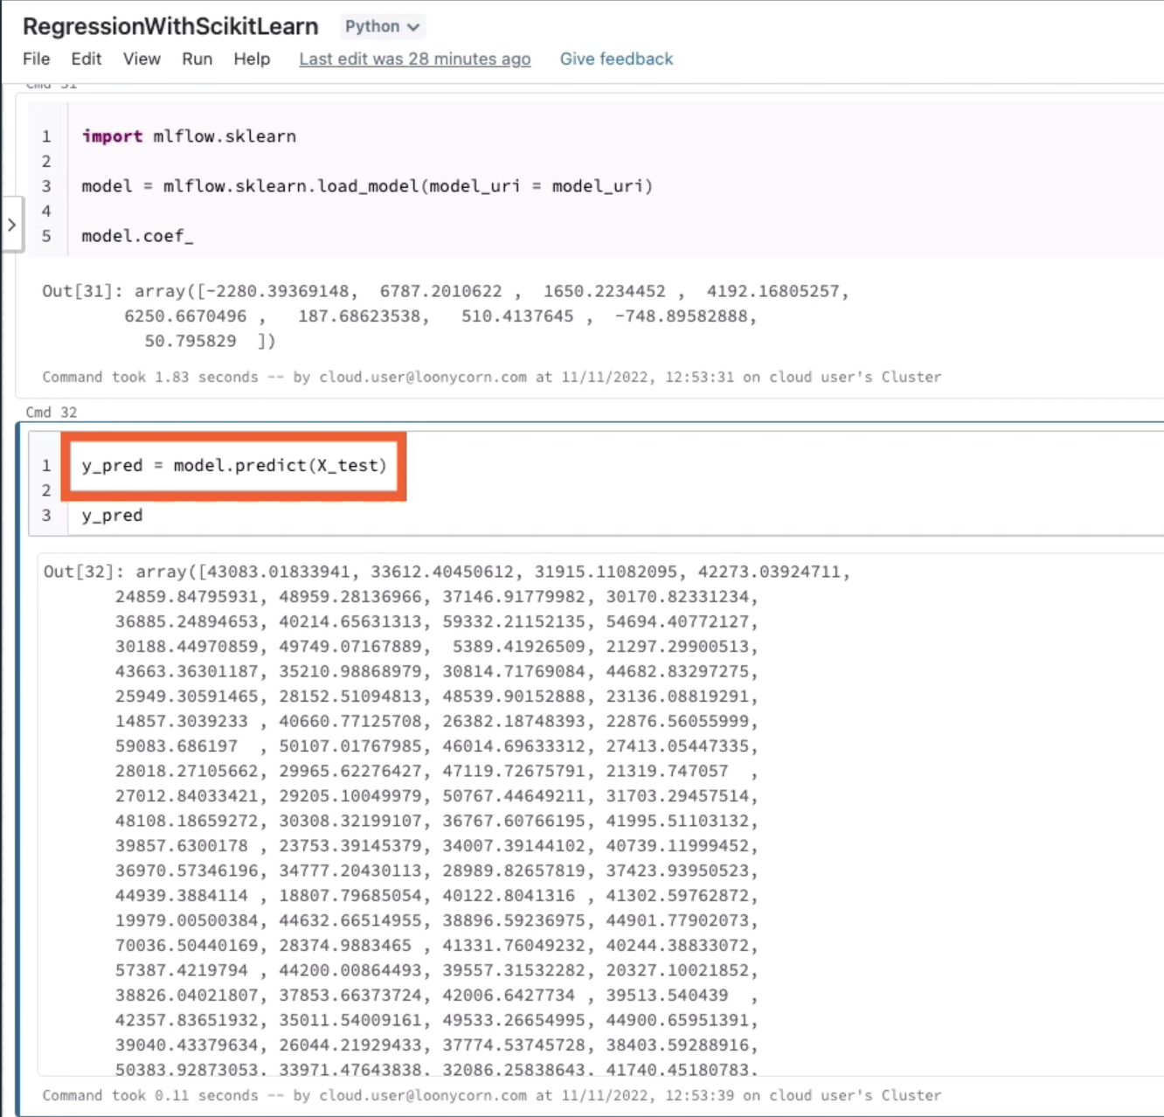

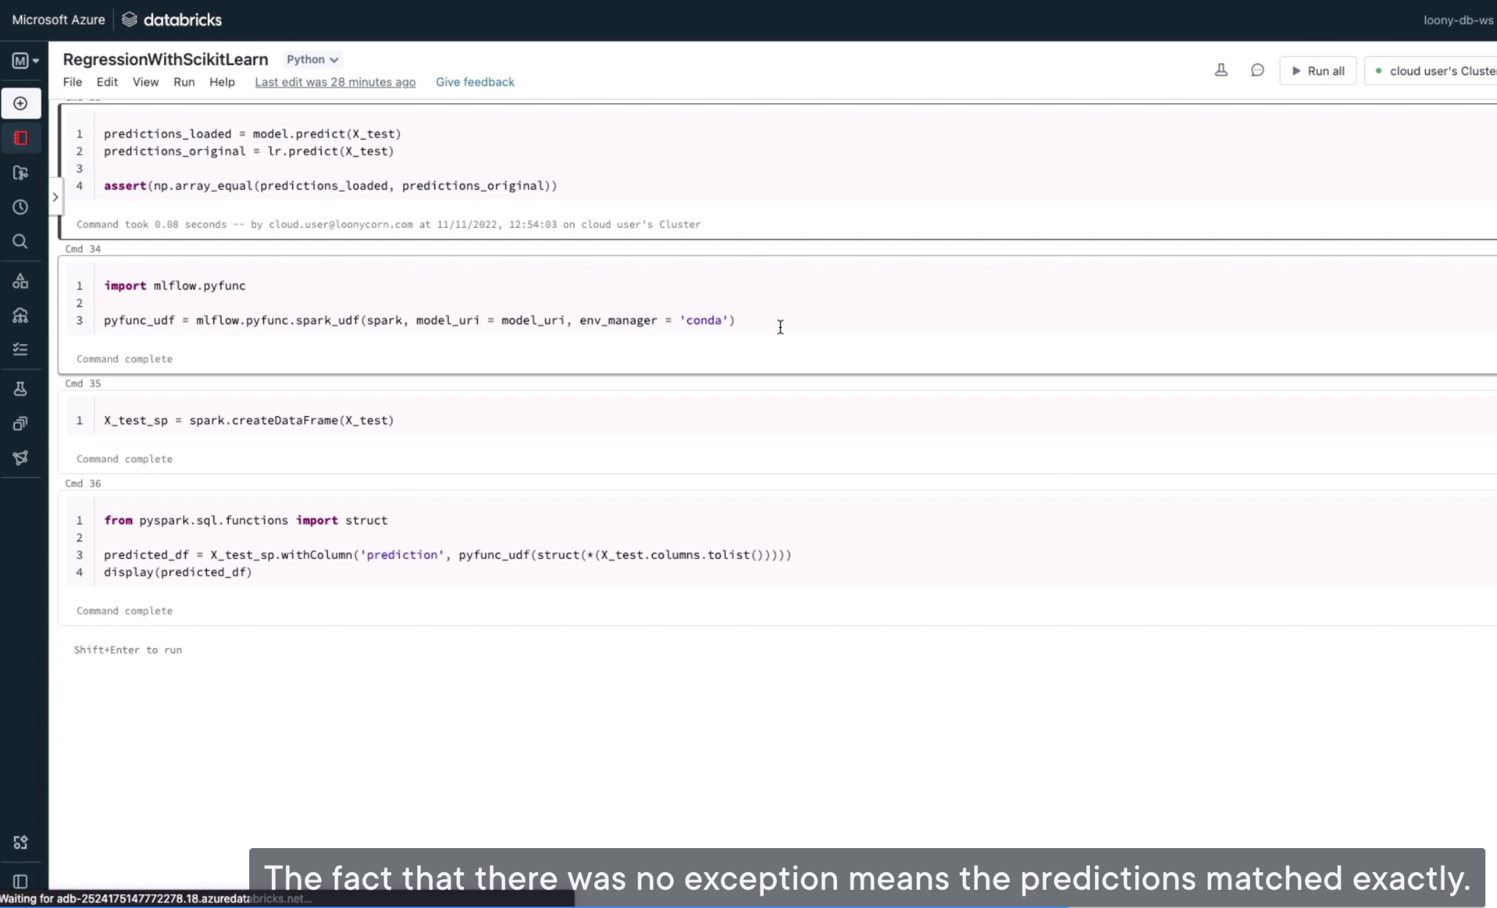

You can also load the model as a Spark UDF, so that you can make predictions using a spark dataframe.

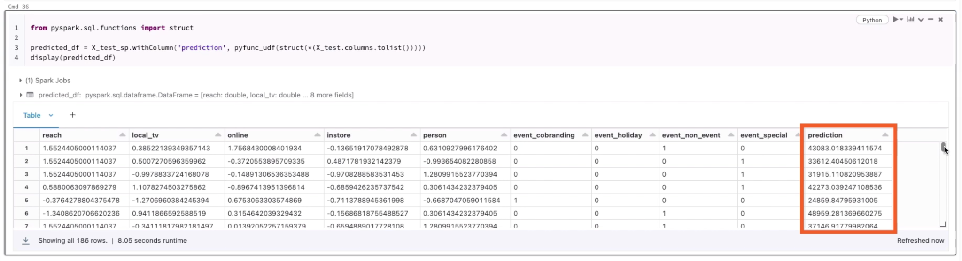

# Using Bamboolib for Data Exploration and Transformation

Bamboolib is a user interface component that allows no-code data analysis and transformations from within a Databricks notebook.

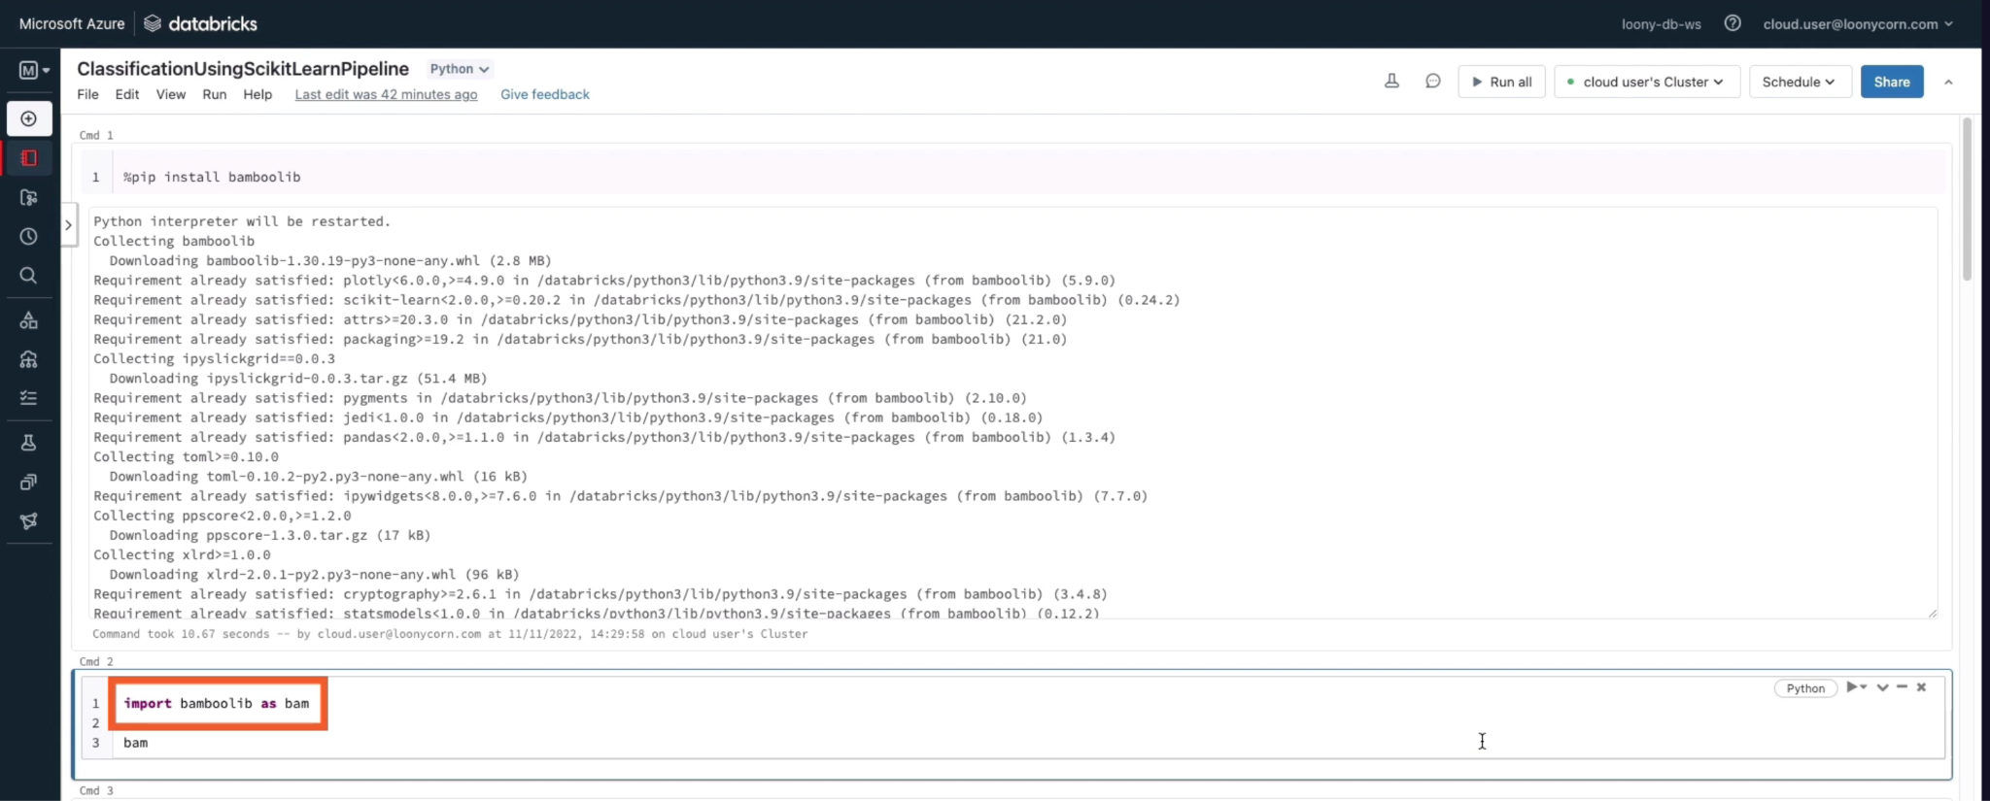

This will bring up a user interface widget that you can use to analyze and process your data

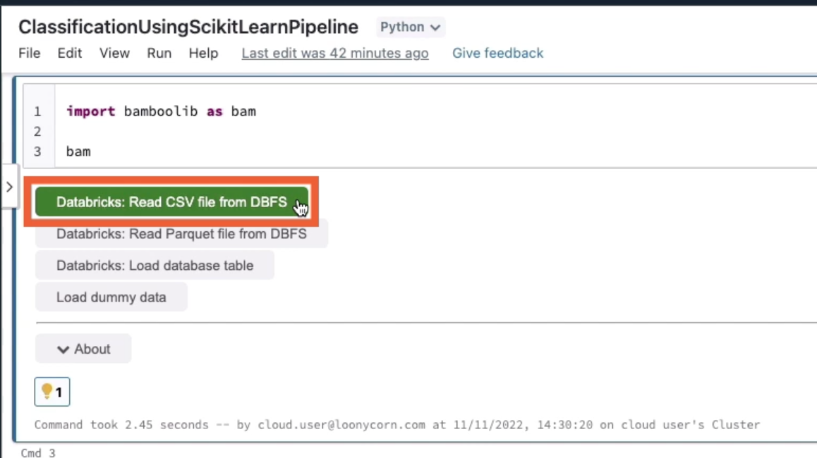

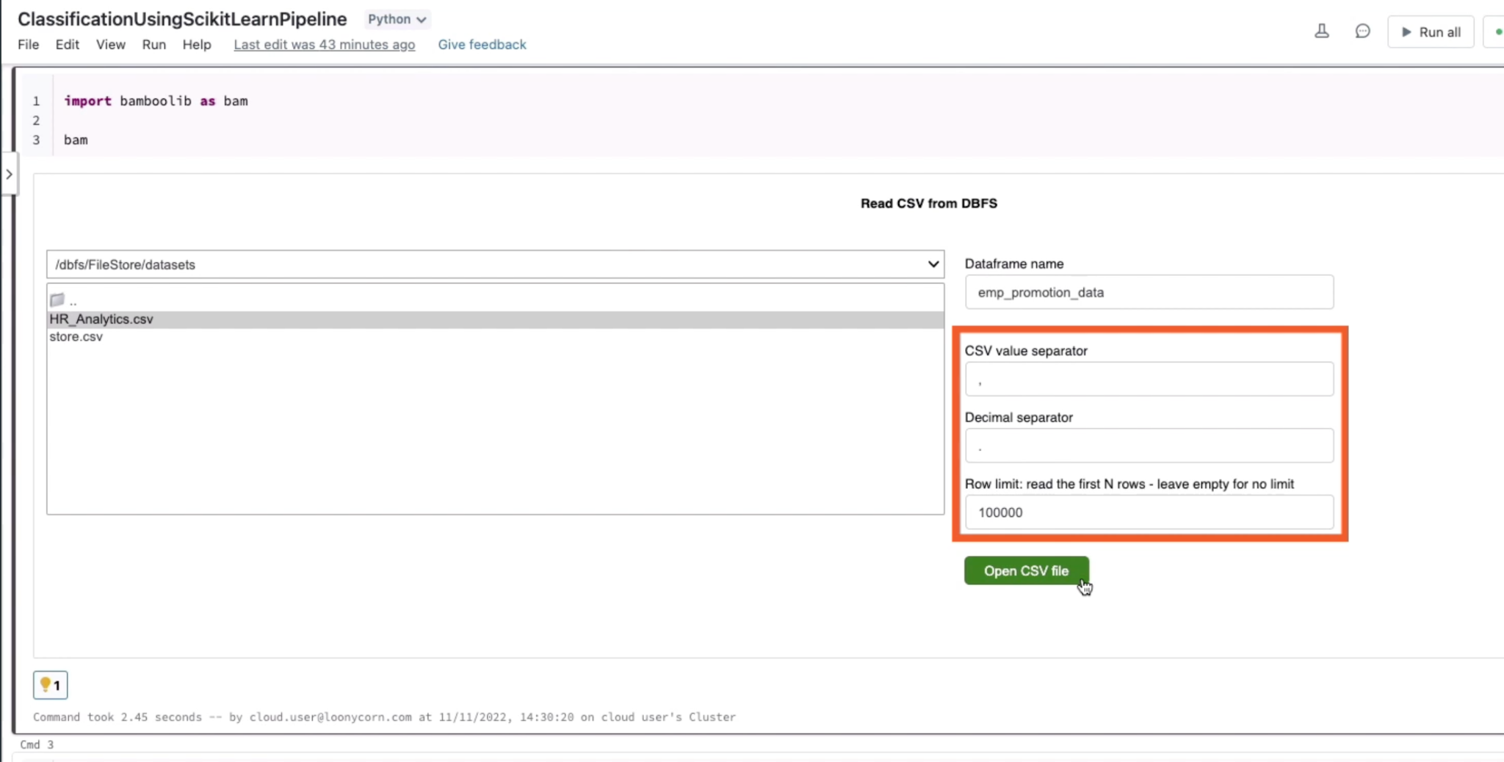

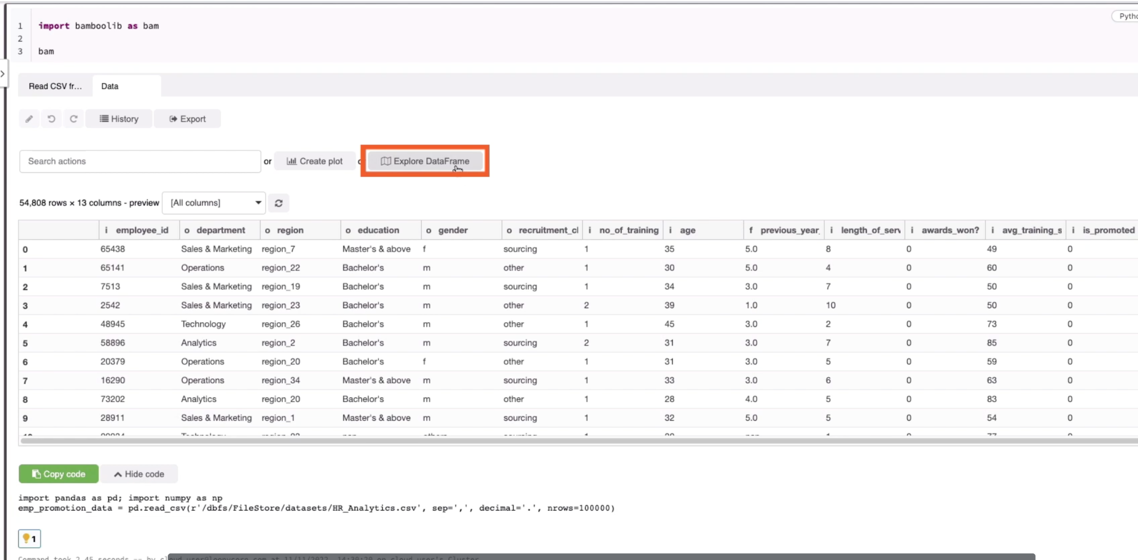

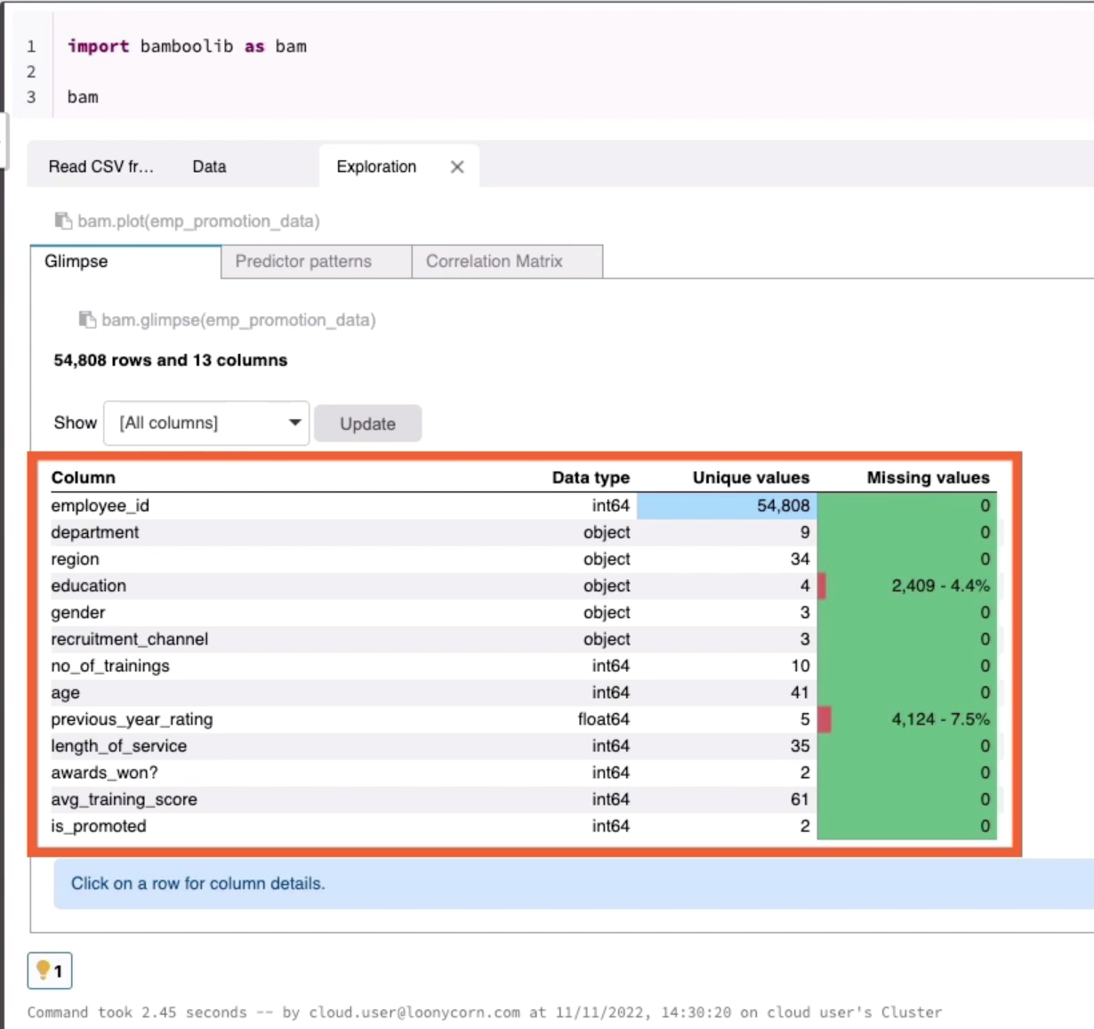

Here are the details for the department column

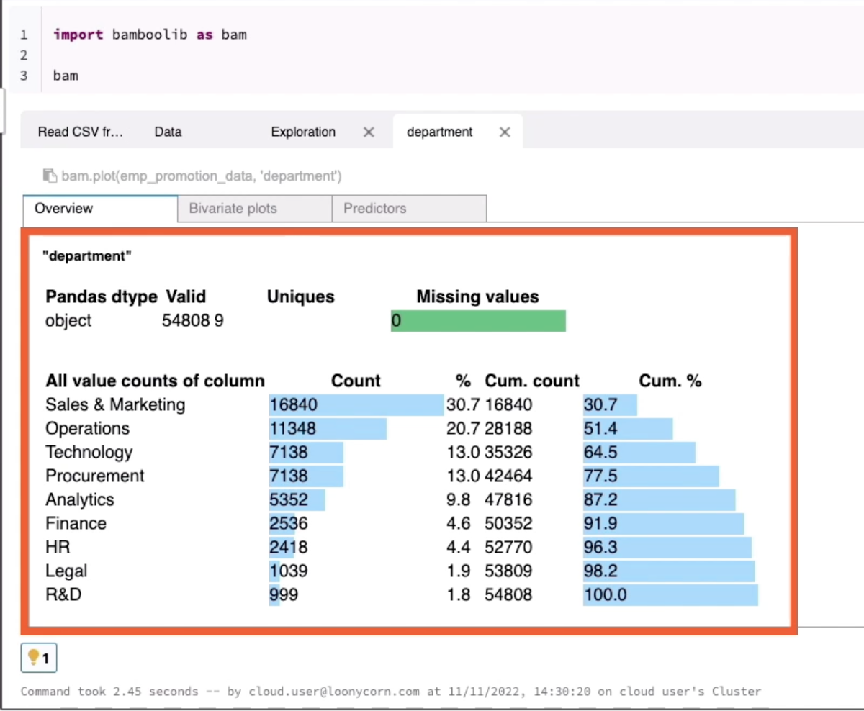

You can also get predictive power score. Y axis represents targets, X axis are features

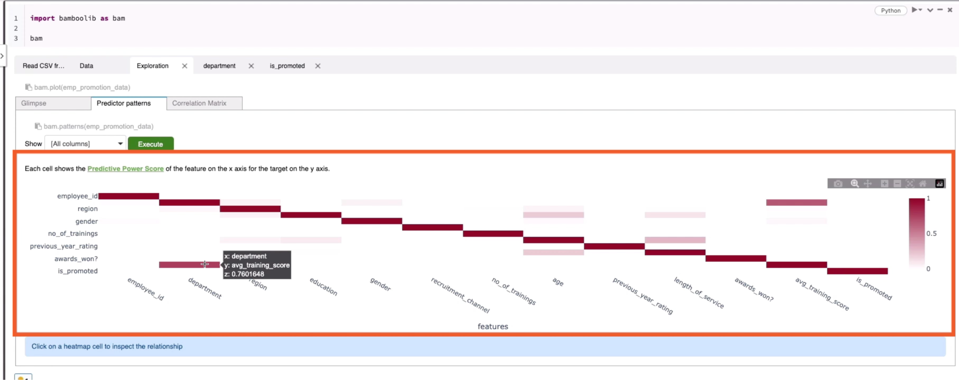

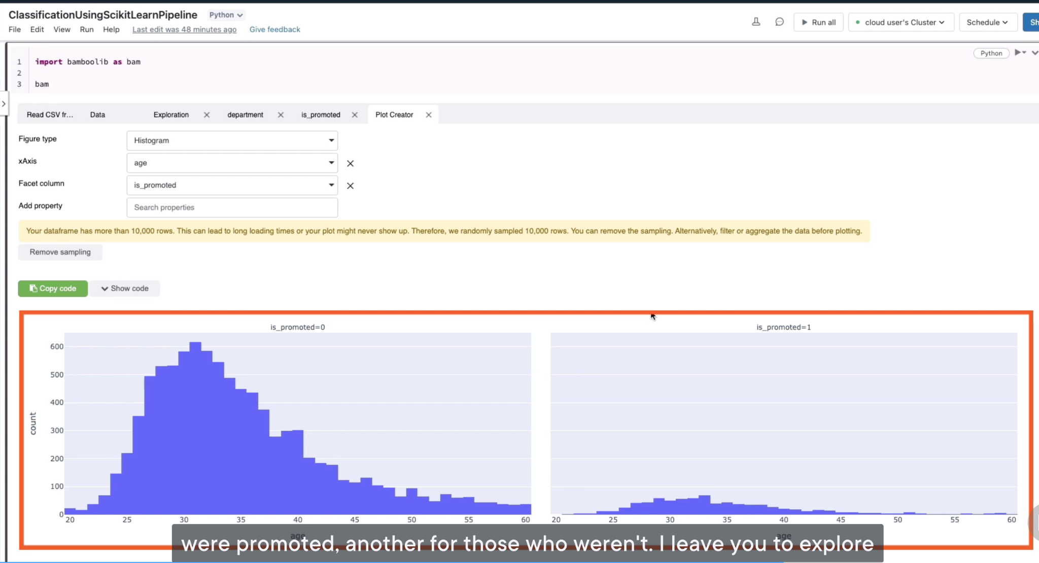

# Autologging to Track Metrics for a Classification Model

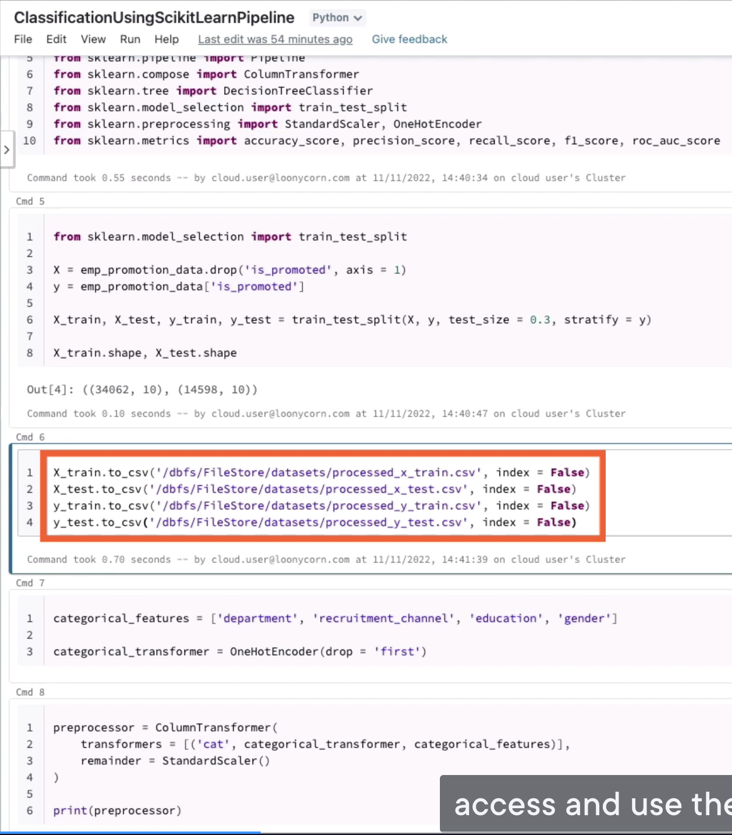

We didn’t specify experiment location, so it will automatically start notebook experiment:

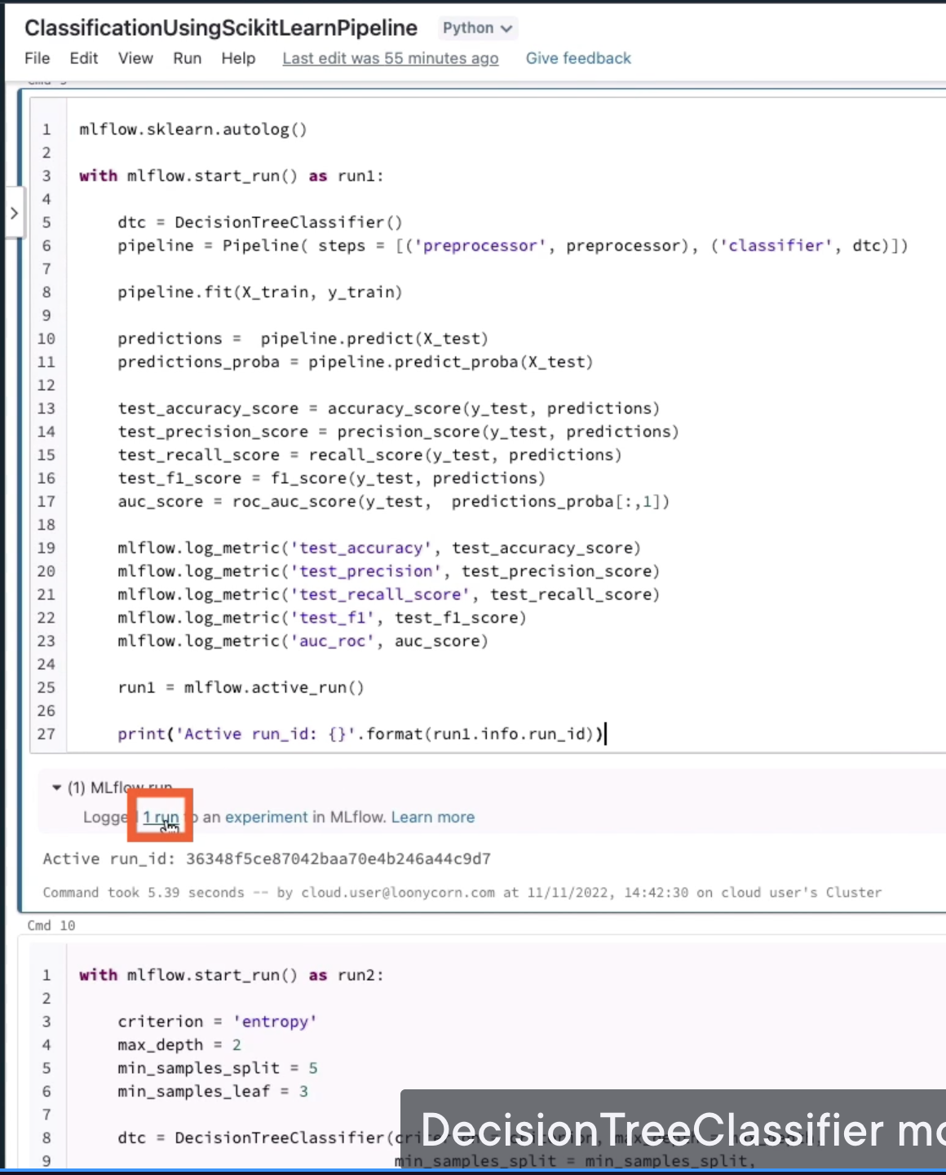

The experiment will be created with a random name

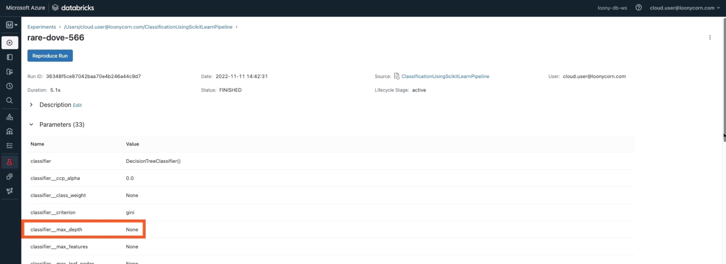

Back to notebook, let’s train another decision tree classification model

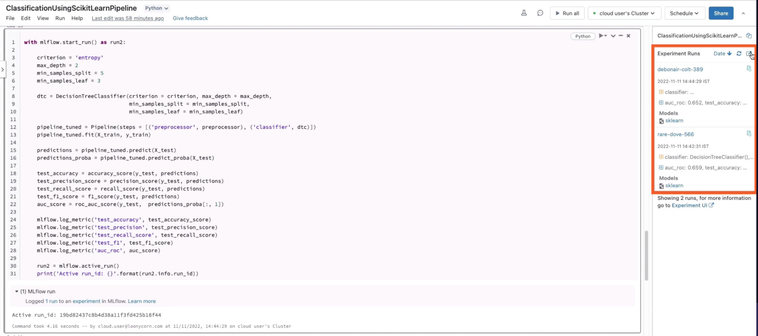

It is same as notebook name, this is the notebook experiment that was automatically created

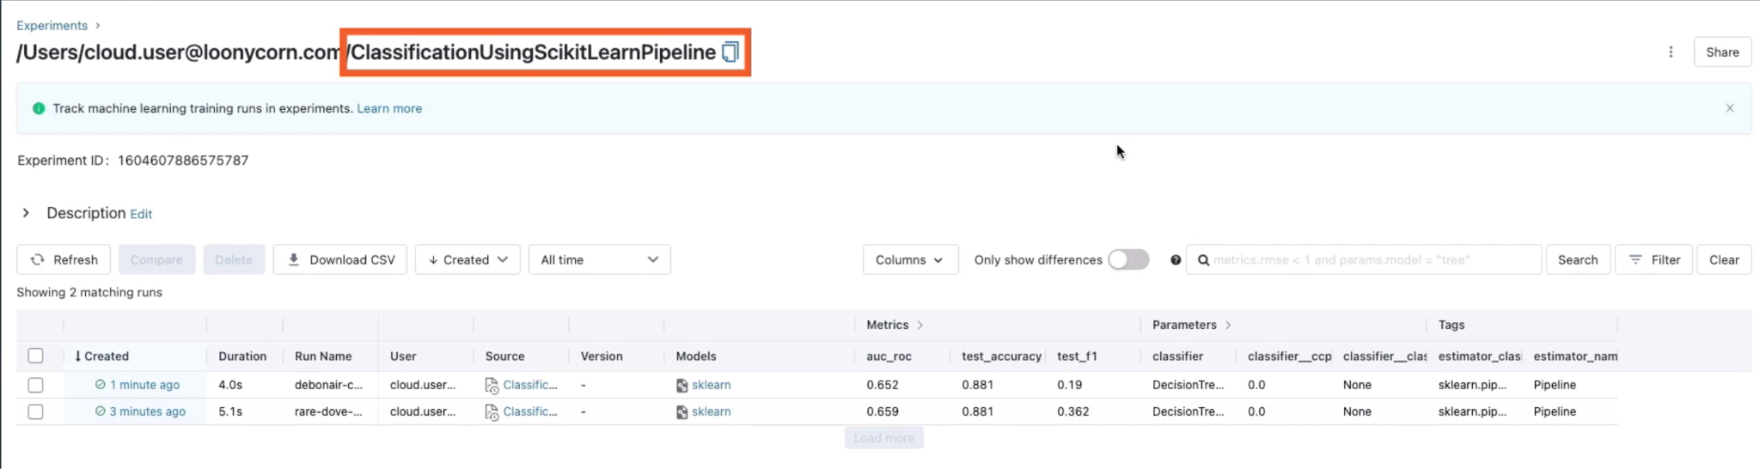

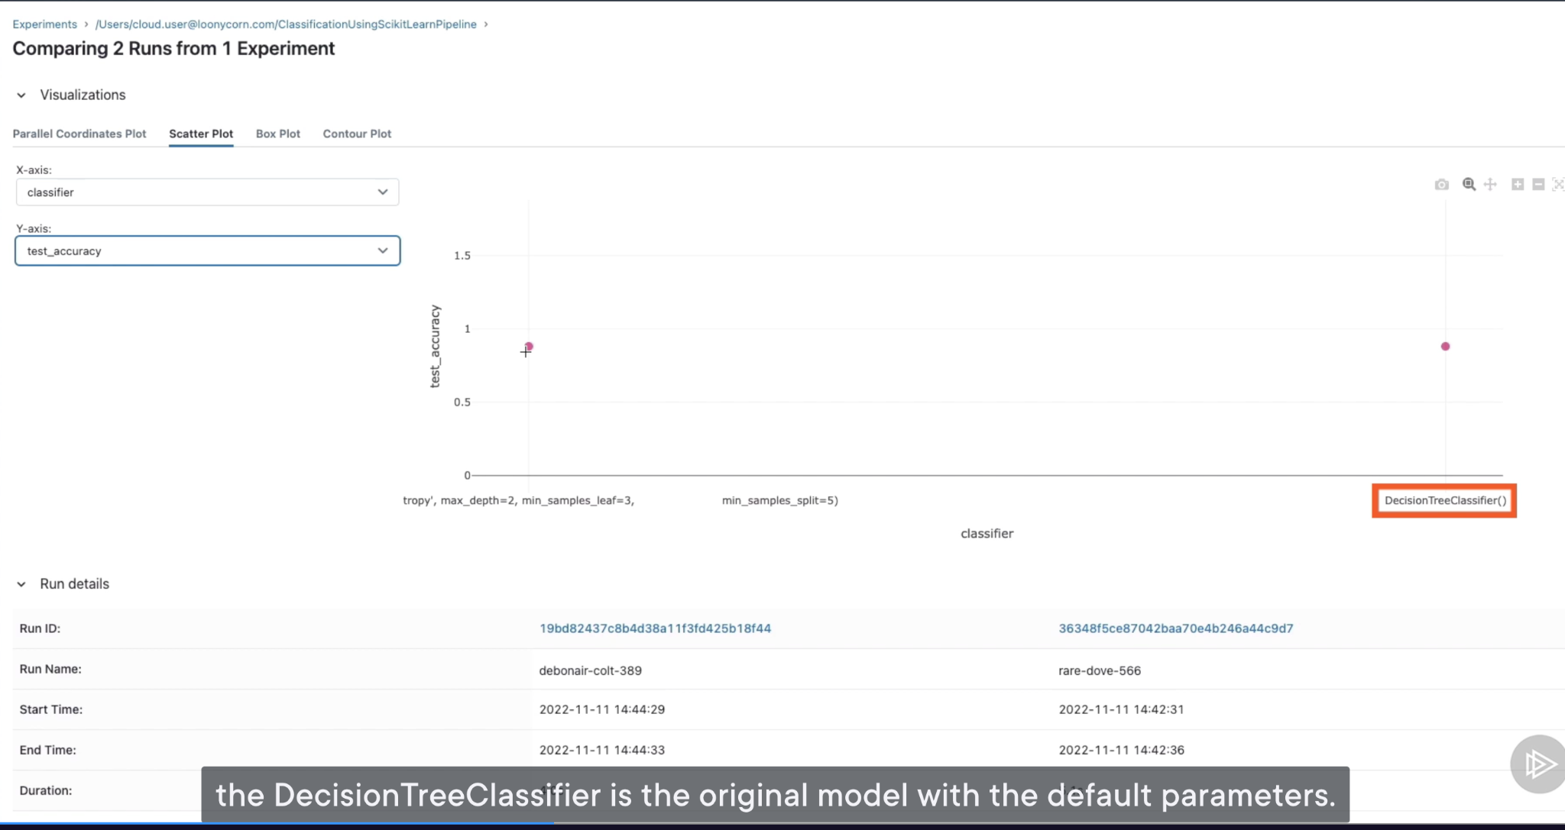

See how we can deploy our model to the Model Registry and then use our deployed model for prediction

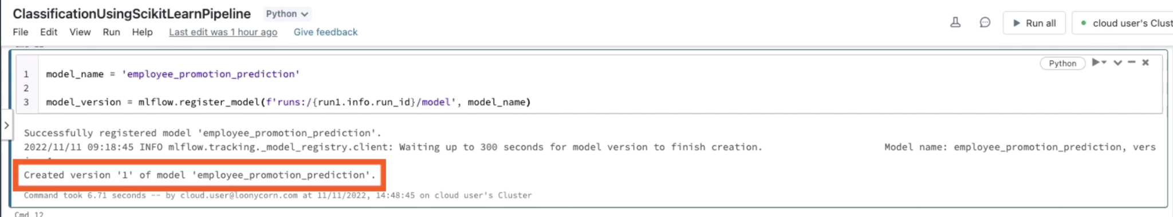

Once you registered your model, you should be able to view the model in your model’s page

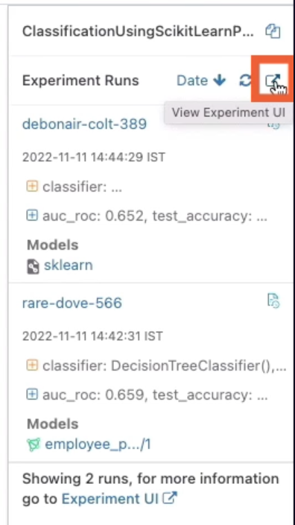

Now you can see 1 model has been registered. You can see a name associated with the model that we trained first.

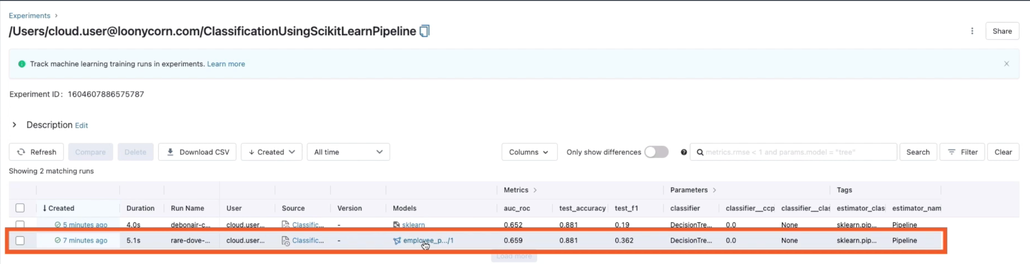

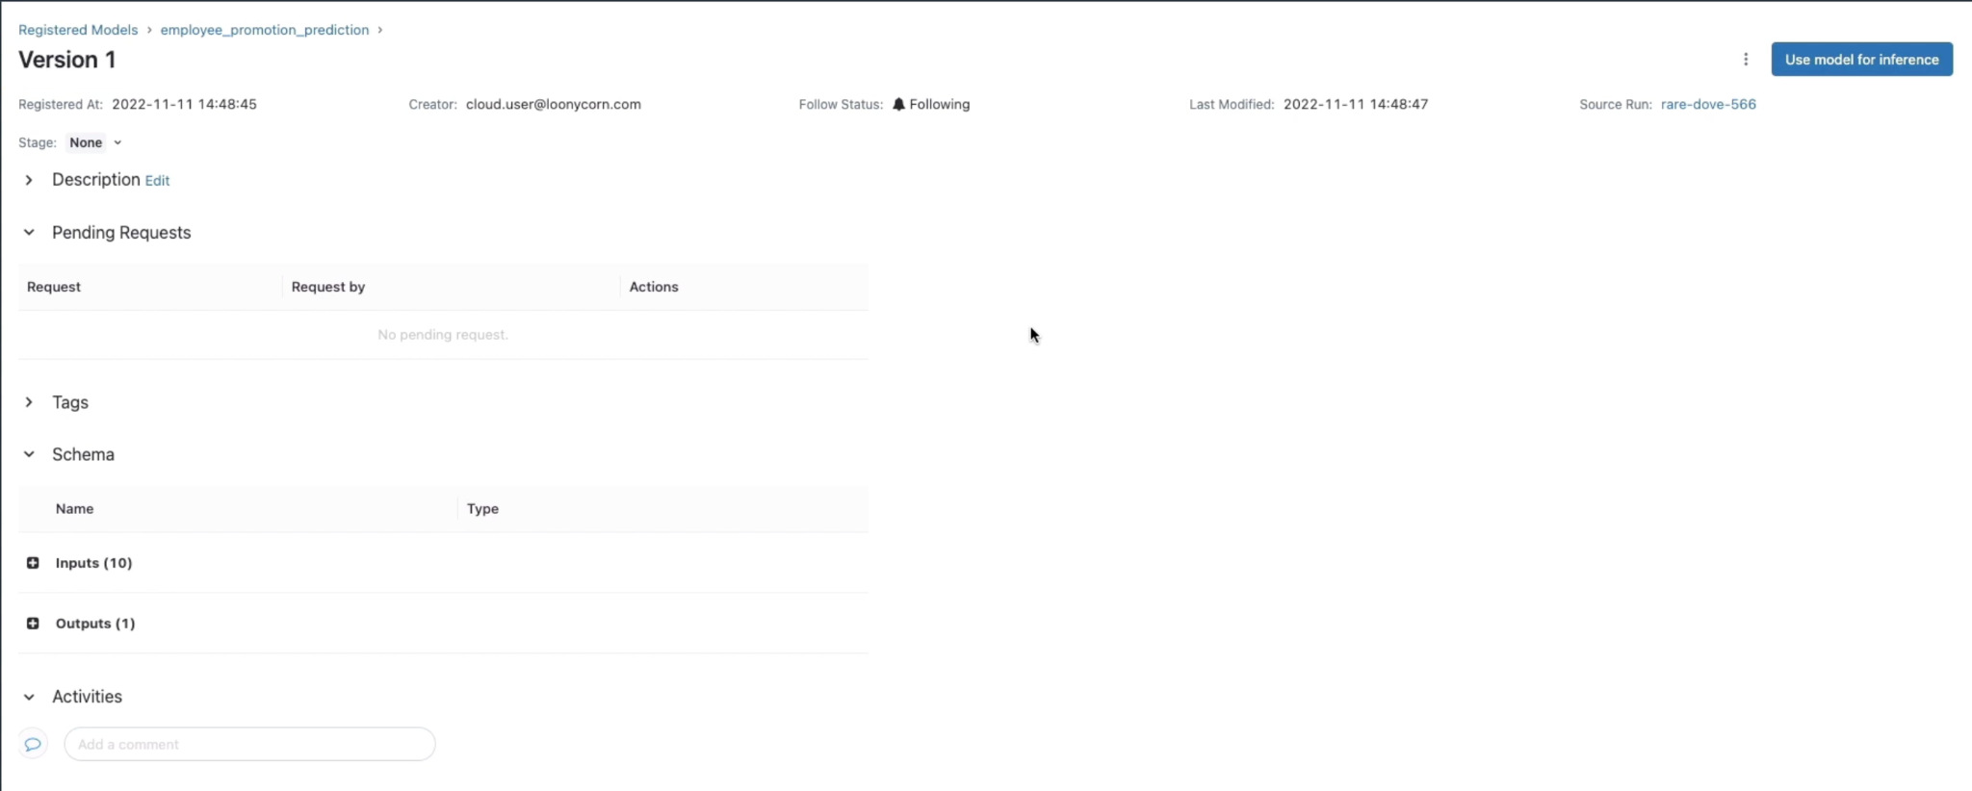

This same model should be available under the Models section in the left navigation pane.

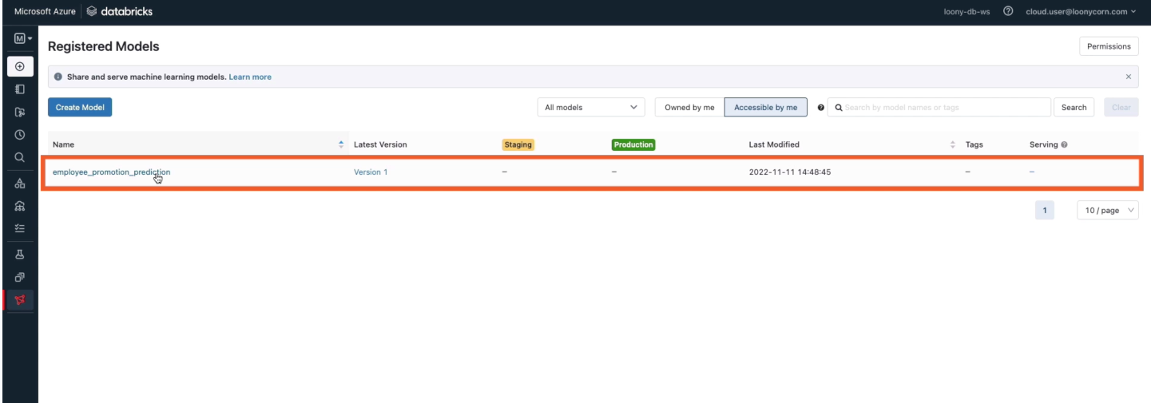

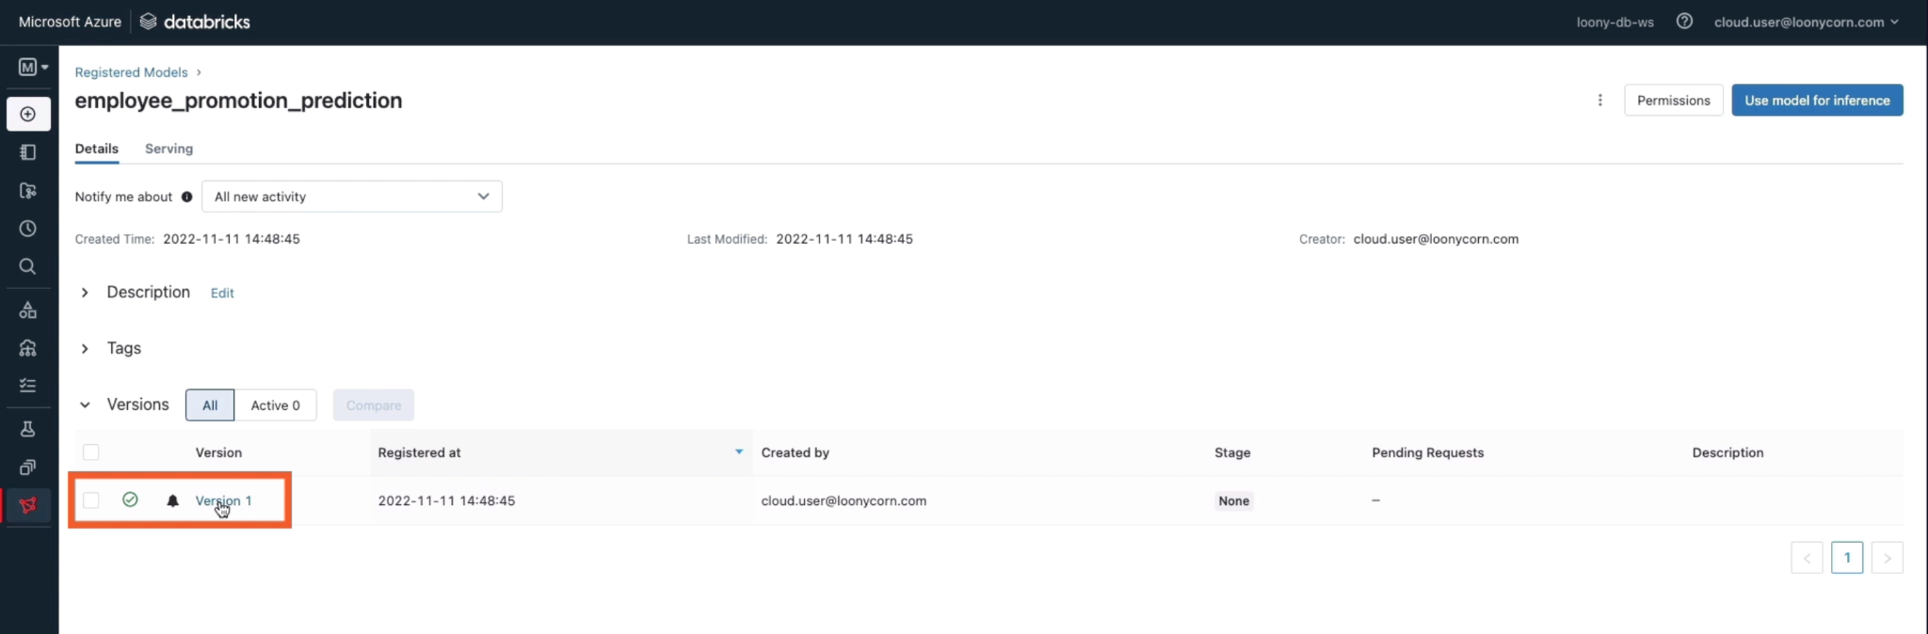

For Stage:

Staging allows you to categorize your models. You may have models in the testing phase, they will be in Staging.

If you have models that have finalized, and you want to perform prediction on those models, they will be in the Production stage

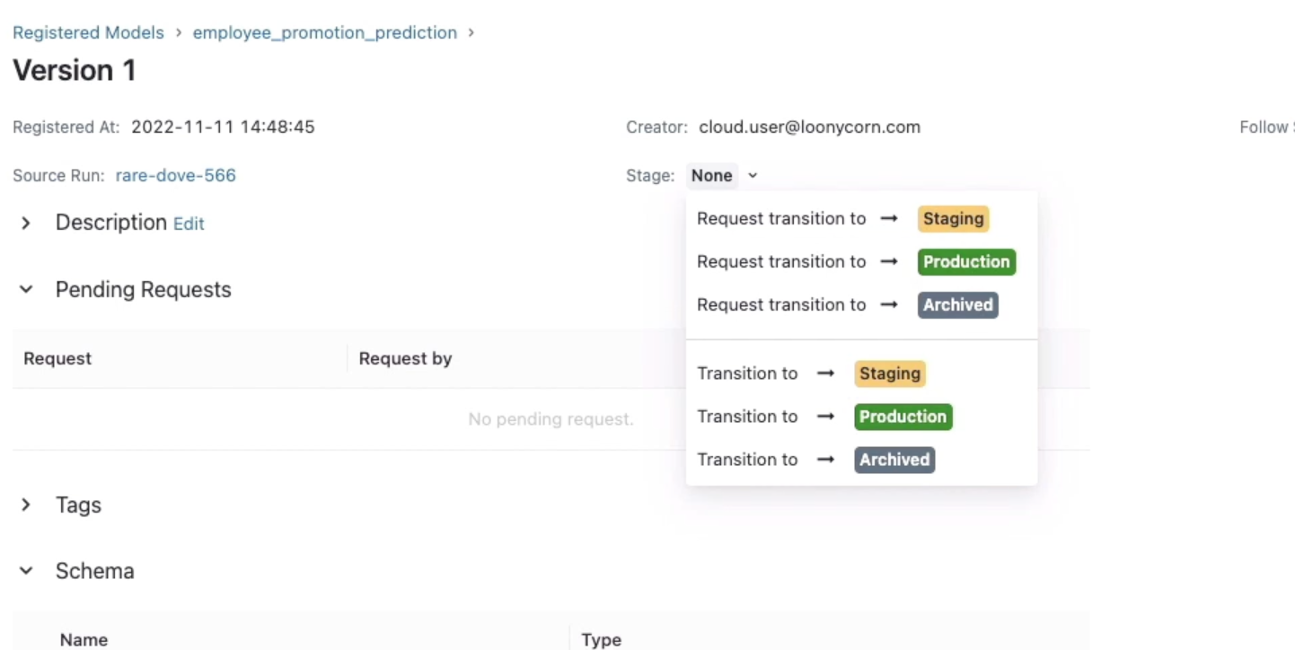

Let’s move our model to production, assuming we have completed testing

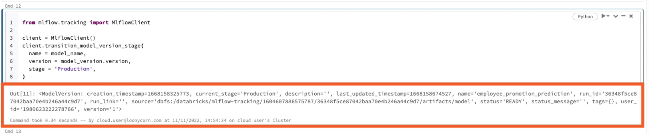

Now go back to “Models”

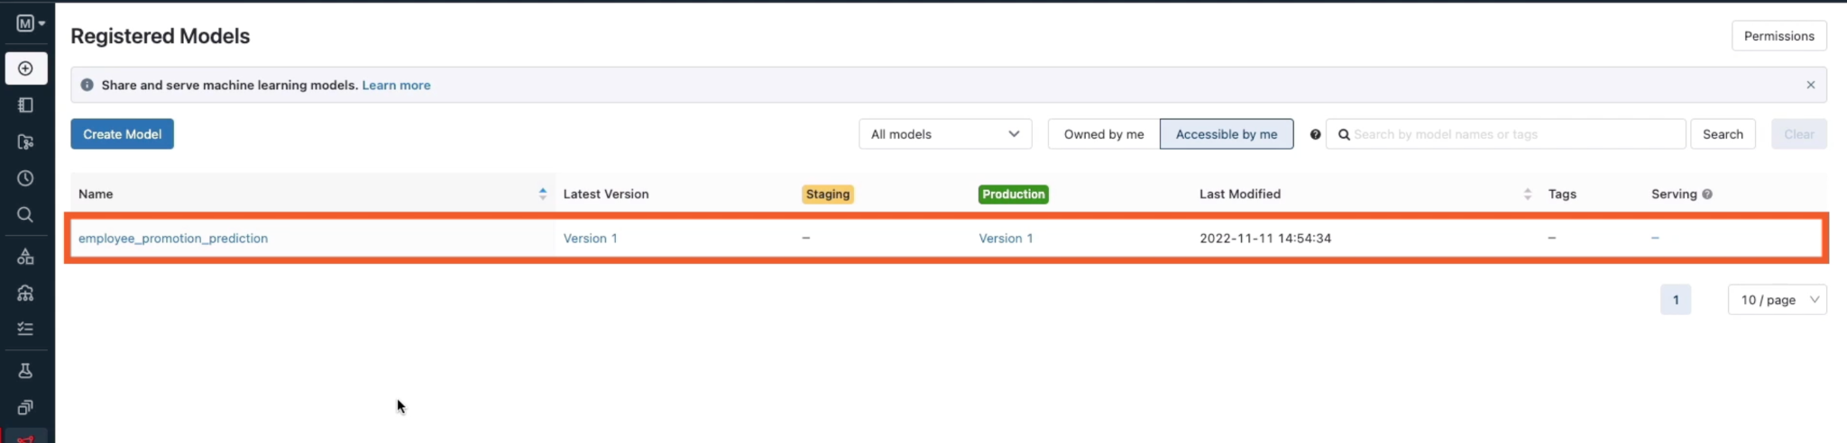

Let’s serve this model, or deploy this model to a serving endpoint so that we can use this model for predictions.

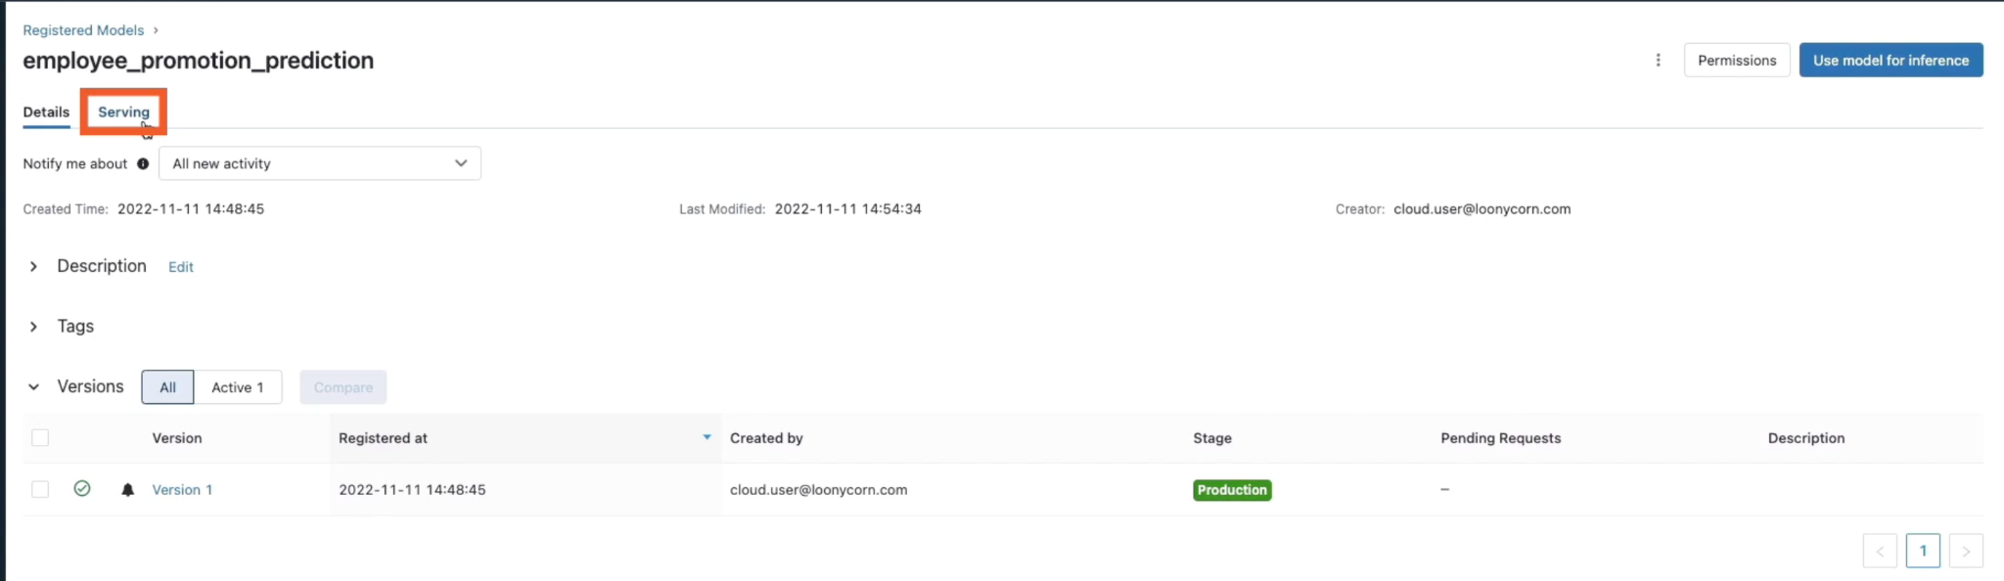

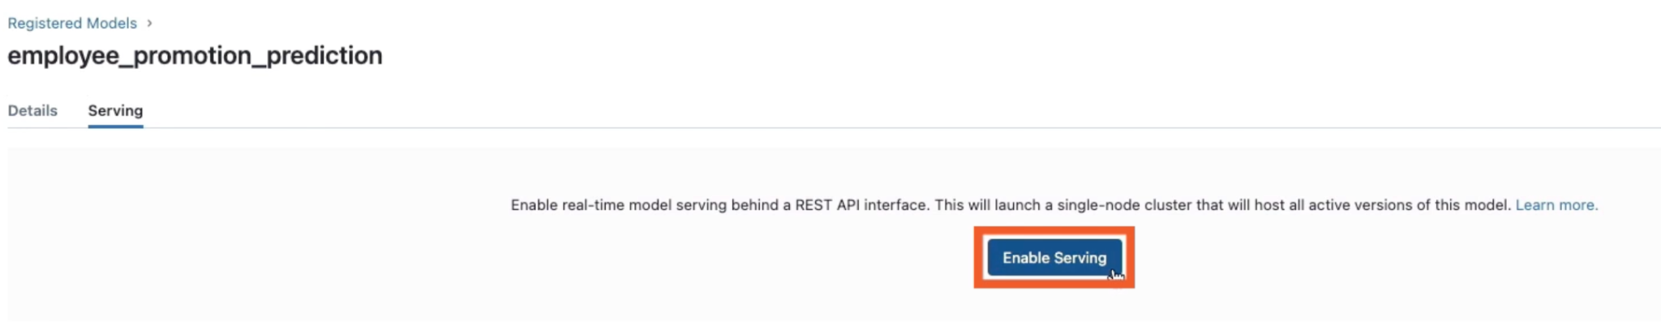

Deploying your model to a real-time HTTP endpoint takes a little bit of time. Because behind the scenes, Databricks is setting up a single node cluster to deploy your HTTP endpoint.

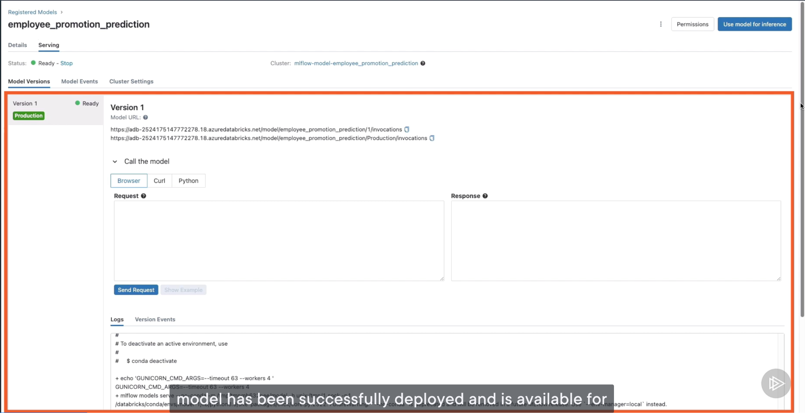

We can invoke the model using Browser, curl, or from Python code

Now head over to Compute, where all clusters are shown, under Job compute, you should find that a new cluster has been created in order to deploy our model

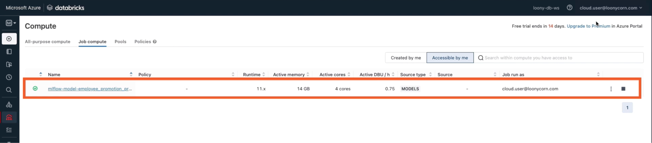

Now let’s use our HTTP REST endpoint that we’ve deployed for this model for predictions. For that, we need a Databricks user token.

Go to User settings

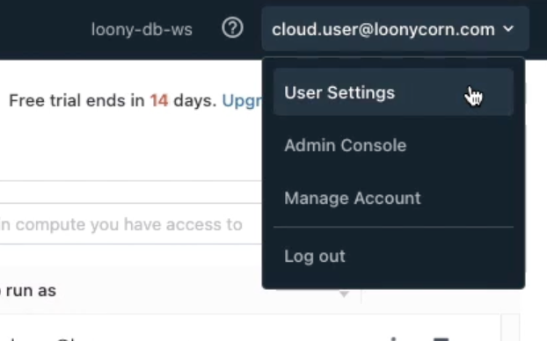

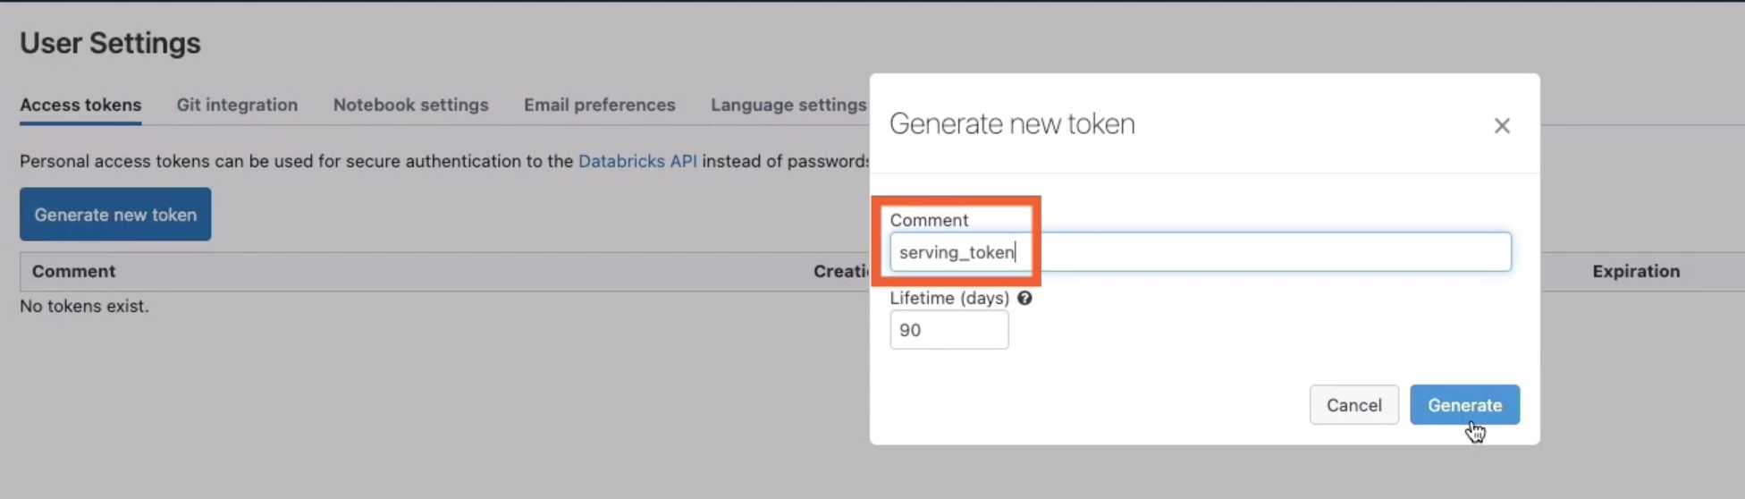

Once the token has been created, copy this and save it safely somewhere

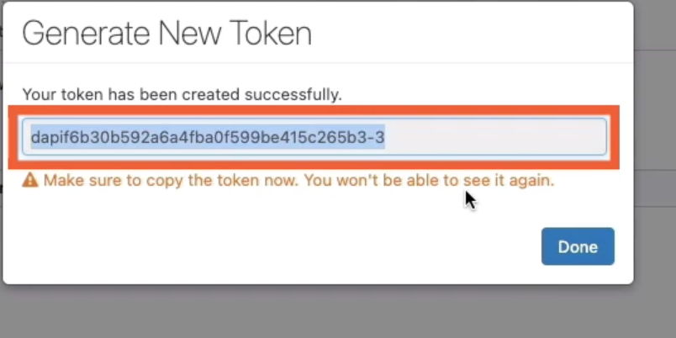

Back to notebook, paste in this token in this line of code:

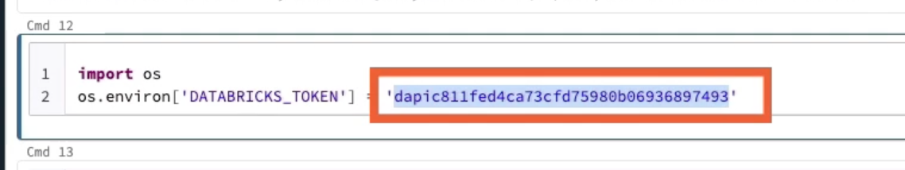

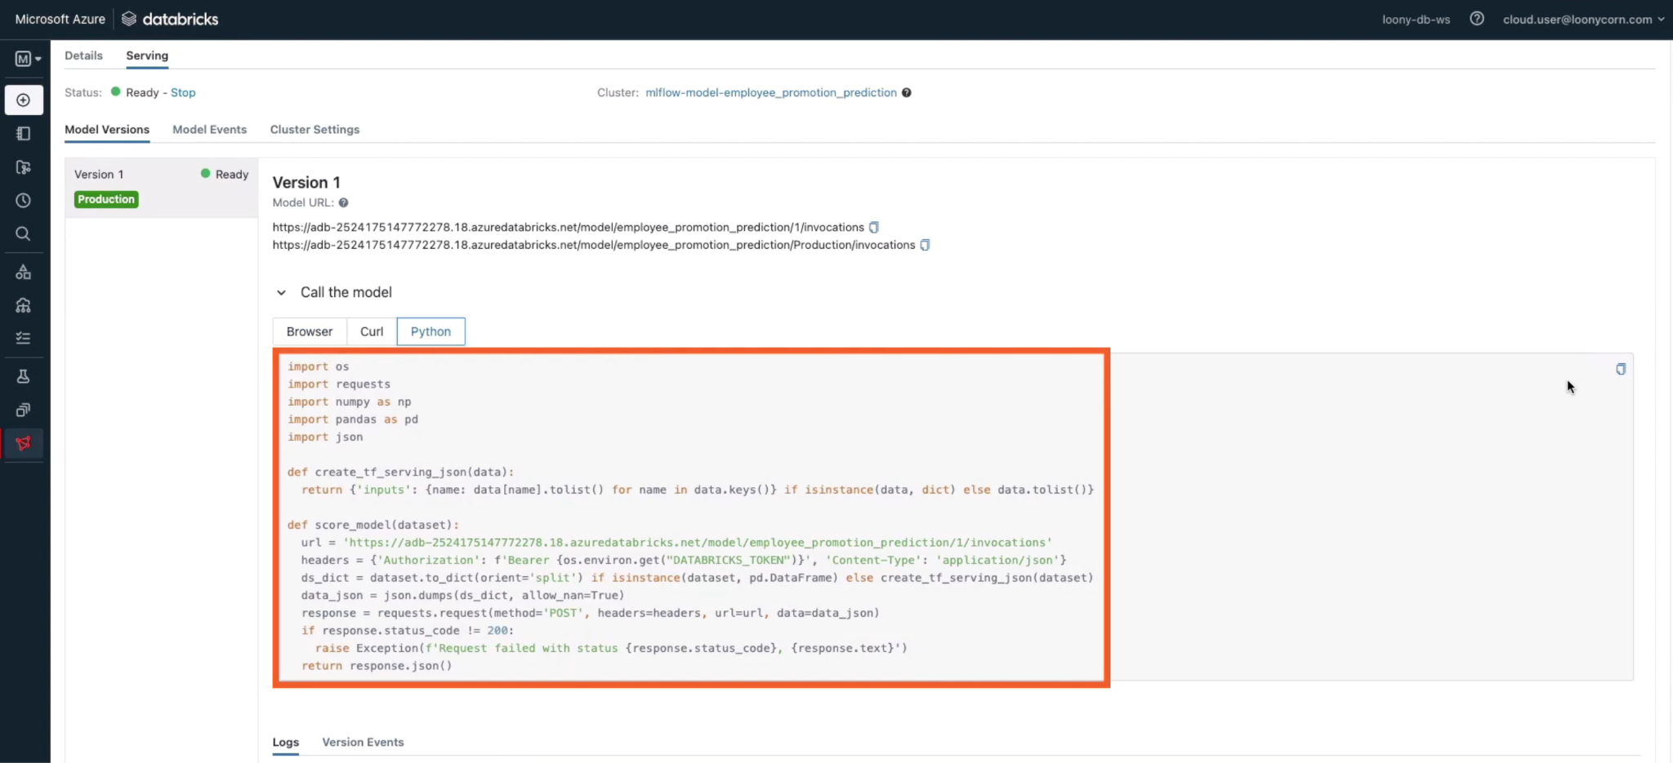

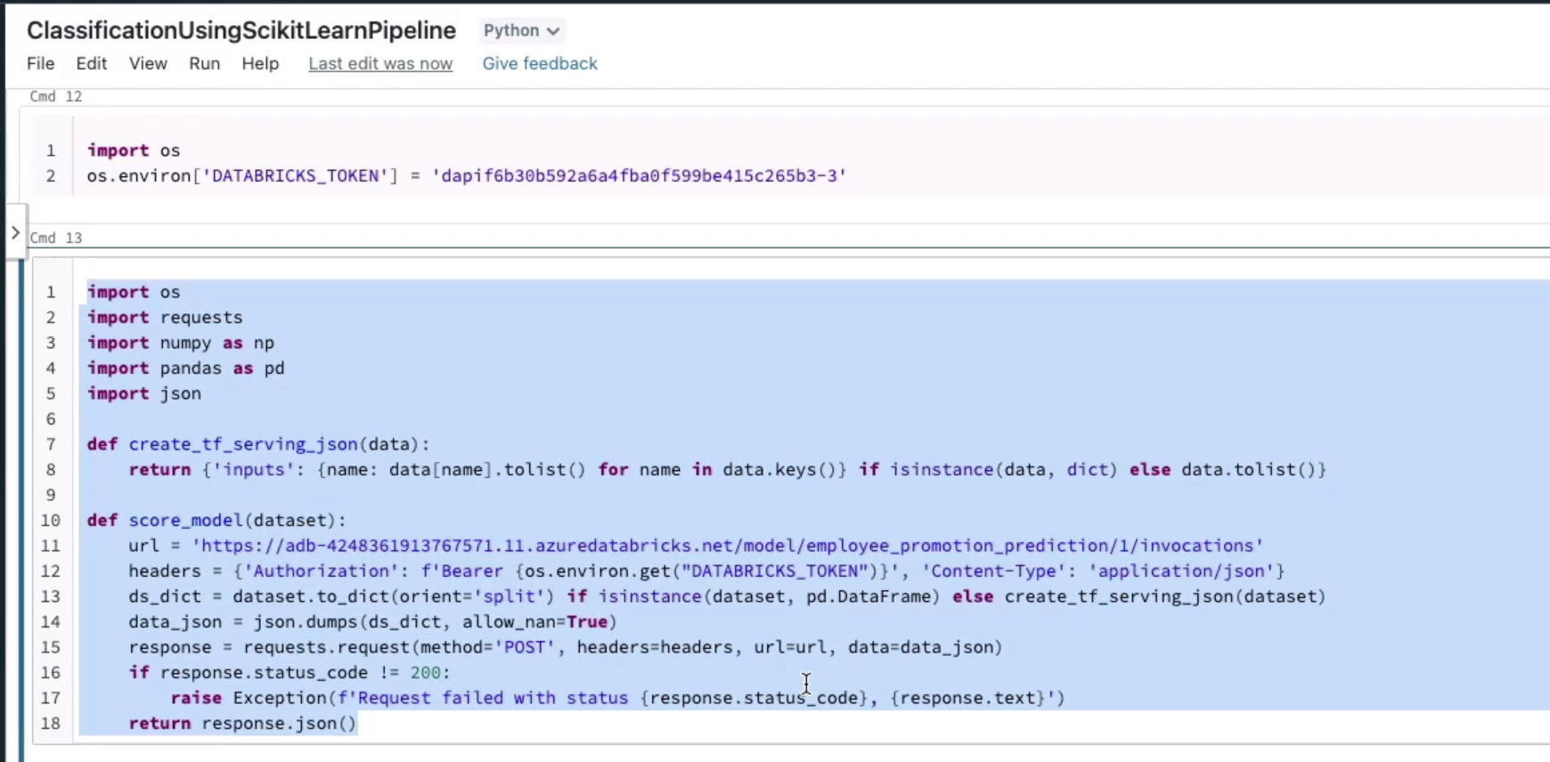

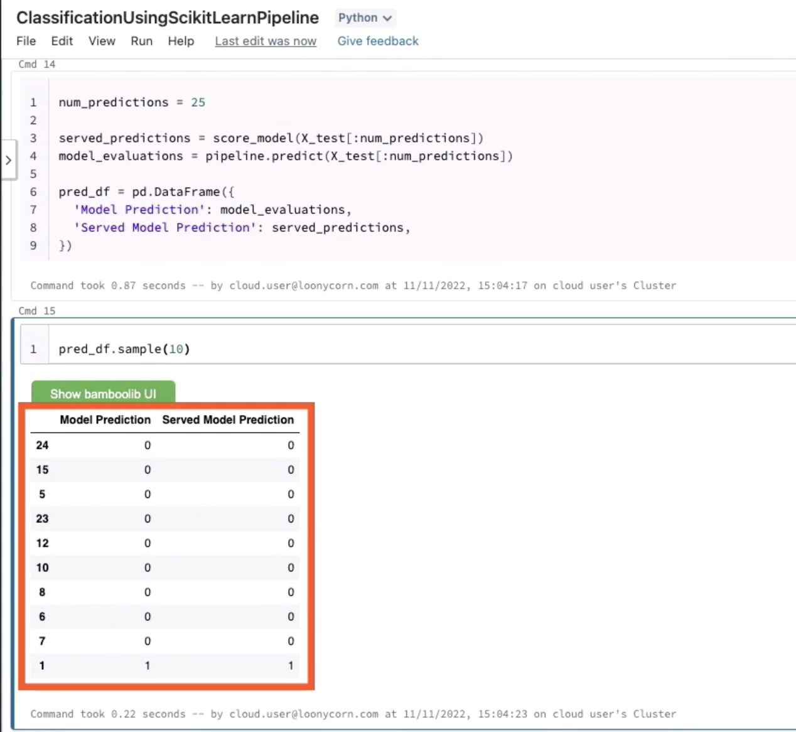

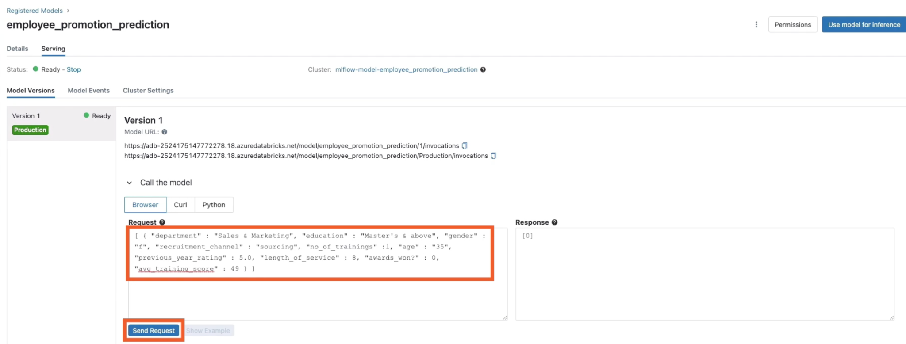

# Implementing XGBoost Models in Databricks

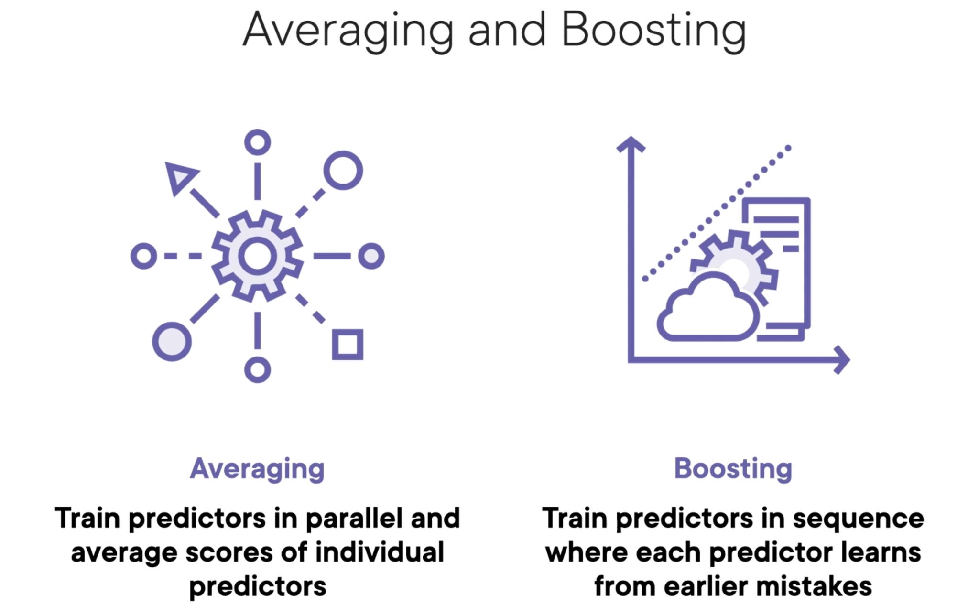

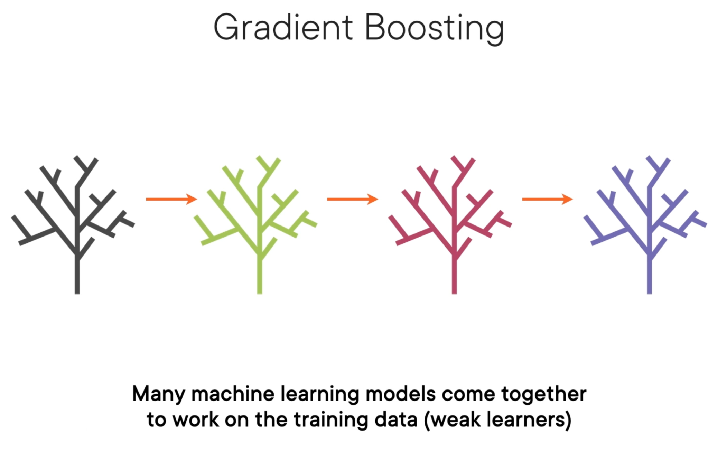

Each individual weak learner may have residuals (data that it was unable to learn from)

Model 2, the next model in the sequence, will learn from the previous model’s residuals

The sequence of models will together extract as much information as possible from the underlying data. The combined sequence will produce a strong learner

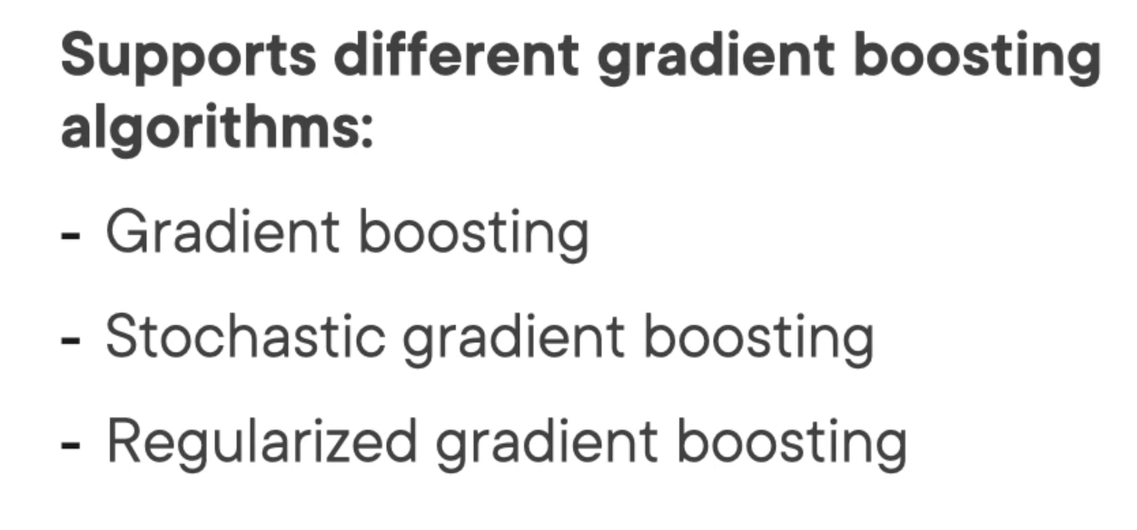

Support for out-of-core computing for very large datasets that don’t entirely fit into memory at one go

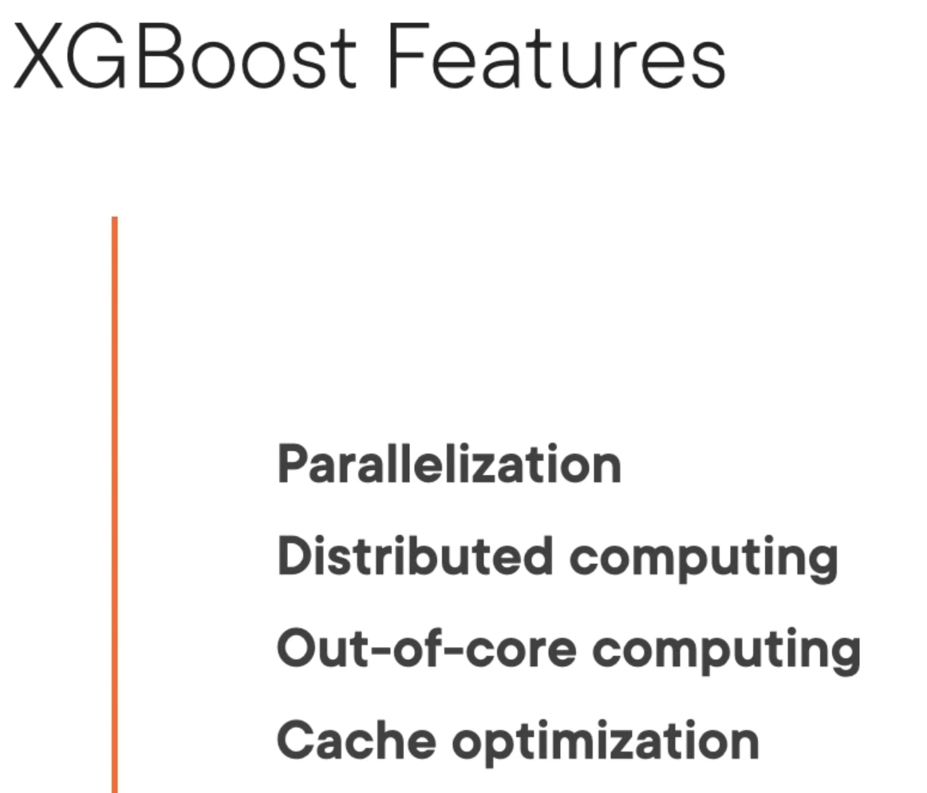

# Inferring model signature and Logging Models

We set log_models=False, means that trained model artifacts are sth that we will need to explicitly log, will not be automatically logged, unlike our other metrics that will be logged automatically.

Use log_artifact to log this confusion matrix.

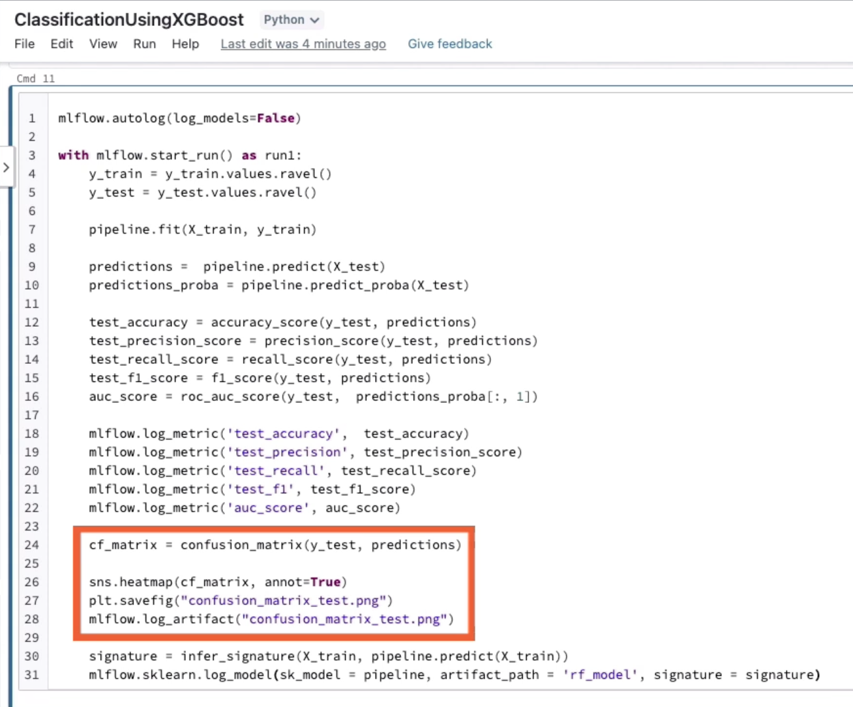

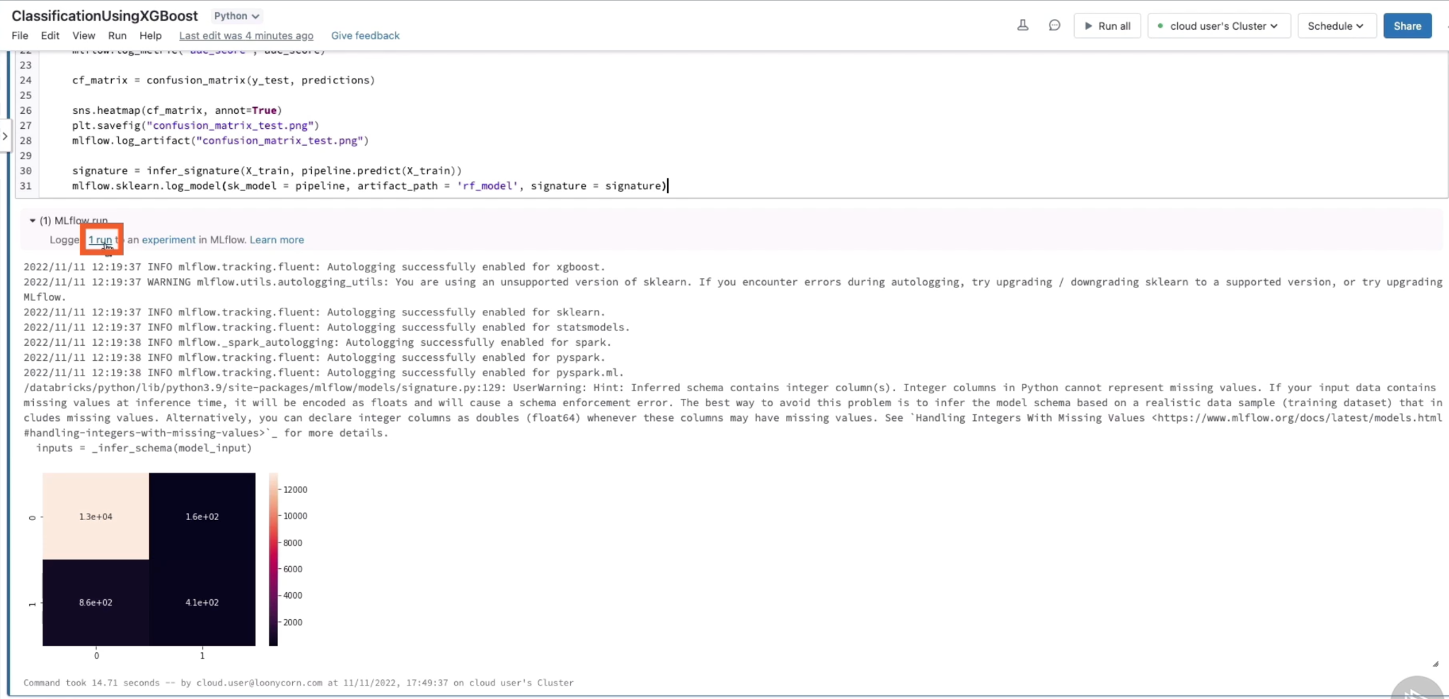

All metrics start with training, those were autologged

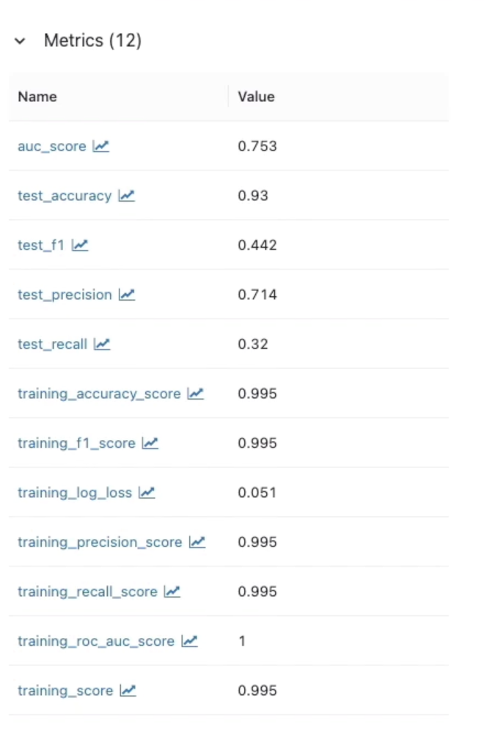

You will find the artifacts are located at what we specifically named rf_model directory.

We have used the infer_signature method to infer the signature of the inputs and outputs to this model, and this is specified under the signature section in the MLmodle file.

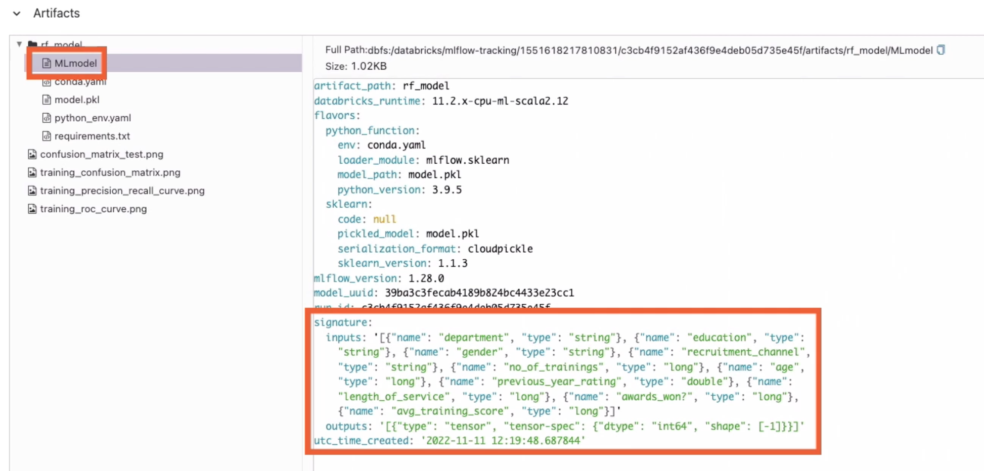

If you’re planning to deploy this model for prediction, it’s important that your model has a signature that the deployment tool can infer and use to pass information along to your model.

# Autologging XGBoost Model Runs

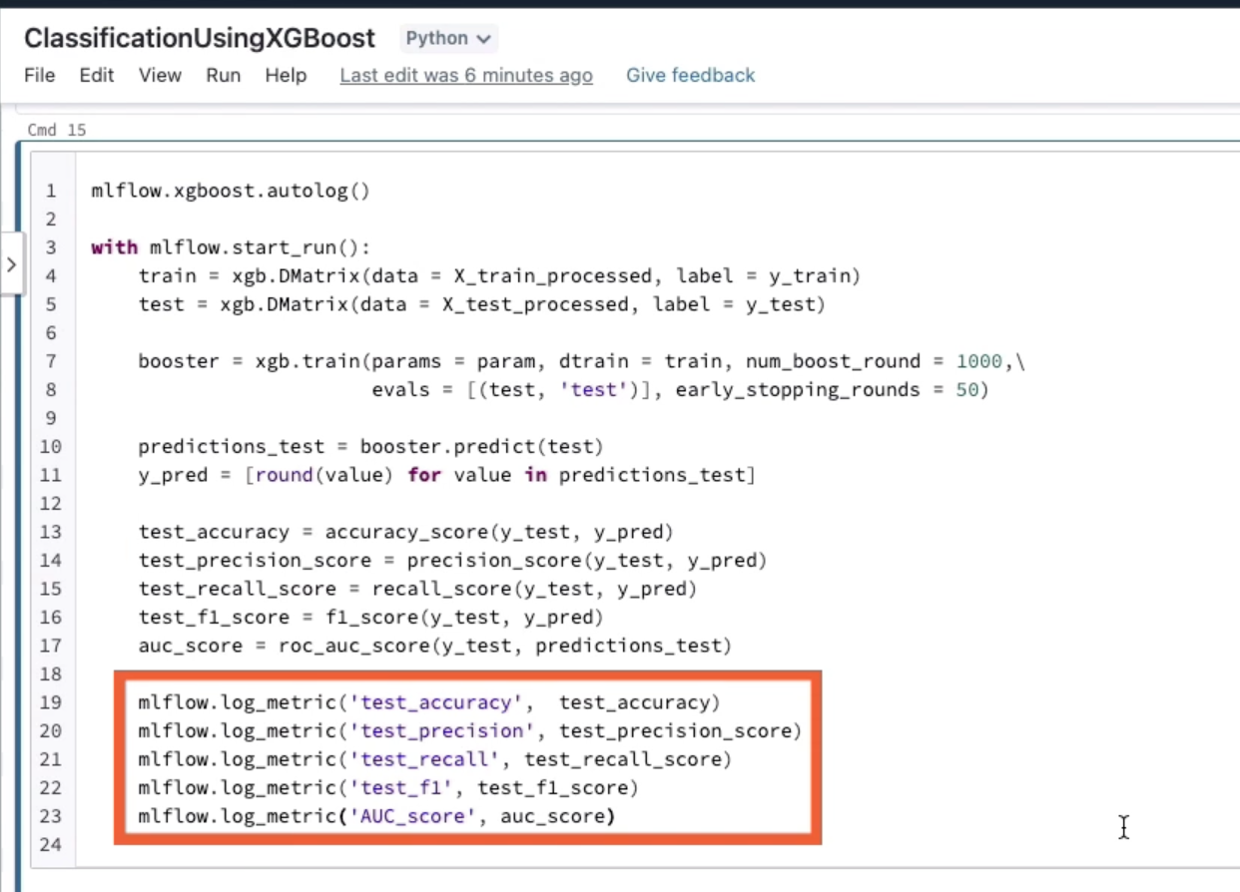

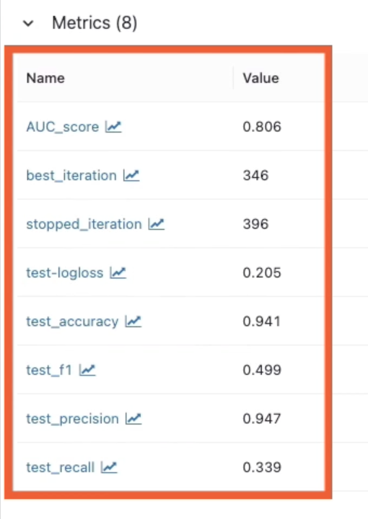

# ML using Apache Spark

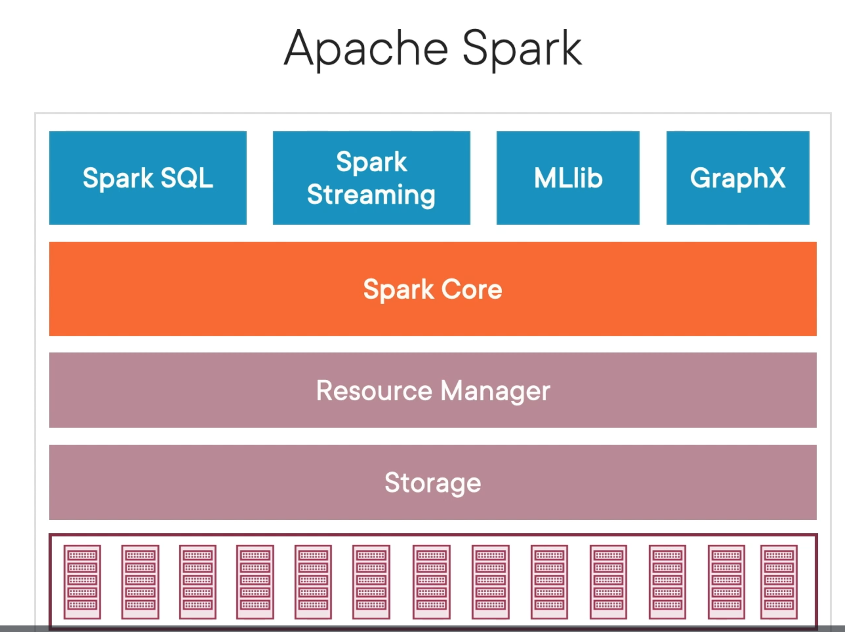

XGBoost models can be trained using Spark ML pipelines

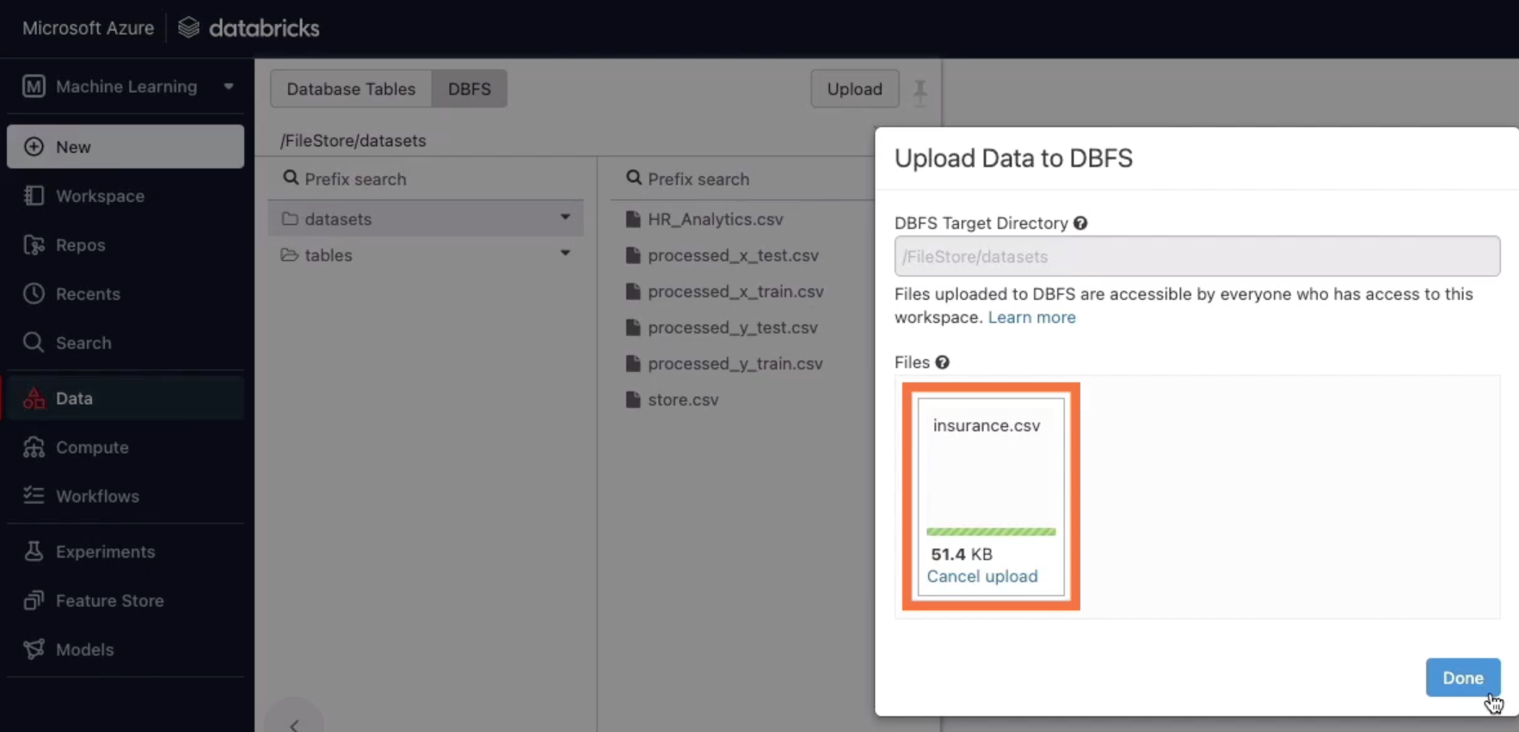

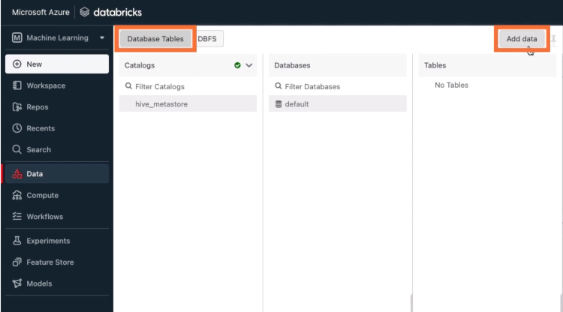

I’ll show you how to load this data into a Delta table. A Delta table is at the heart of the data lakehouse platform in Databricks. Delta tables allow you to perform massive scale processing on huge amounts of data. It stores the underlying data in the open-source Parquet format and adds a metadata and caching and indexing layer on top, this layer allows you to work with Parquet files with additional functionality. You get version control, transaction support, everything that you need in a data warehouse when you use Delta tables.

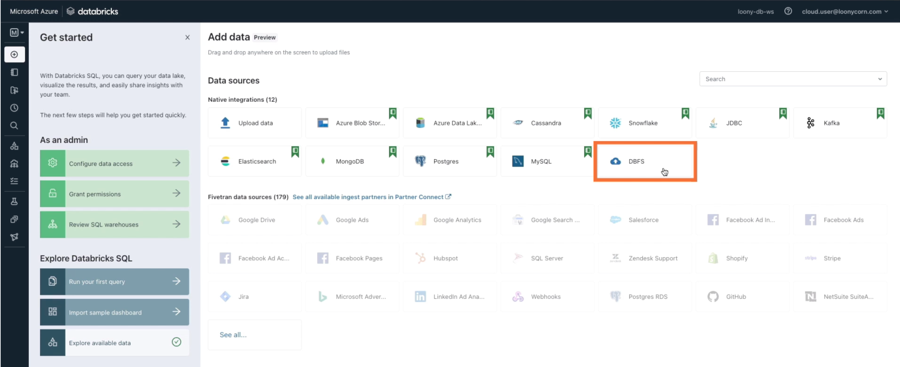

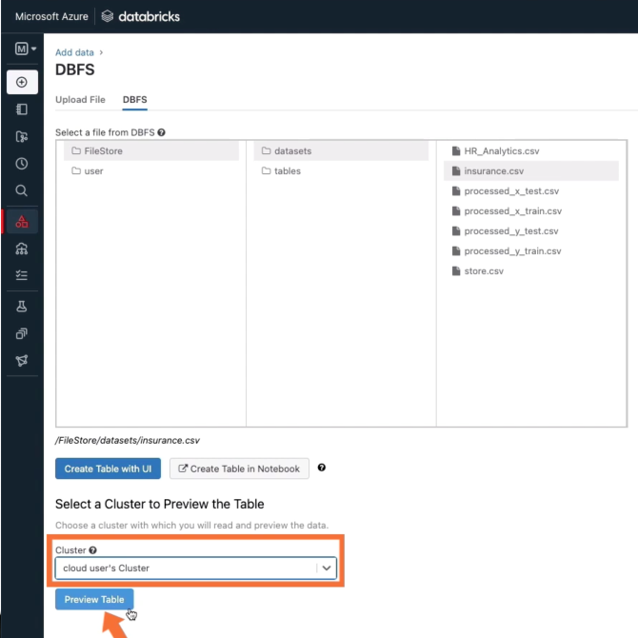

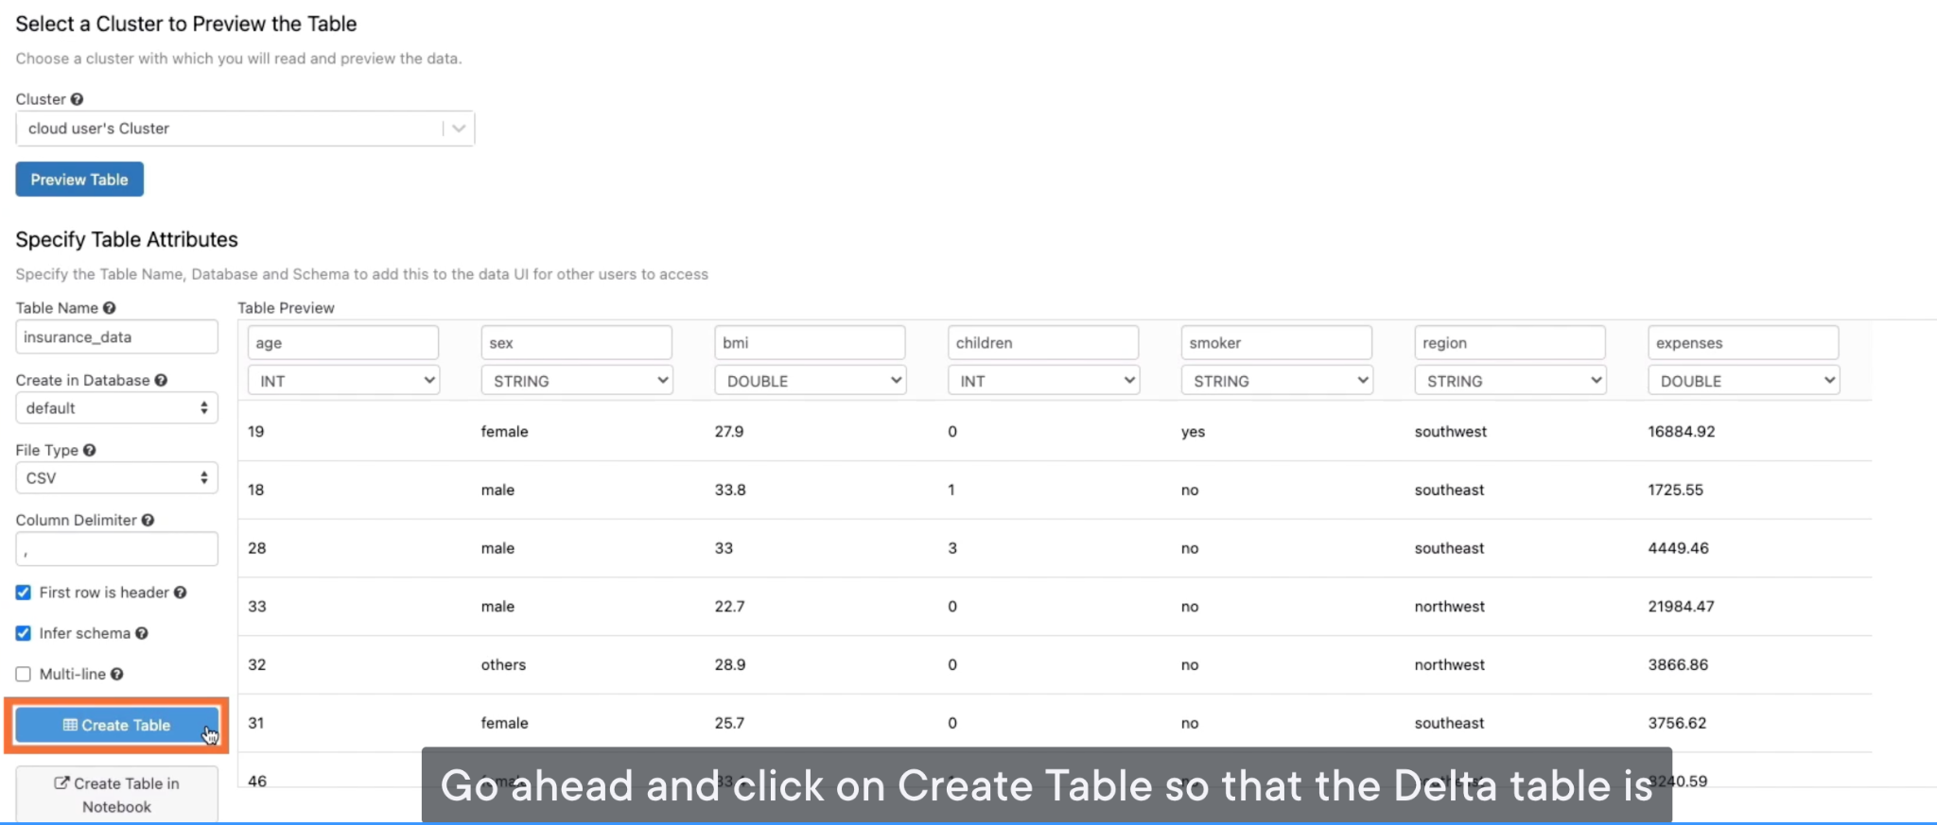

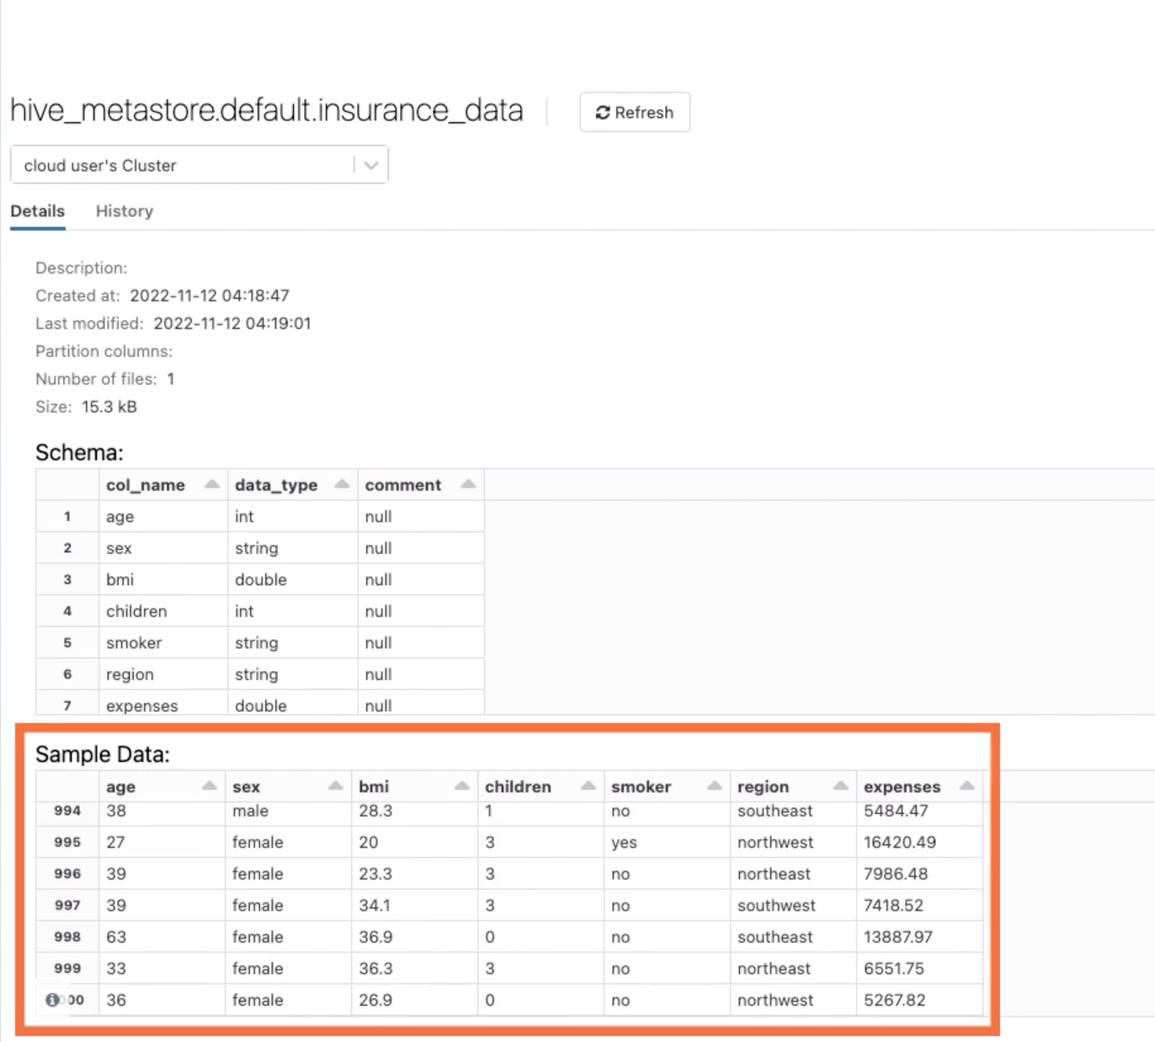

## Training a Model Using a Spark ML Pipeline

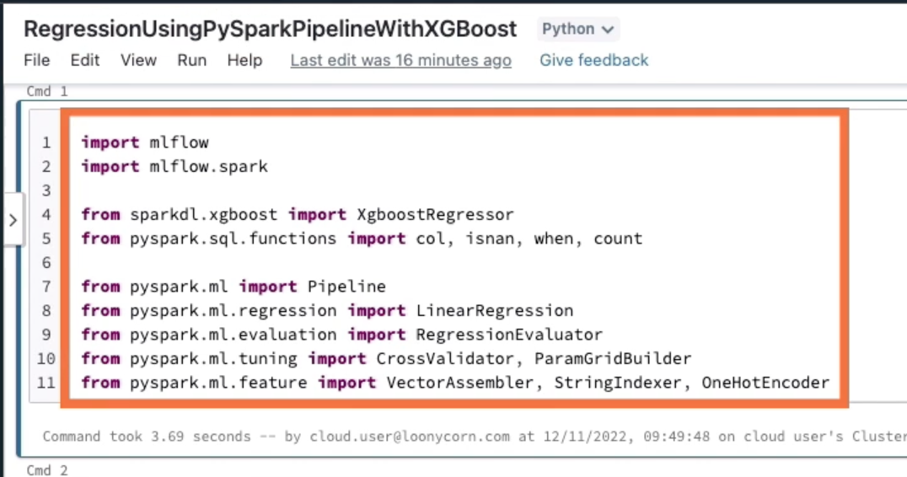

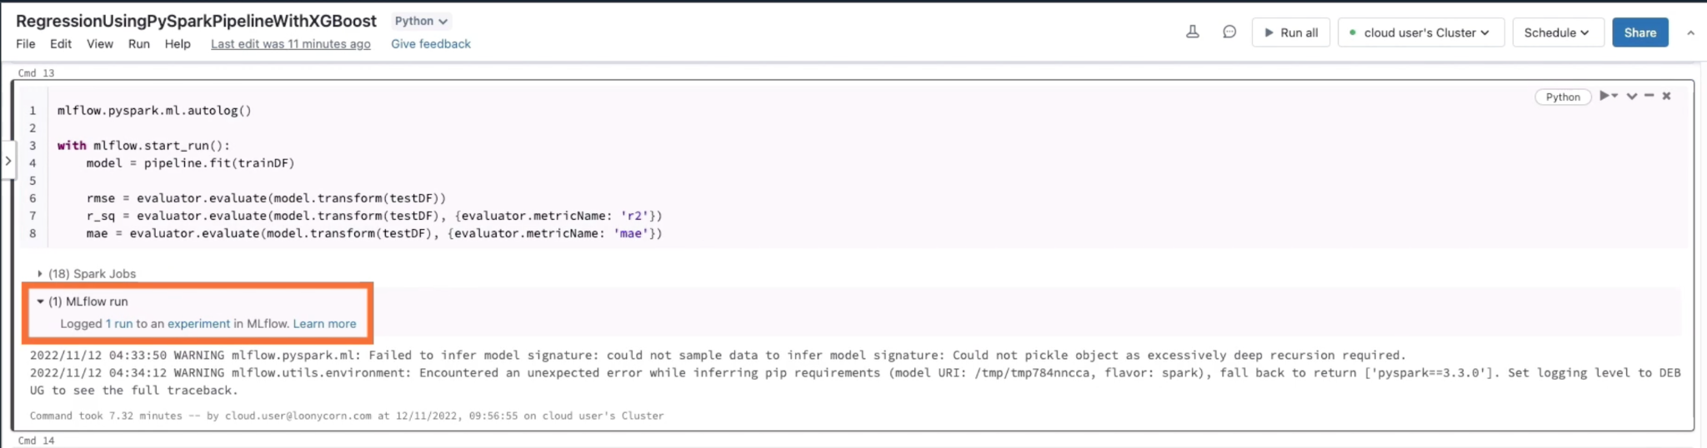

MLflow doesn’t autolog a whole bunch of metrics for Spark models. Only the metrics computed by the RegressionEvaluator on the test data were autologged.

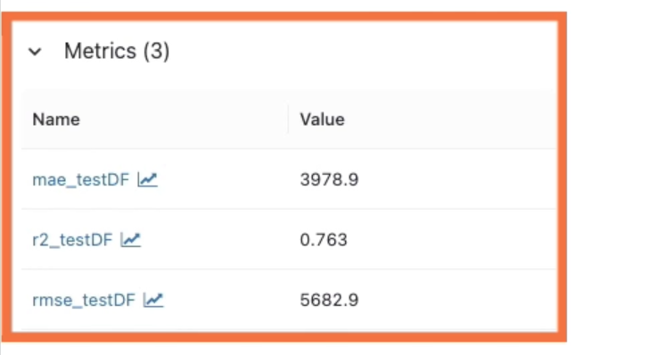

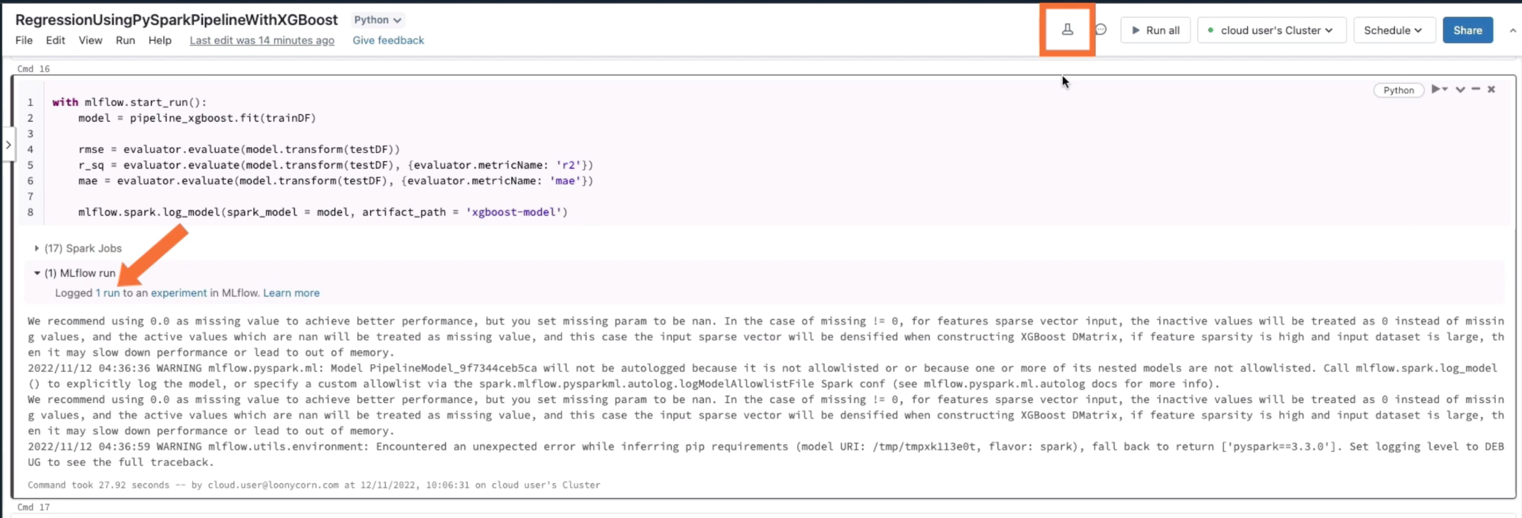

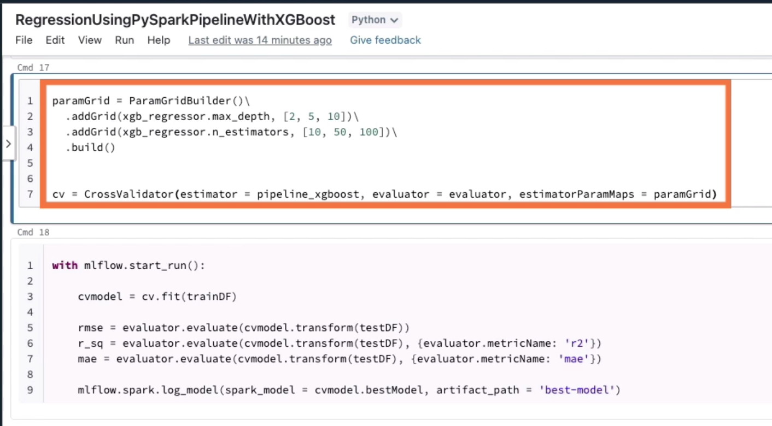

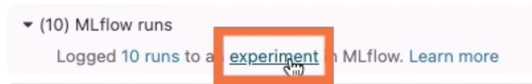

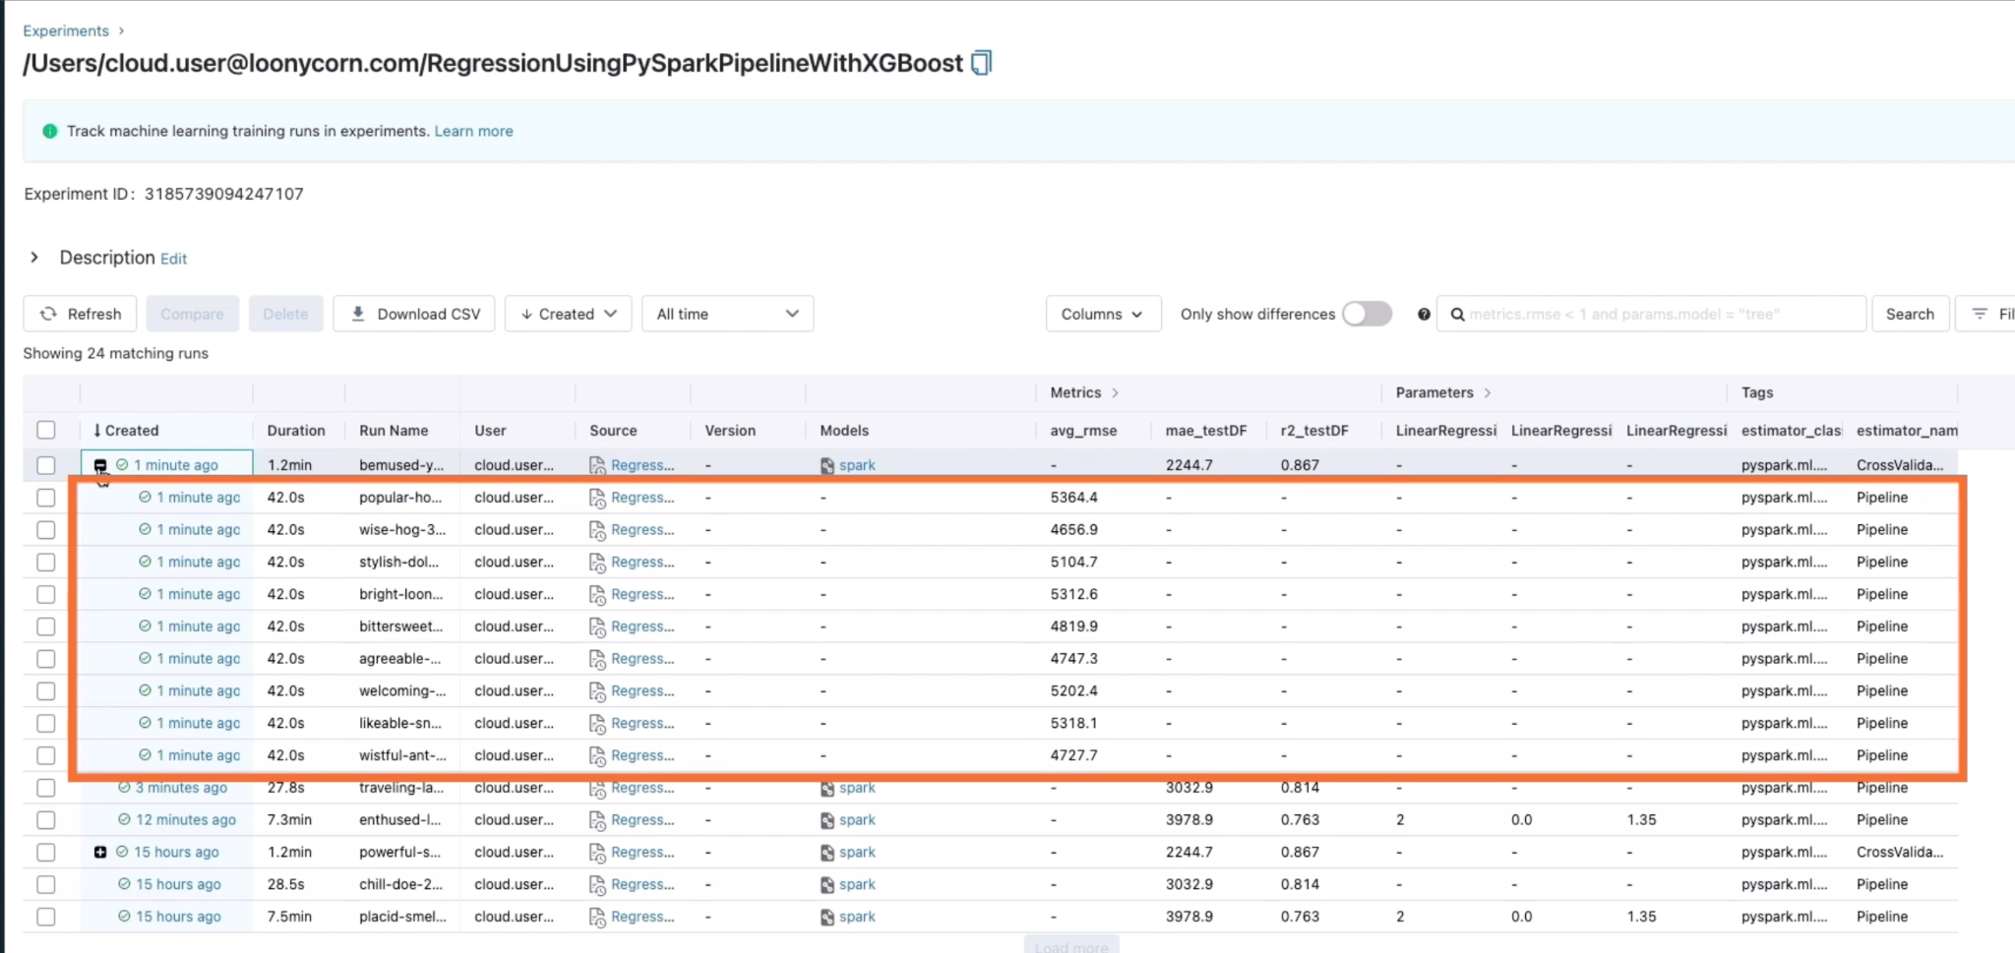

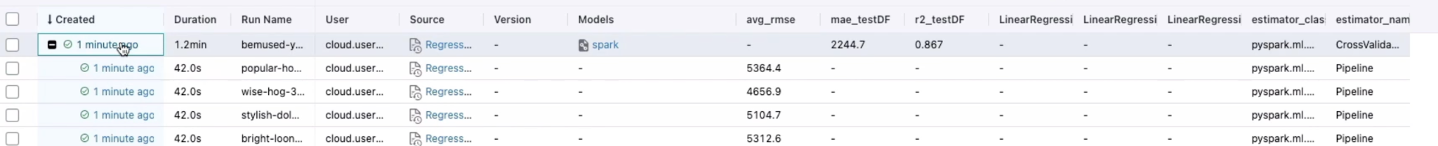

The parent one records the best model

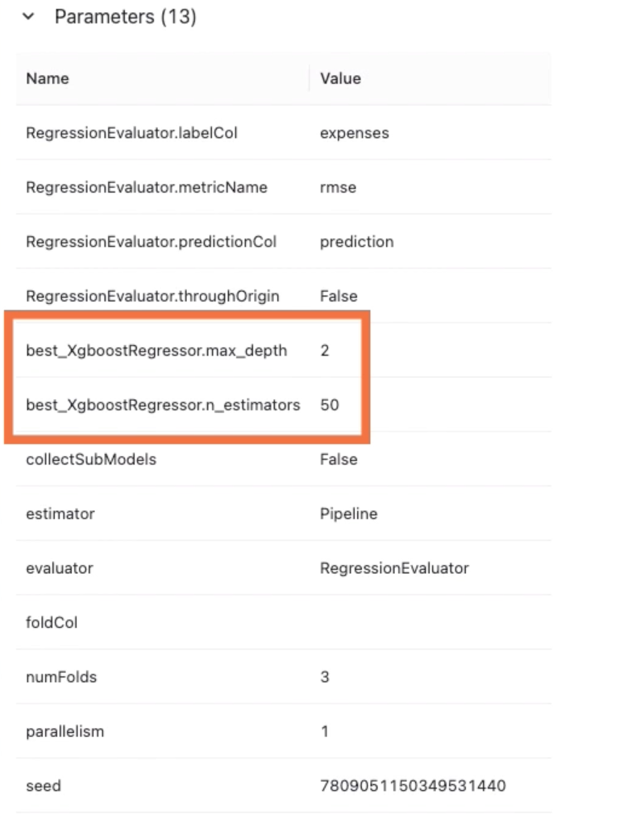

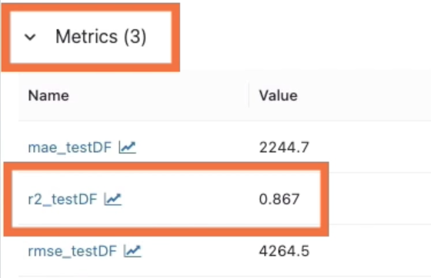

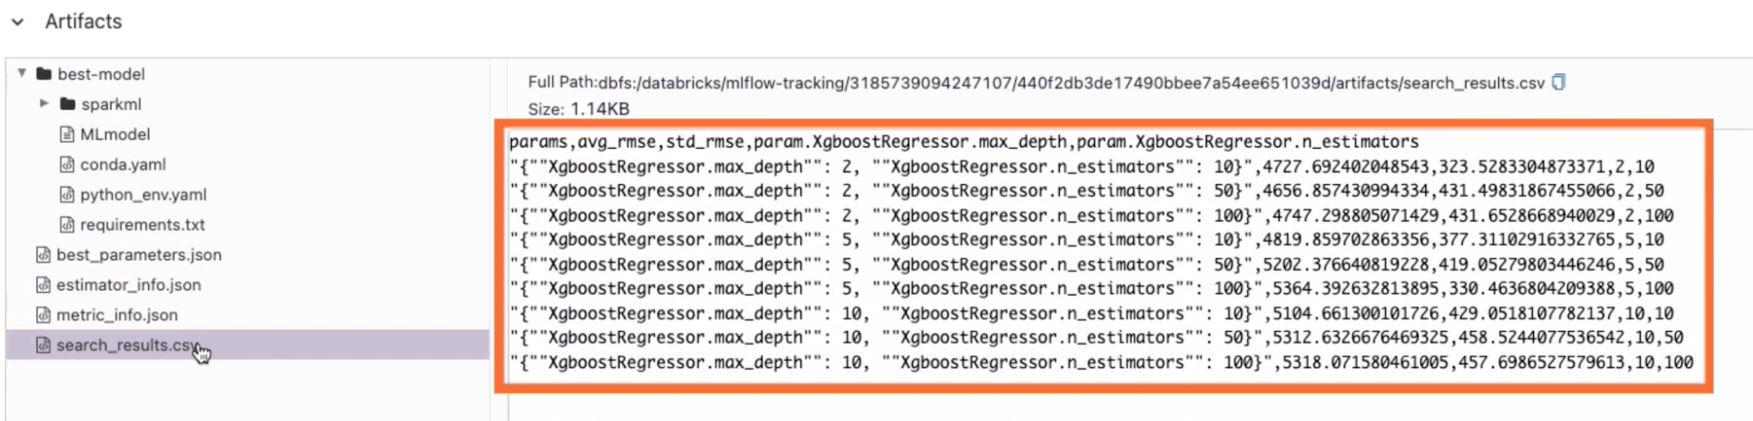

# Hyperparameter Tuning for ML Models

## Hyperopt for Hyperparameter Tuning

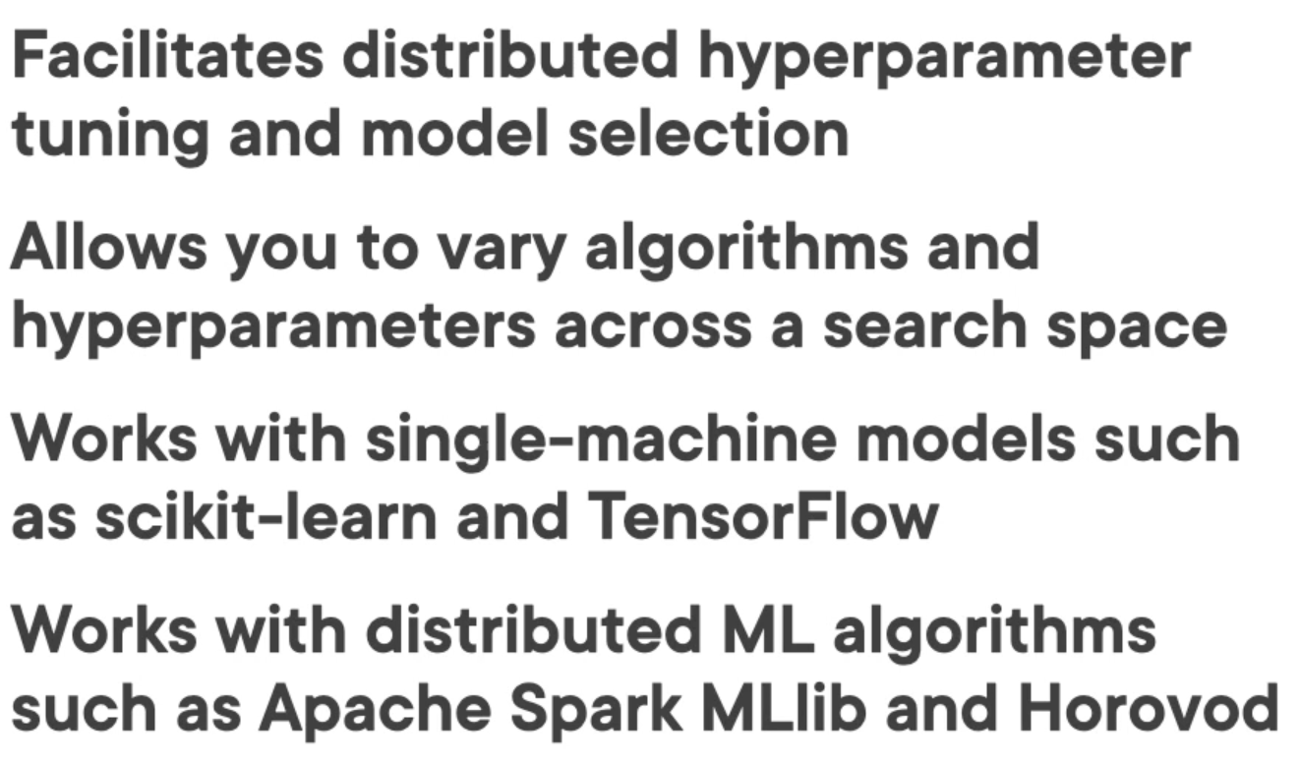

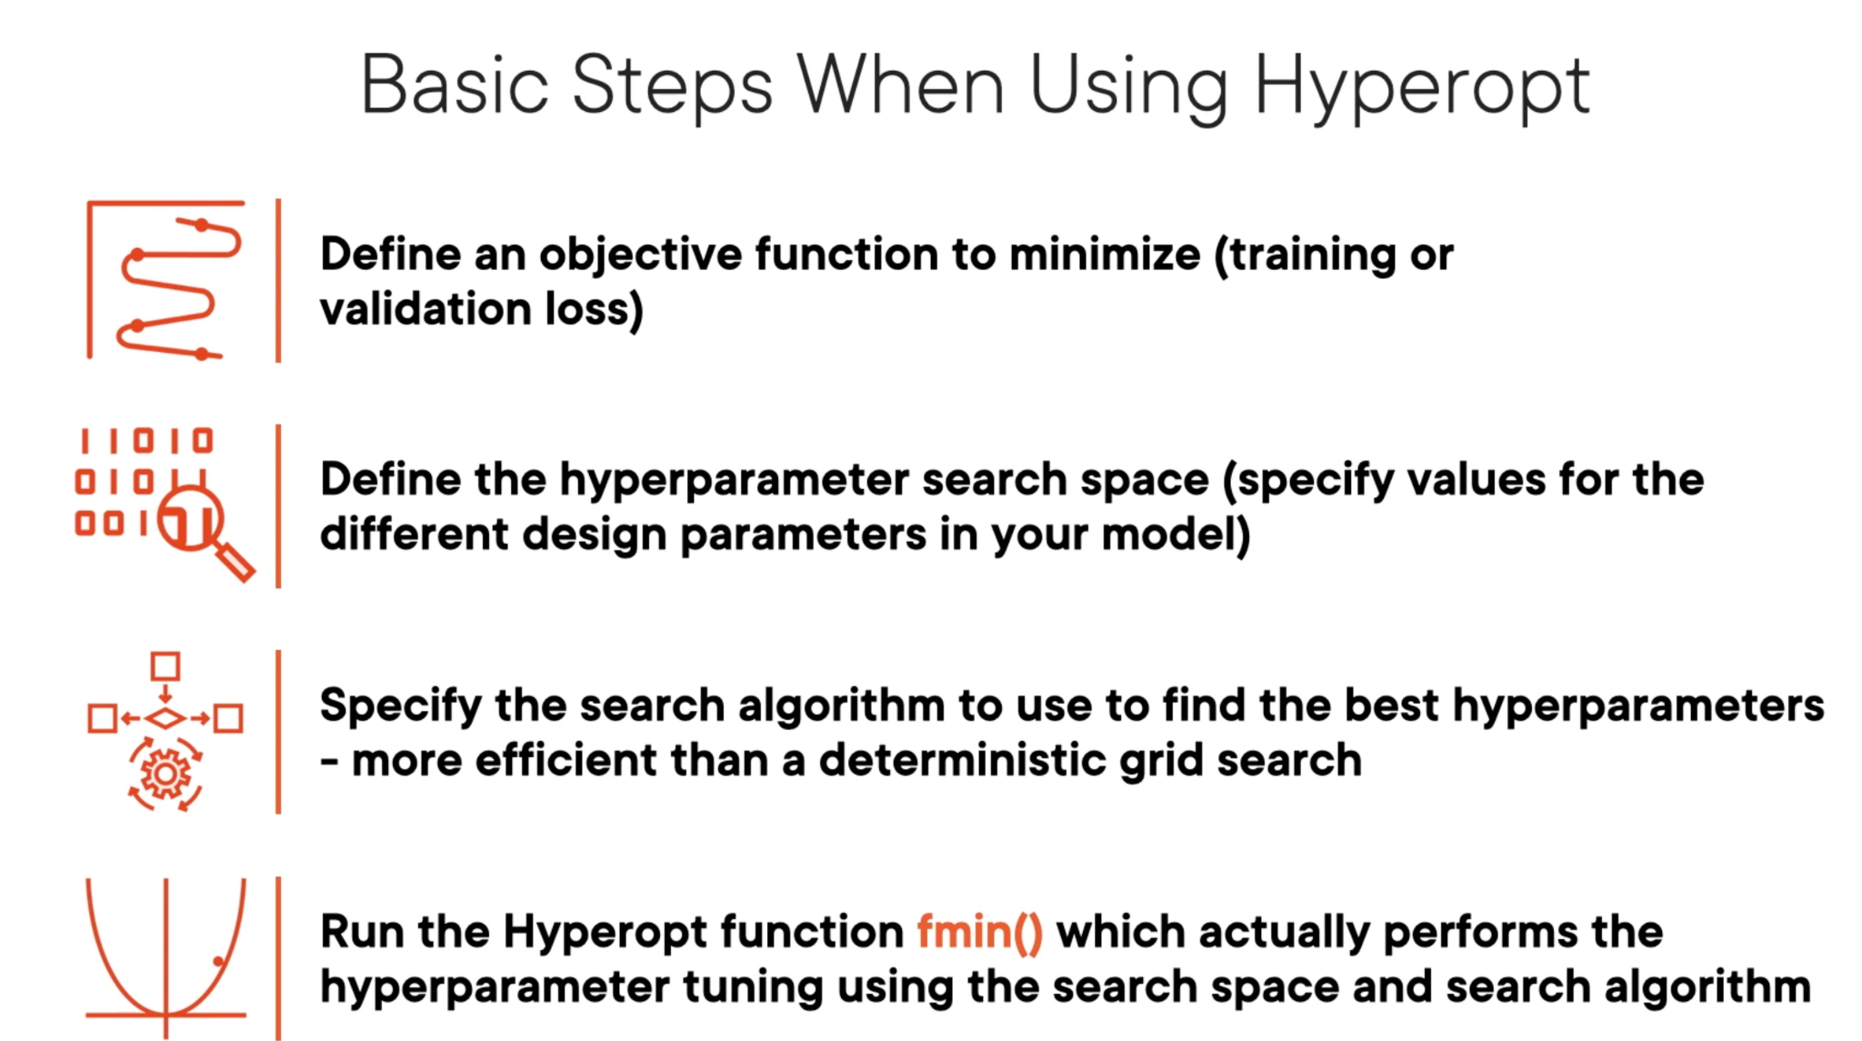

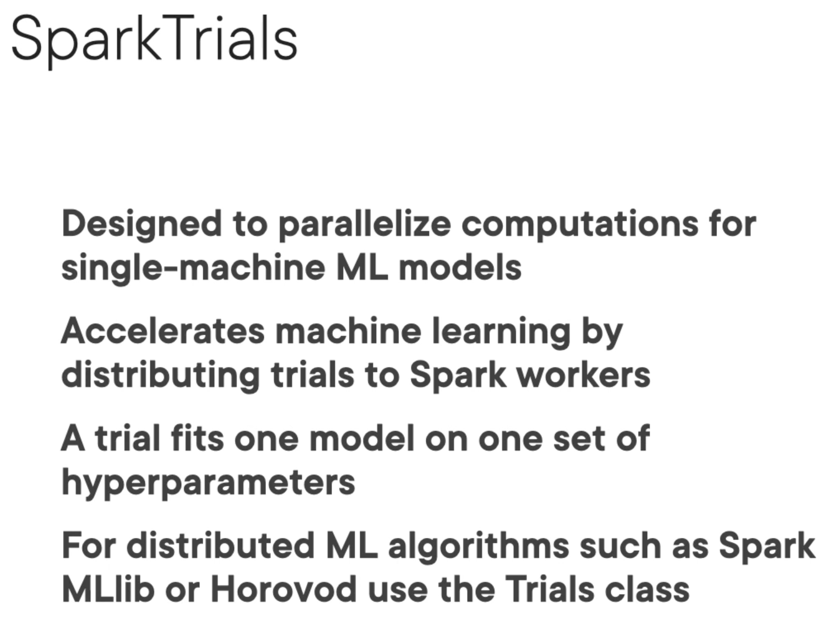

### Explicitly Logging Model Parameters

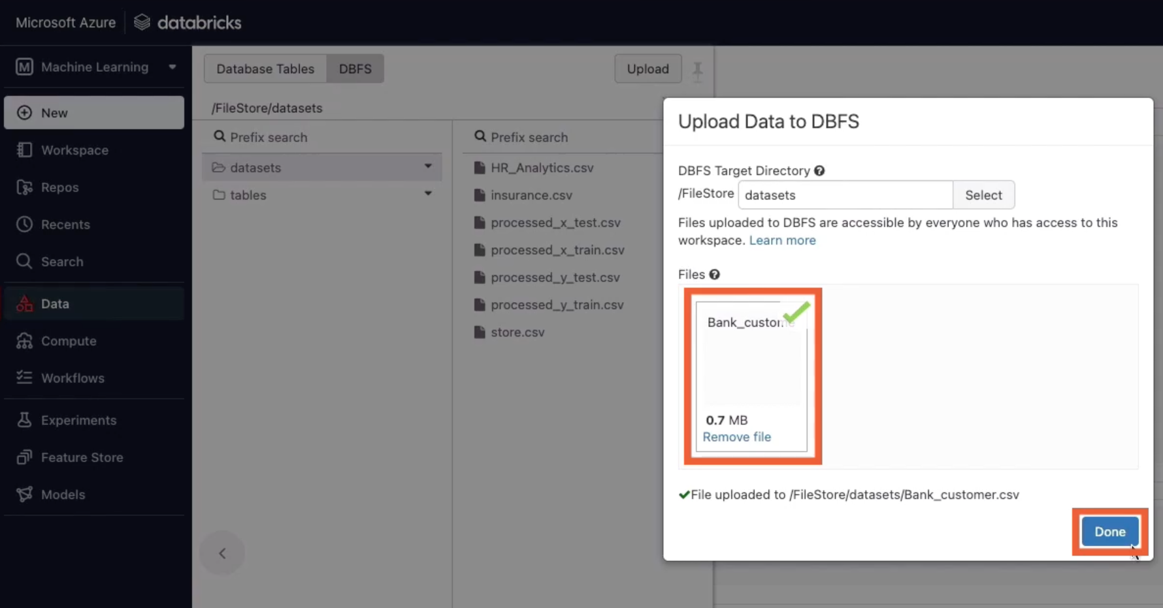

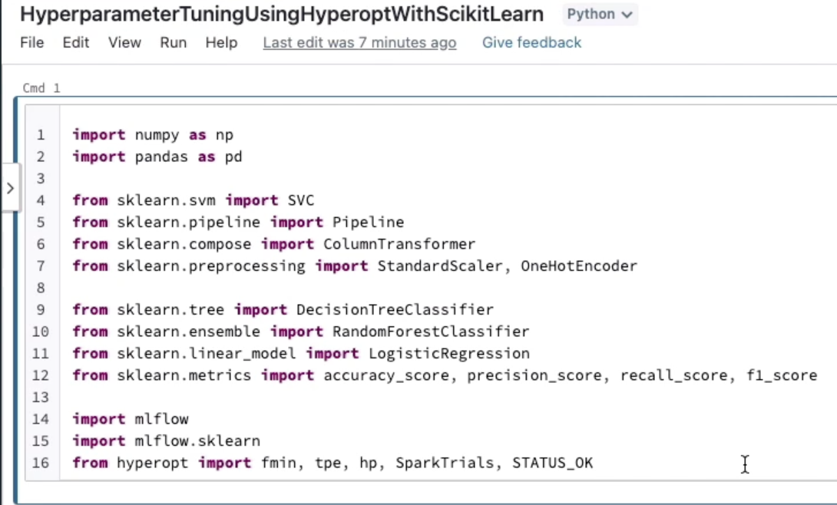

I havn’t turned on autologging, which means I will need to explicitly log whatever parameters and metrics I’m interested in

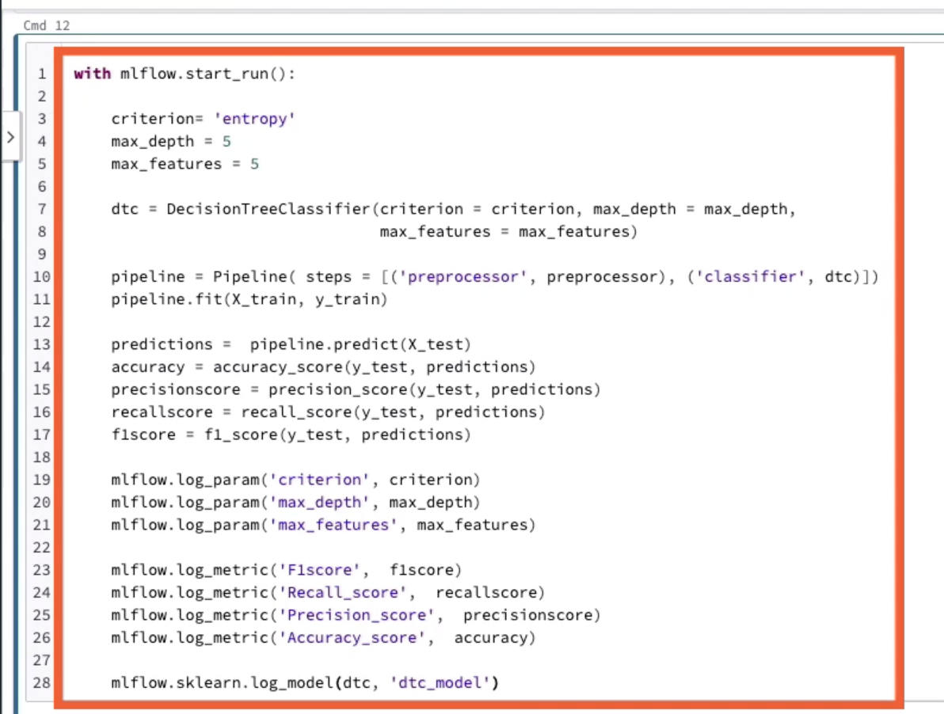

This is how you explicitly log model parameters in a run without using autolog

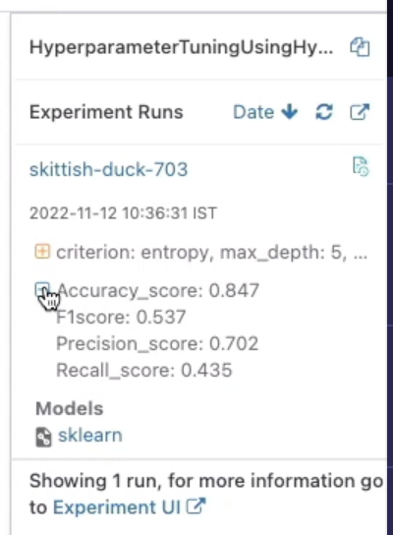

### Hyperparameter Tuning Using Hyperopt

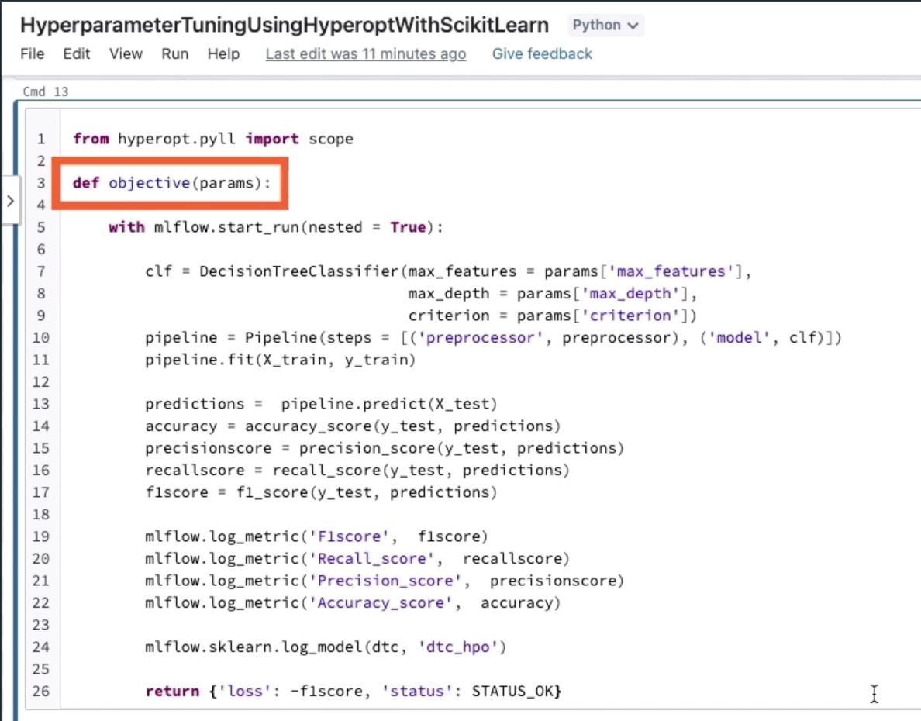

nested=True, because it is a nested run under larger hyperparameter tuning process

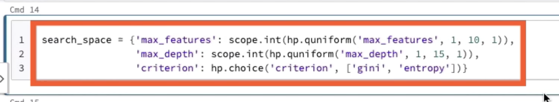

Tpe.suggest uses a Tree of Parzen Estimators, a Bayesian approach which iteratively and adaptively selects new hyperparameter settings to explore based on past results.

Another choice for the algorithm is hyperopt.rand.suggest, this is a random search algorithm. It’s a non-adaptive approach that samples over the search space

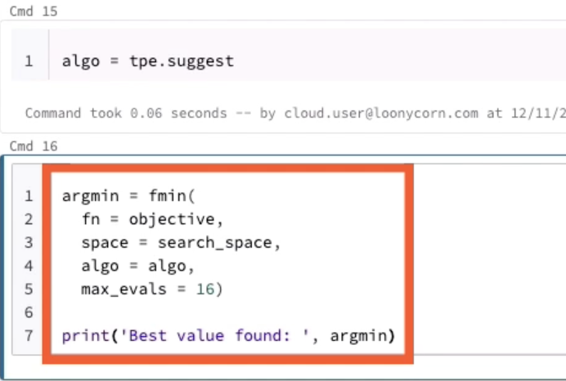

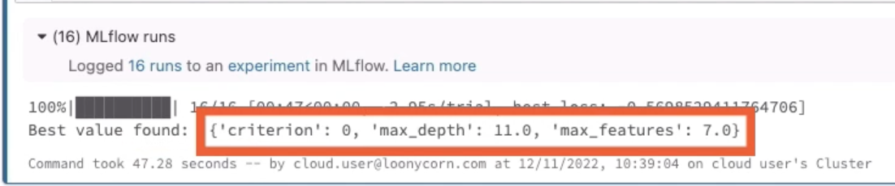

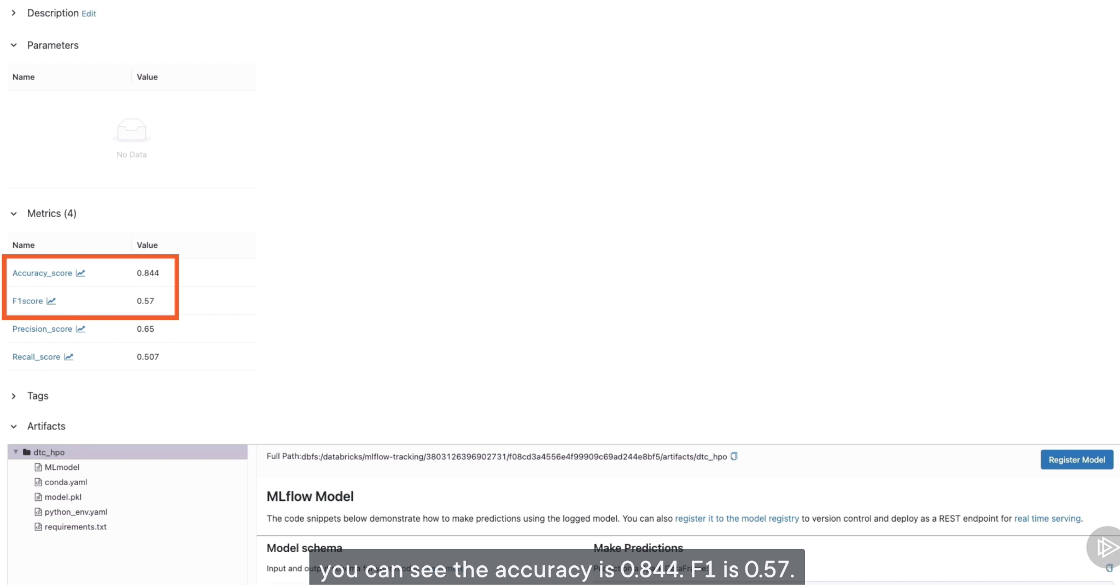

The hyperparameter tuning that we performed earlier did not use distributed processing. This time I will use the SparkTrials class for distributed training

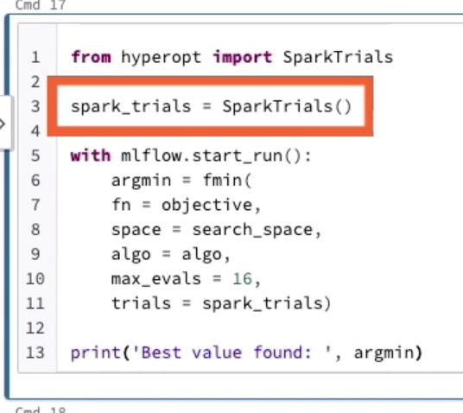

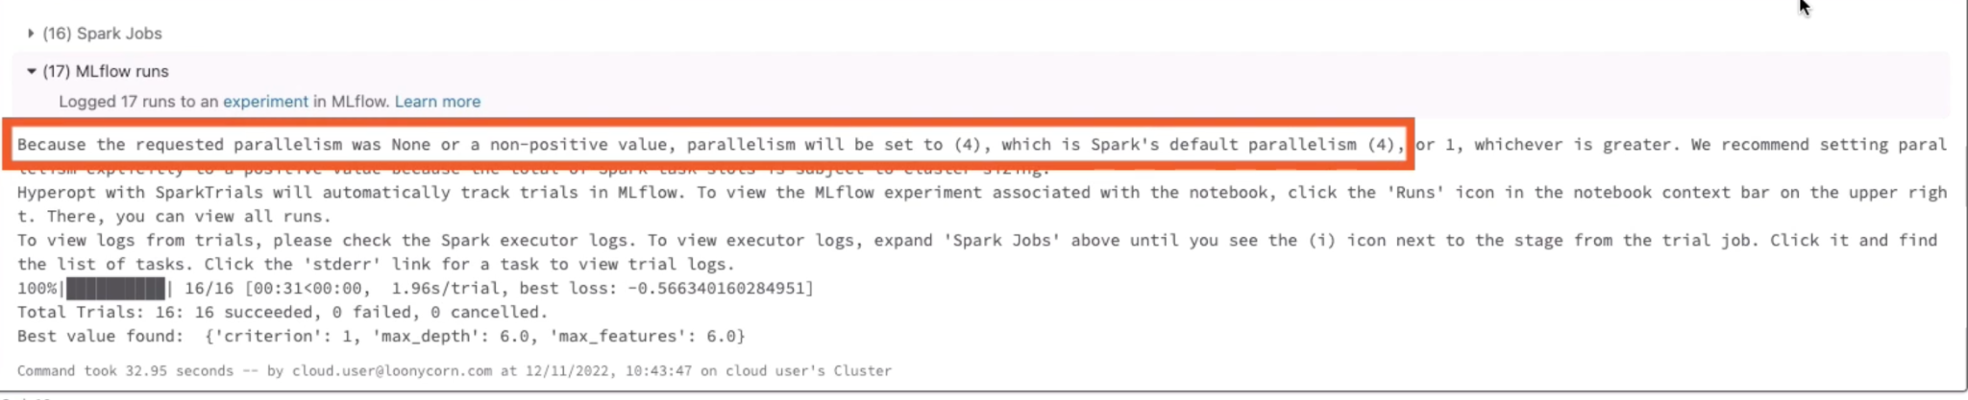

Parallelism is set to 4, because our single-node Spark cluster has 4 cores. Faster than running training sequentially

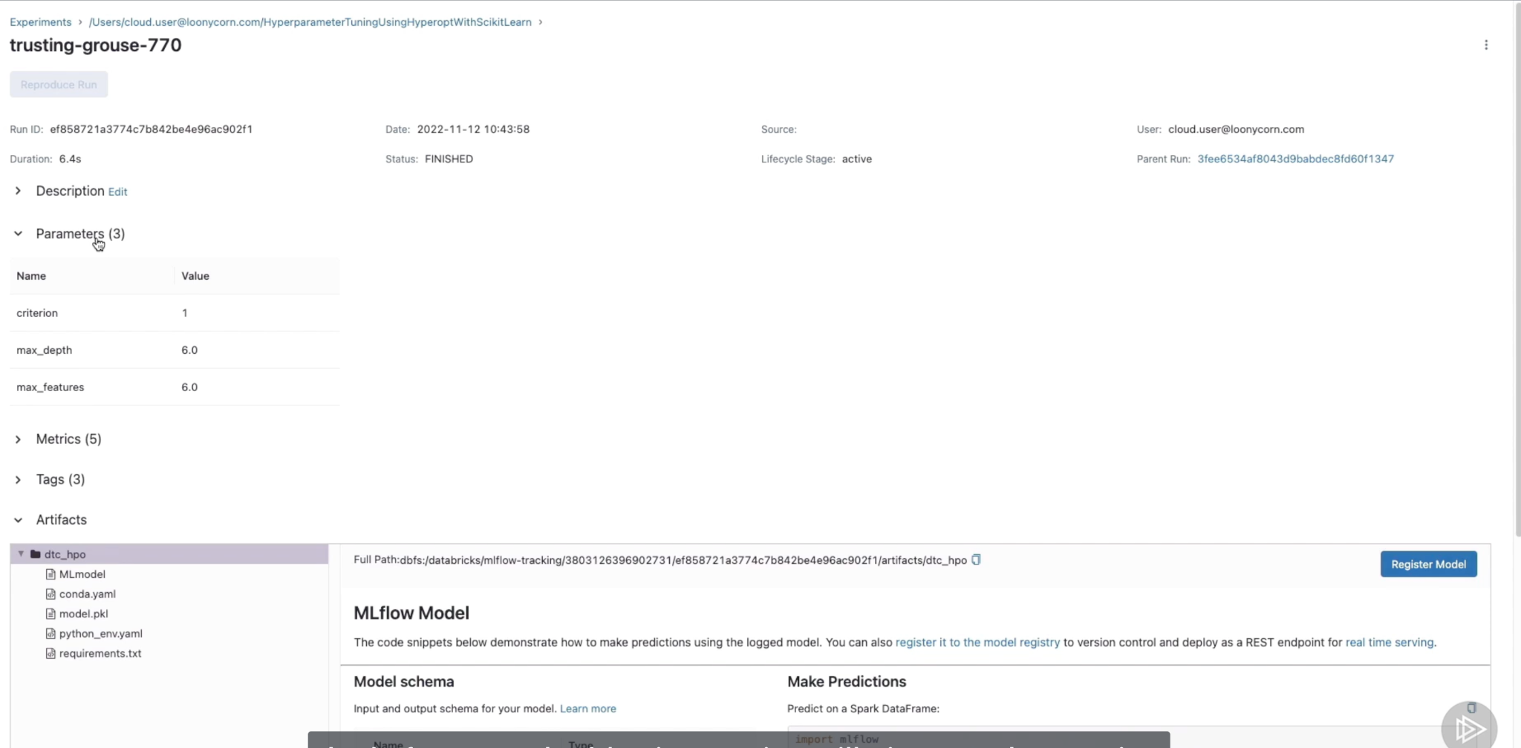

### Hyperparameter Training using Different Classifiers

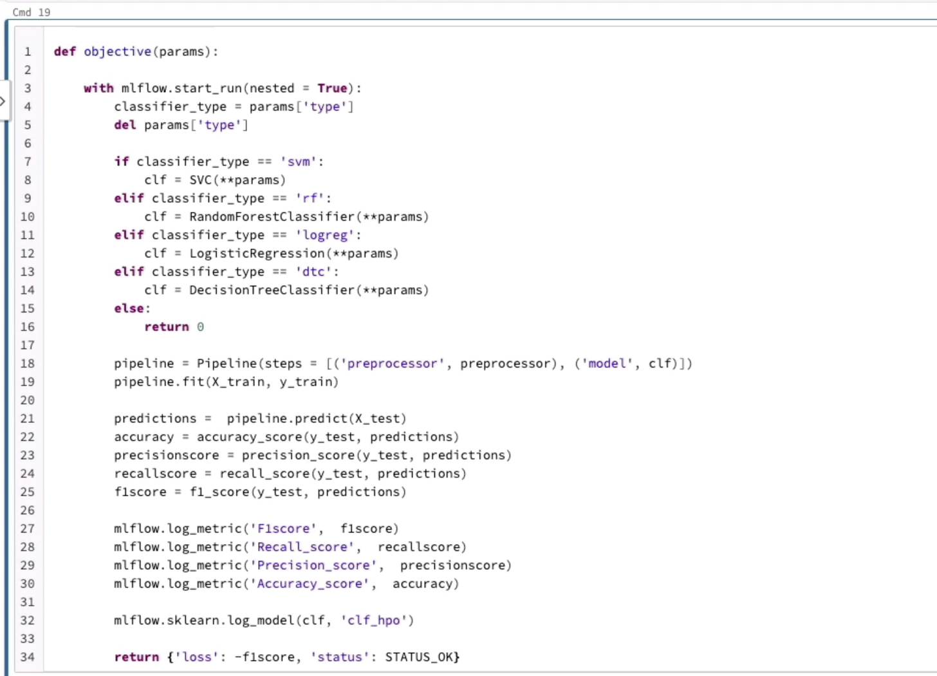

The line 3 ensures each fmin call is logged to a separate MLflow min run, and it makes it easier to log extra tags.

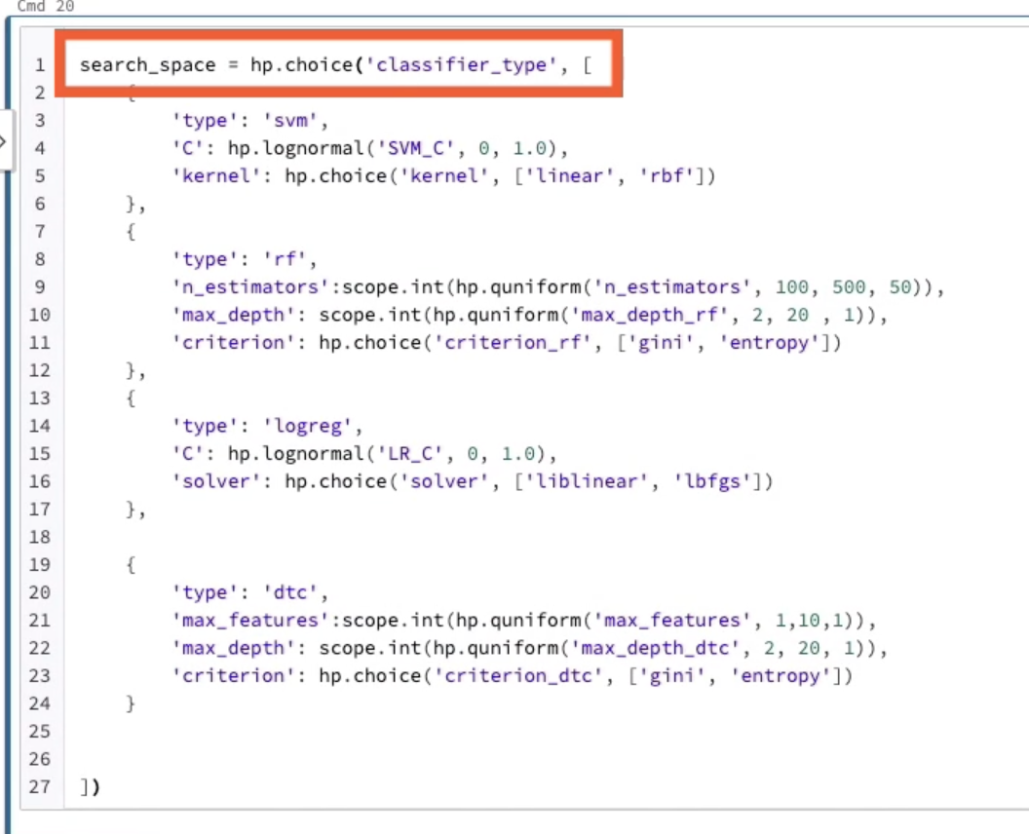

Hp.choice, based on the classifier type, we specify the search space.

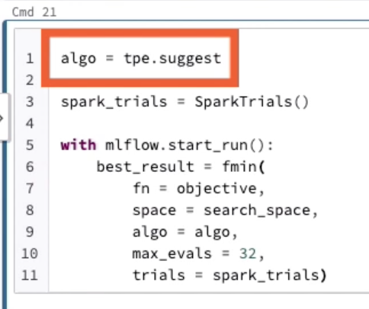

max=evals means 32 models are trained

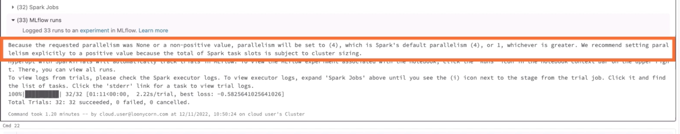

4 models will be trained concurrently because my Spark cluster has 4 cores

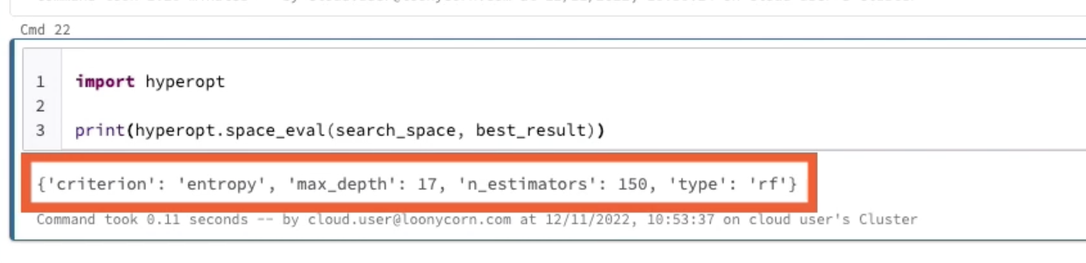

This way we can easily find the best possible model’s parameters